Supplementary Data
Byproducts of aqueous chlorination of equol and their estrogenic potencies
Yuyin ZHOU,† Shiyi ZHANG,† Fanrong Zhao,† Hong Zhang,† Wei An,‡ Min Yang,‡ Zhaobin Zhang,† and Jianying HU†,*
†Laboratory for Earth Surface Processes, College of Urban and Environmental Sciences,
Peking University, Beijing 100871, China
‡State Key Laboratory of Environmental Aquatic Chemistry, Research Center for
Eco-Environmental Sciences, Chinese Academy of Sciences, Beijing 100085, China
*Corresponding author. Email address: hujy@urban.pku.edu.cn (Jianying HU)

Chlorination Procedures. The experiments were carried out in a glass reactor placed in a water bath to maintain a 25°C reaction temperature. Synthetic raw water was prepared with 6 L of Milli-Q pure water, adjusted to pH 7.5 by phosphoric acid and spiked with 500 μg/L of standard equol. After sodium hypochlorite (1.46 mg/L) (ca. 5% available Cl; Kanto Chemical Co., Tokyo) was added to the solution, aliquots (1 L) were taken out at 10, 30, 60, 180, 360, and 1440 min. Then was added to decompose the residual sodium hypochlorite. The sample before chlorine reaction (0 min) was prepared with 1 L of Milli-Q pure water, adjusted to pH 7.5 by phosphoric acid and spiked with 500 μg/L of standard equol after adding the same amount of sodium hypochlorite and , to eliminate possible contamination from the added sodium hypochlorite and . Water samples (1 L) were extracted by Oasis HLB (500 mg, 6 mL) solid phase extraction (SPE) cartridges according to the method reported previously (Fan et al. 2013). The extracts were dried under a gentle nitrogen stream, and redissolved with 0.1 mL of DMSO prior to UHPLC-quadrupole-orbitrap-MS analysis.
UHPLC-quadrupole-orbitrap-HRMS Condition. The condition of quadrupole-orbitrap-high resolution mass spectrometer was similar to previous study (Negreira et al. 2015, Negreira et al. 2016). The quadrupole-orbitrap-high resolution mass spectrometer was equipped with a heated-electrospray ionization source (HESI II). The HESI II source was operated in the negative ionization mode under the following specific conditions: spray voltage, 2.6 kV; sheath gas, 35 arbitrary units; auxiliary gas, 10 arbitrary units; sweep gas, 0 arbitrary units; capillary temperature, 320 °C and vaporizer temperature, 350 °C. Nitrogen (> 99.98%) was employed as sheath, auxiliary and sweep gas
The mass spectrometer performed a full scan event (m/z 50 - 750, 70,000 full width at half maximum (FWHM) resolution at m/z 200). Once retention times and accurate masses of [M – H]– ions of the by-products were obtained, accurate product ion spectra (MS/MS) were obtained in further injections with Orbitrap resolution set at 17500 (at m/z 200). Parent ions were fragmented by high-energy C-trap dissociation (HCD) with a normalized collision energy of 30% and an activation time of 120 ms. The identification of byproducts was based on their accurate masses and isotopic abundances obtained in the MS mode, as well as on their MS/MS fragmentation patterns and the accurate masses of the resulting product ions.
Instrument control and data acquisition were performed with Xcalibur 2.2 software (Thermo Fisher Scientific). An external calibration for mass accuracy was carried out on the day prior to the analysis according to the manufacturer's guidelines. Equol and its byproducts were ionized in the negative mode, yielding the corresponding [M – H]– ion. In order to guarantee accurate determination of equol as well as its potential byproducts, the performance of the UHPLC-quadrupole-Orbitrap HRMS system was first assessed with standards in ultrapure water. The high-resolution/accurate-mass capabilities of this hybrid mass spectrometer allowed detection of the target compound with a mass measurement error of 0.732 ppm.

Synthesis of Chlorinated Equols. The synthesis of chlorinated equols is referred to the method used to synthesize chlorinated estrogens (Fan et al. 2013). An aqueous solution of sodium hypochlorite (1%, 10 ml) was added dropwise to a solution of equol (200 mg) in 100 ml methanol with stirring. The solution was stirred for 3 h at room temperature. After addition of saturated aqueous sodium sulfite, the solution acidified with 2 M hydrochloric acid was extracted with ethyl acetate. The organic layer was washed with brine, dried over magnesium sulfate, and concentrated to 2 mL under reduced pressure. The residue was separated into its component compounds using a preparative HPLC (Waters 2690) with UV absorbance detector (Waters 2487) to isolate three chlorinated products, including monochloro-equol (MCequol), dichloro-equol (DCequol), and trichloro-equol (TCequol). The UV detector was set at 280 nm. The chromatographic separation was conducted by a Waters HR C18 column (6 μm; 19 mm × 300 mm) with acetonitrile (A) and ultrapure water (B) used as the mobile phases. The column was maintained at 40°C, and the flow rate and injection volume were 6 mL/min and 500 μL, respectively. 40% A was increased to 75% in 50 min and maintained for 30 min, and then increased to 100% in 10 min, and maintained for 20 min, followed by a decrease to the initial conditions of 40% A and held for 20 min to allow for equilibration. The synthesized products were characterized by UHPLC-quadrupole-orbitrap-HRMS and NMR spectra. NMR spectra of MCequol, DCequol and TCequol are shown in Fig. S2.

References
Fan, Z.; Hu, J.; An, W.; Yang, M., 2013. Detection and occurrence of chlorinated byproducts of bisphenol a, nonylphenol, and estrogens in drinking water of china: comparison to the parent compounds. Environ. Sci. Technol. 47, 10841-10850.
Hu, J.; Cheng, S.; Aizawa, T.; Terao, Y.; Kunikane, S., 2003. Products of Aqueous Chlorination of 17β -Estradiol and Their Estrogenic Activities. Environ. Sci. Technol. 37, 5665-5670.
Negreira, N.; López de Alda, M.; Barceló, D., 2015. Degradation of the cytostatic etoposide in chlorinated water by liquid chromatography coupled to quadrupole-Orbitrap mass spectrometry: Identification and quantification of by-products in real water samples. Sci. Total Environ.506, 36-45.
Negreira, N.; Regueiro, J.; López de Alda, M.; Barceló, D., 2016. Reactivity of vinca alkaloids during water chlorination processes: Identification of their disinfection by-products by high-resolution quadrupole-Orbitrap mass spectrometry. Sci. Total Environ. 544, 635-644.

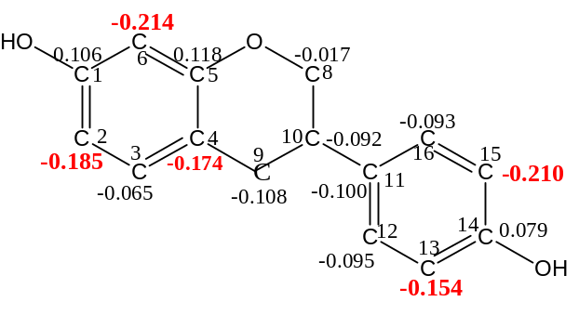
Fig. S1. Partial atomic charges of equol.

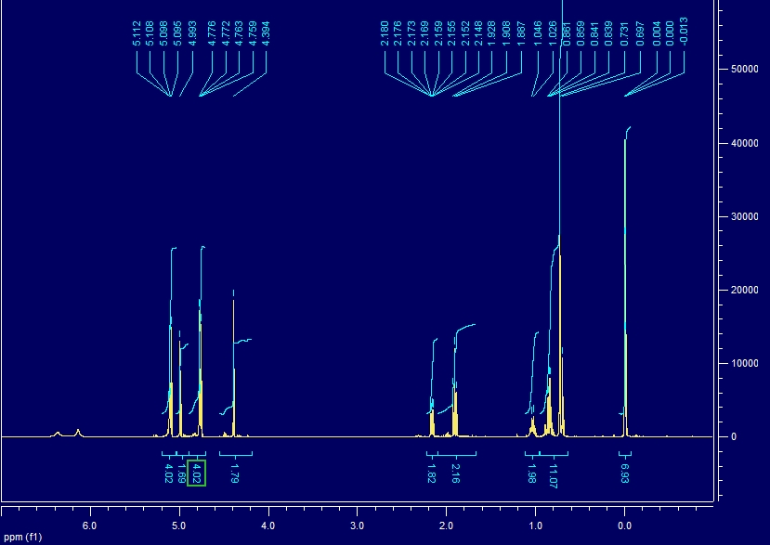
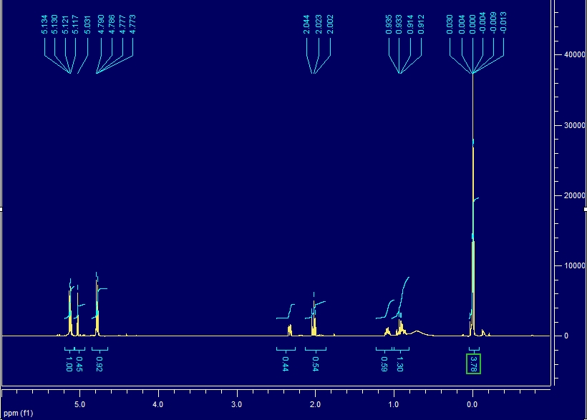
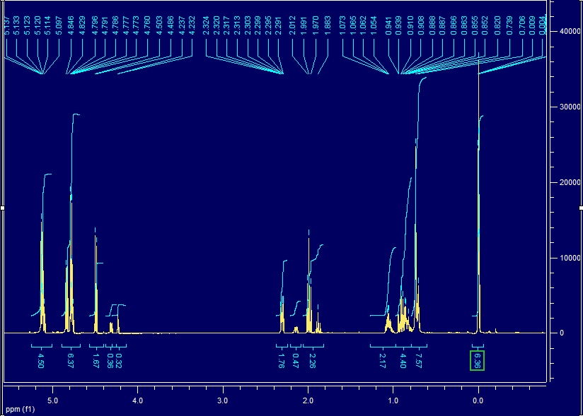
Fig. S2. NMR spectra of MCequol, DCequol, and TCequol.

