Supplementary Material
Simultaneous determination of (N-ethyl perfluorooctanesulfonamido ethanol)-based phosphate diester and triester and their biotransformation to perfluorooctanesulfonate in freshwater sediments

Shiyi Zhang ¹, Hui Peng^{2, 3}, Di Mu¹, Haoqi Zhao¹, and Jianying Hu*¹

1 MOE Laboratory for Earth Surface Process, College of Urban and Environmental Sciences, Peking University, Beijing 100871, China
² Department of Chemistry, University of Toronto, Toronto, Canada
³ School of the Environment, University of Toronto, Toronto, Canada
Corresponding author:
Jianying HU, College of Urban and Environmental Sciences, Peking University, Beijing 100871, China, TEL & FAX: 86-10-62765520, e-mail: hujy@urban.pku.edu.cn

Microbial activity test
The Petrifilm™ Aerobic Count (AC) was used to test microbial activity according to the manufacturer’s instructions. Approximately 0.1 mL of supernatant of both active and inactive slurry was removed on days 0, 21, 49, 77, 91 and 105 of the experiment and diluted with 10 mL of deionized water. A control was also prepared with deionized water and no sediment. The top film of the Petrifilm™ Aerobic Count (AC) plate was lifted and 1.0 ml of diluted sample or control was dispensed onto the center of the bottom film. Slowly, and while preventing air bubbles from being trapped, the top film was placed onto the sample. Thereafter, a plastic spreader was placed and pushed gently downward onto the center of the plate to distribute the water sample. The plastic spreader was removed and plates were left undisturbed for at least 1 min to permit gel solidification. Plates were incubated in a horizontal position, in a moist chamber at 35°C. After 48 h, the AC plates were assessed visually for ‘red dots’ which indicated the presence of microbial colonies.

Purification of the SAmPAP triester by HPLC fractionation
A previously developed HPLC fractionation method for purification of the SAmPAP diester (Peng et al., 2013) was used for the SAmPAP triester in this study, with some modification. In detail, HPLC fractionation was used to isolate the SAmPAP triester from the technical product FC-807 which was obtained from the Hubei Hengxin Company. Fractions were collected at 2-min intervals from 95 min to 120 min, and the SAmPAP triester in each fraction was quantified by use of UPLC-MS/MS, following a 10,000-fold dilution with methanol. Fractions which contained the SAmPAP triester were collected, combined, and evaporated. Fractionation was conducted by use of a Waters HR C18 column (6 µm; 19 mm×300 mm) which was maintained at 40°C. The flow rate and the injection volume were 6 mL/min and 100 µL, respectively. Methanol (A) and ultrapure water (B) were used as mobile phases: 20% A was increased to 50% in 10 min, then to100% in 100 min and kept for 20 min, followed by a decrease to initial conditions of 20% and held for 20 min to allow for equilibration. Following purification, the SAmPAP triester was characterized by ultra-high performance liquid chromatography-hybrid quadrupole-Orbitrap mass spectrometry (UHPLC-Q-Orbitrap) with a full scan range from 100-2000 m/z. A single peak of the SAmPAP triester was clearly observed, and intensities of other peaks were more than 50-fold lower than the SAmPAP triester, (Fig. SM3). Finally, the potential impurities (PFOS, perfluorooctane sulfonamide ethanol (FOSE), perfluorooctane sulfonamide ethanol based phosphate monoester, the SAmPAP diester, PFOSA, EtFOSA, FOSAA and EtFOSAA) were quantified using targeted monitoring of potential contaminants. None of these chemicals were detected in the purified SAmPAP triester (1 mg/L).

UHPLC-Q-Orbitrap analysis
The Ultimate 3000 UHPLC system (Dionex, Sunnyvale, California, USA) was coupled to a Q- Exactive MS (Thermo Scientific, Rockford, Illinois, USA) to characterize the purification of the SAmPAP triester. Separation of the purified SAmPAP triester was achieved with a Waters ACUITY UPLC BEH C18 column (1.7 µm; 2.1 mm × 100 mm). The injection volume was 5 µl. Methanol (A) and 5 mM ammonium acetate (B) were used as the mobile phases. Initially 10% A was increased to 100% in 3 min and maintained for 2.5 min, followed by a decrease to initial conditions of 10% A and held for 2 min to allow for equilibration. The flow rate was 0.3 mL/min. Mass spectrometry was performed using an Orbitrap with a heated electrospray ionization source (HESI) in positive ion mode, while data were collected in centroid mode. The instrument was set to acquire over the range 100-2000 m/z with a resolving power of 70,000 FWHM. Collision energies were set at 40 arbitrary units. The spray voltage was maintained at 3.2 kV in positive ion mode, Sheath gas flow was 35 arbitrary units, and auxiliary gas flow rate was kept at 10 arbitrary units and capillary temperature at 320°C. Nitrogen was used as both sheath and auxiliary gas. Heater temperature was kept at 350°C and S-lens RF level at 50. The instrument was externally calibrated prior to the measurement using the mixture of mass calibrants.

Instrumental Analysis
Analysis of extracts was accomplished by a previously developed ultra-performance liquid chromatography tandem mass spectrometry (UPLC-MS/MS) which utilized an Acquity Ultra Performance LC (Waters, Milford, Massachusetts, U.S.). A C18 column (100 × 2.1 mm, 1.7 μm particle size) from Waters (Milford, Massachusetts, USA) was used for chromatographic separation at 40°C and a flow rate of 0.2 mL/min. For the sake of displacing the peaks caused by contamination from the UPLC, a C18 pre-column (50 mm × 2.1 mm, 1.7 μm particle size) (Milford, MA, USA) was used before the six-port valve of the UPLC. The injection volume was 10 μL. Methanol and water containing 5 mM ammonium acetate were utilized as mobile phases. Gradient conditions were initiated with 10% methanol followed by a linear increase to 75% methanol within 10 min. The proportion of methanol was raised to 100% at 15 min and held for 4 min before it was returned to 10% and the equilibration was kept for 4 min. The weak wash solvent was 900 μL of Water/MeOH (v/v, 9:1). The strong wash solvent was 400 μL of Water/MeOH (v/v, 1:9). The run time of washing program was 2 min. Mass spectrometry was performed using a Premier XE tandem quadrupole mass spectrometer equipped with an electrospray ionization source and operated in the negative ion mode (except for the SAmPAP triester, which required analysis in the positive ion mode). The two most abundant multiple reaction monitoring (MRM) transitions, cone voltages, and collision energies were summarized in Table SM1. Optimal MS conditions were as follows: source temperature, 110°C; desolvation temperature, 350°C; capillary voltage, 1.0 kV for the negative ion mode, 3.0 kV for the positive ion mode; desolvation gas flow, 800 L/h; and cone gas flow, 100 L/h.
References
Peng, H., Zhang, S.Y., Sun, J.X., Zhang, Z., Giesy, J.P., Hu, J.Y., 2014. Isomer-specific accumulation of perfluorooctanesulfonate from (N-ethyl perfluorooctanesulfonamido) ethanol-based phosphate diester in Japanese medaka (Oryzias latipes). Environ. Sci. Technol. 48, 1058-1066.

Table S1
Perfluorinated compounds examined in the present Study, acronym, chemical formulae, precursor ions, product ions and corresponding surrogates.
Name | Chemical  Formula | MRM  transition | Cone voltage (V) | Collision energy (eV) | Surrogate  Standard
Perfluorohexanoate (PFHxA) | C₅F₁₁CO₂⁻ | 313>269 ª  313>119 | 12 | 10  20 | ¹³C₂-PFHxA
Perfluoroheptanoate (PFHpA) | C₆F₁₃CO₂⁻ | 363>319 ª  363>169 | 14 | 9  17 | ¹³C₄-PFOA
Perfluorooctanoate (PFOA) | C₇F₁₅CO₂⁻ | 413>369 ª  413>169 | 15 | 10  18 | ¹³C₄-PFOA
Perfluorononanoate (PFNA) | C₈F₁₇CO₂⁻ | 463>419 ª  463>219 | 16 | 11  17 | ¹³C₅-PFNA
Perfluorodecanoate (PFDA) | C₉F₁₉CO₂⁻ | 513>469 ª  513>219 | 20 | 12  16 | ¹³C₂-PFDA
Perfluoroundecanoate (PFUnDA) | C₁₀F₂₁CO₂⁻ | 563>519 ª  563>169 | 20 | 13  20 | ¹³C₂-PFUnDA
Perfluorododecanoate (PFDoDA) | C₁₁F₂₃CO₂⁻ | 613>569 ª  613>169 | 23 | 12  25 | ¹³C₂-PFDoDA
Perfluorotridecanoate (PFTriDA) | C₁₂F₂₅CO₂⁻ | 663>619 ª  663>269 | 23 | 12  26 | ¹³C₂-PFDoDA
Perfluorotetradecanoate (PFTeDA) | C₁₃F₂₇CO₂⁻ | 713>669 ª  713>169 | 23 | 15  30 | ¹³C₂-PFDoDA
Perfluorohexanesulfonate (PFHxS) | C₆F₁₃SO₃⁻ | 399>80 ª  399>99 | 52 | 40  32 | ¹⁸O₂-PFHxS
Perfluoroheptanesulfonate (PFHpS) | C₇F₁₅SO₃⁻ | 449>80 ª  449>99 | 50 | 45  35 | ¹³C₄-PFOS
Perfluorooctanesulfonate (PFOS) | C₈F₁₇SO₃⁻ | 499>80ª  499>99 | 55 | 50  40 | ¹³C₄-PFOS
Perfluorooctanesulfonamide (PFOSA) | C₈F₁₇SO₂NH₂ | 498>78ª  498>169 | 42 | 40  34 | EtFOSAA-d₅
Perfluorooctane sulfonamideo acetate(FOSAA) | C₈F₁₇SO₂NH(CH₂COOH) | 556>498ª  556>83 | 45 | 24  38 | EtFOSAA-d₅
N-ethylperfluorooctane Sulfonamide(EtFOSA) | C₈F₁₇SO₂NHC₂H₅ | 526>169 ª  526>219 | 42 | 30  30 | EtFOSAA-d₅
N-ethylperfluorooctanesulfon amido aceticacid (EtFOSAA) | C₈F₁₇SO₂N(C₂H₅)CH₂COOH | 584>419 ª  584>83 | 32 | 22  22 | EtFOSAA-d₅
N-ethyl perfluorooctanesulfonamido ethanol (EtFOSE) | C₈F₁₇SO₂N(C₂H₅)C₂H₄OH | 630>59 ª | 35 | 30 | EtFOSAA-d₅
(N-ethyl perfluorooctanesulfonamido ethanol)-based phosphate diester (SAmPAPdiester) | (C₈F₁₇SO₂N(CH₂CH₃)CH₂CH₂O)₂PO₂⁻ | 1203>526ª  1203>219 | 70 | 48  66 | ¹³C₄-8:2 diPAP
(N-ethyl perfluorooctanesulfonamido ethanol)-based phosphate triester (SAmPAP triester) | (C₈F₁₇SO₂N(CH₂CH₃)CH₂CH₂O)₃PO | 1758>554ª  1758>120 | 70 | 40  100 | TEHP-d₅₁
ª MRM transition used for quantitation.

Table S2
MDLs, MQLs, procedural blank concentrations, recoveries and matrix effects of target compounds in sediment.
 | MDL, ng/g(1g sediment) | MQL, ng/g(1g sediment) | Procedure blank ± SD(n=6), ng/g | Recovery, % |  |  |  | Matrix effect (%)
 |  |  |  | 0.1 ng/g |  | 1 ng/g | 10 ng/g | Matrix effect (%)
PFHxA | 0.006 | 0.020 | ND | 85±6 | 82±5 |  | 85±10 | -6±4
PFHpA | 0.010 | 0.032 | ND | 89±2 | 83±3 |  | 86±3 | -11±5
PFOA | 0.005 | 0.017 | ND | 80±12 | 79±5 |  | 81±12 | -10±4
PFNA | 0.005 | 0.017 | ND | 95±7 | 85±2 |  | 91±4 | -6±4
PFDA | 0.006 | 0.020 | ND | 81±6 | 77±3 |  | 85±6 | -3±3
PFUnDA | 0.005 | 0.017 | ND | 85±9 | 84±6 |  | 79±7 | -10±4
PFDoDA | 0.005 | 0.017 | ND | 75±2 | 73±2 |  | 82±2 | -16±4
PFTriDA | 0.010 | 0.032 | ND | 73±12 | 62±10 |  | 75±15 | -16±6
PFTeDA | 0.010 | 0.032 | ND | 75±12 | 62±10 |  | 70±11 | -13±2
PFHxS | 0.005 | 0.017 | ND | 93±5 | 94±3 |  | 85±8 | -13±4
PFHpS | 0.005 | 0.017 | ND | 95±12 | 106±13 |  | 91±10 | -12±4
PFOS | 0.010 | 0.032 | ND | 111±15 | 108±8 |  | 100±12 | -10±5
PFOSA | 0.006 | 0.020 | ND | 76±6 | 97±12 |  | 87±2 | -2±4
FOSAA | 0.021 | 0.070 | ND | 68±7 | 57±3 |  | 55±8 | -13±1
EtFOSA | 0.001 | 0.003 | ND | 62±3 | 64±3 |  | 55±4 | -12±3
EtFOSAA | 0.010 | 0.033 | ND | 68±13 | 79±7 |  | 78±14 | -9±4
EtFOSE | 0.010 | 0.033 | ND | 66±12 | 71±12 |  | 75±6 | -13±4
SAmPAP diester | 0.027 | 0.090 | 0.046±0.009 | 100±21 | 97±26 |  | 127±26 | -8±4
SAmPAP triester | 0.024 | 0.080 | 0.019±0.008 | 93±9 | 93±14 |  | 85±12 | -3±2

Table S3
TOC (g/kg dw) and concentration (ng/g dw) of PFCs in sediment samples.
No. | TOC in sediment(g/kg) | PFHxA | PFHpA | PFOA | PFNA | PFDA | PFUnDA | PFDoDA | PFTriDA | PFTeDA | PFHxS | PFHpS | PFOS
1 | 7.78 | n.d. | n.d. | 0.51 | n.d. | 1.21 | 0.24 | 0.04 | 0.36 | 0.08 | 0.43 | n.d. | 0.62
2 | 8.28 | 0.28 | 0.04 | 0.30 | n.d. | 0.18 | 0.24 | 0.22 | 0.09 | n.d. | 0.06 | n.d. | 0.37
3 | 10.11 | 0.27 | 0.09 | 0.36 | 0.03 | 0.30 | 0.31 | 0.23 | 0.11 | 0.06 | 0.05 | n.d. | 0.15
4 | 8.52 | 0.13 | 0.01 | 0.33 | 0.24 | 0.07 | 0.10 | n.d. | n.d. | n.d. | 0.02 | n.d. | 0.21
5 | 14.41 | 0.52 | n.d. | 2.47 | n.d. | 0.14 | 0.50 | 0.32 | 0.04 | n.d. | 0.26 | n.d. | 0.82
6 | 13.32 | 0.14 | 0.04 | 0.18 | 0.03 | 0.13 | 0.08 | n.d. | n.d. | n.d. | 0.01 | n.d. | 2.24
7 | 7.75 | 0.70 | 0.12 | 1.77 | 0.10 | 0.61 | 1.06 | 0.66 | 0.42 | n.d. | 0.20 | n.d. | 0.24
8 | 11.97 | 0.56 | n.d. | 3.21 | 1.14 | 0.73 | 0.79 | 0.71 | 0.19 | 0.05 | 0.09 | n.d. | 1.41
9 | 10.58 | 0.30 | 0.13 | 0.24 | 0.09 | 0.23 | 0.21 | 0.24 | 0.12 | 0.10 | 0.08 | n.d. | 0.60
10 | 2.97 | n.d. | n.d. | n.d. | n.d. | 0.46 | 1.49 | 0.30 | 0.21 | 0.08 | 0.16 | n.d. | 0.02
11 | 13.46 | 0.14 | n.d. | 0.40 | 0.10 | 0.03 | 0.01 | n.d. | n.d. | n.d. | 0.02 | n.d. | 0.37
12 | 14.94 | 0.77 | n.d. | 1.00 | 0.22 | 2.34 | 0.71 | 1.02 | n.d. | n.d. | 0.60 | n.d. | 0.75
13 | 11.85 | 0.47 | n.d. | 0.35 | 0.11 | 0.20 | 0.34 | 0.51 | 0.59 | 0.54 | 0.12 | 0.11 | 0.69
14 | 7.90 | 0.70 | 0.15 | 1.06 | 0.16 | 1.10 | 1.65 | 0.76 | 0.58 | 0.14 | 0.20 | 0.02 | 0.42
15 | 6.77 | 1.55 | n.d. | 0.30 | n.d. | 0.08 | 0.20 | 0.46 | 0.85 | 0.67 | 0.13 | n.d. | 0.22
16 | 2.00 | n.d. | n.d. | n.d. | n.d. | 0.02 | 0.13 | n.d. | n.d. | n.d. | 0.01 | n.d. | 0.07
17 | 2.77 | n.d. | n.d. | n.d. | 0.07 | 0.98 | 0.20 | 0.40 | 0.59 | n.d. | 0.21 | n.d. | 0.11
18 | 7.57 | 1.87 | 0.35 | 7.74 | n.d. | 1.36 | 0.16 | 0.16 | 0.35 | n.d. | 0.19 | n.d. | 1.13
19 | 5.52 | 0.33 | n.d. | 0.43 | 0.03 | 0.36 | 0.31 | 0.33 | 0.17 | 0.09 | 0.07 | n.d. | 1.08
20 | 5.42 | 0.31 | n.d. | 3.26 | 0.37 | 2.03 | 0.09 | 0.37 | 0.26 | n.d. | 0.93 | n.d. | 0.12
21 | 8.10 | 0.41 | 0.06 | 0.34 | 0.05 | 0.18 | 0.11 | 0.14 | 0.10 | n.d. | 0.07 | n.d. | 0.87
22 | 7.33 | 0.73 | n.d. | 0.70 | 0.03 | 1.38 | 1.34 | 0.47 | 0.29 | n.d. | 0.39 | n.d. | 1.03
23 | 7.04 | 0.41 | n.d. | 11.90 | 0.08 | 3.12 | 0.35 | 0.26 | 0.41 | 0.30 | 0.43 | n.d. | 0.99
24 | 8.04 | 1.61 | n.d. | 0.43 | 0.13 | 0.07 | 0.34 | 0.22 | 0.07 | n.d. | n.d. | n.d. | 0.32
25 | 7.73 | 0.37 | 0.07 | 0.23 | 0.11 | 0.55 | 0.42 | 0.26 | 0.12 | n.d. | 0.11 | n.d. | 0.46
26 | 9.46 | 0.45 | n.d. | 1.07 | 0.11 | 0.81 | 1.01 | 0.97 | 0.28 | n.d. | 0.19 | n.d. | 0.43
27 | 8.12 | 0.53 | 0.07 | 0.35 | 0.05 | 0.35 | 0.44 | 0.45 | 0.18 | 0.09 | 0.05 | n.d. | 0.92
28 | 9.60 | 0.35 | 0.08 | 0.25 | 0.06 | 0.29 | 0.32 | 0.38 | 0.22 | 0.08 | 0.09 | n.d. | 1.90
29 | 8.75 | 0.25 | n.d. | 0.82 | 0.12 | 0.87 | 1.23 | 1.53 | 0.73 | 0.26 | 0.25 | n.d. | 3.03
30 | 10.84 | 0.17 | 0.02 | 0.32 | 0.22 | 0.21 | 0.25 | 0.16 | 0.03 | 0.03 | n.d. | 0.04 | 0.24
31 | 7.63 | n.d. | n.d. | n.d. | 0.89 | 2.24 | 0.55 | 0.35 | n.d. | n.d. | 0.06 | n.d. | 0.33
32 | 9.49 | 0.32 | n.d. | 0.21 | 0.06 | 0.29 | 0.21 | 0.31 | 0.07 | n.d. | 0.06 | n.d. | 2.74
33 | 6.78 | 0.35 | 0.10 | 0.46 | 0.08 | 0.26 | 0.23 | 0.26 | 0.09 | n.d. | 0.11 | n.d. | 0.36
34 | 6.75 | 0.39 | 0.05 | 0.62 | 0.07 | 0.56 | 0.50 | 0.29 | 0.11 | 0.07 | 0.06 | n.d. | 0.65
35 | 8.67 | n.d. | n.d. | n.d. | n.d. | 0.16 | 0.62 | 0.31 | 0.26 | 0.33 | 0.16 | n.d. | 1.05
36 | 8.72 | 0.39 | 0.05 | 0.62 | 0.07 | 0.56 | 0.50 | 0.29 | 0.11 | 0.07 | 0.06 | n.d. | 0.36
37 | 9.39 | 0.42 | 0.05 | 0.51 | 0.07 | 0.51 | 0.53 | 0.39 | 0.17 | 0.04 | 0.07 | n.d. | 4.45
38 | 8.89 | 0.40 | n.d. | n.d. | n.d. | 0.07 | 0.13 | 0.27 | 0.77 | 0.31 | 0.25 | n.d. | 0.52
39 | 11.29 | n.d. | n.d. | 0.97 | 0.08 | 0.52 | 2.00 | 0.64 | 0.42 | n.d. | 0.21 | n.d. | 3.52
40 | 9.59 | 0.64 | 0.07 | 0.56 | 0.04 | 0.54 | 0.59 | 0.38 | 0.20 | 0.09 | 0.08 | n.d. | 0.19
41 | 11.63 | 0.15 | 0.05 | 0.30 | 0.05 | 0.42 | 0.34 | 0.27 | 0.13 | 0.07 | 0.08 | 0.02 | 0.72
n.d.: not detected
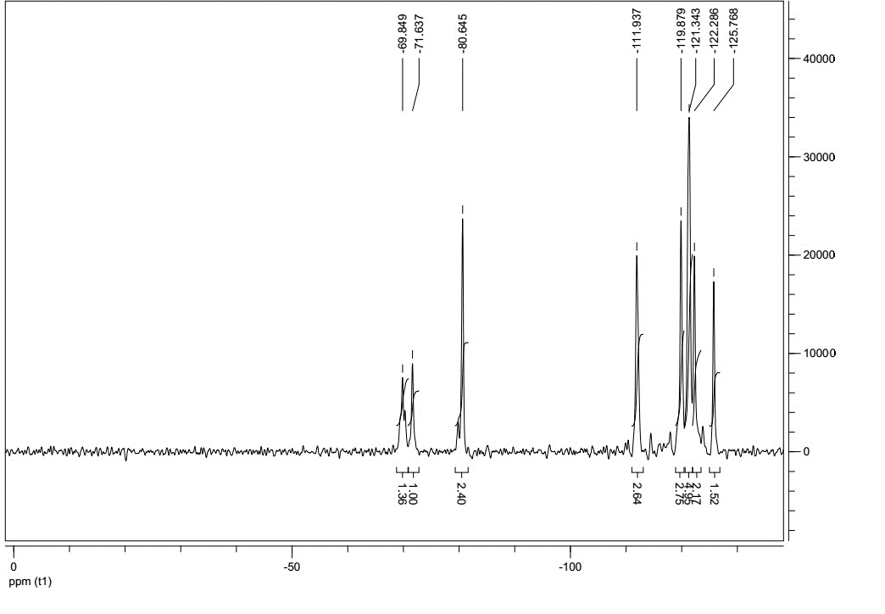

Fig. S1. ¹⁹F NMR spectra of the purified SAmPAP triester.
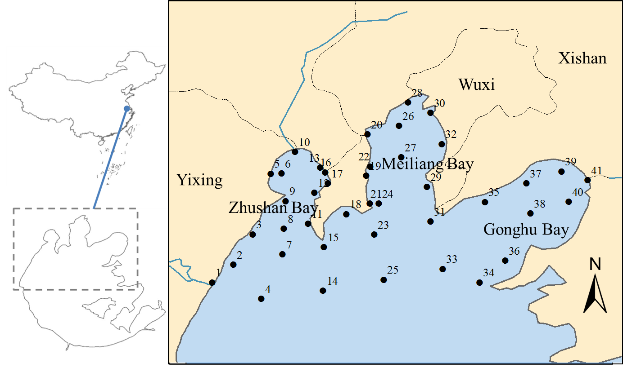

Fig. S2. Map showing sampling locations in Taihu Lake.

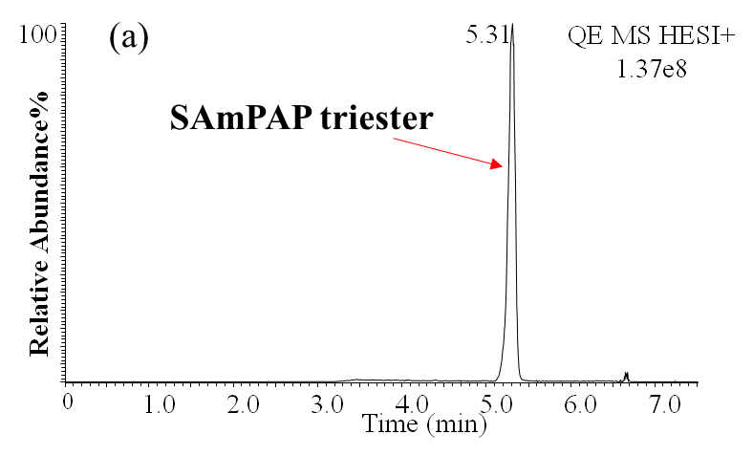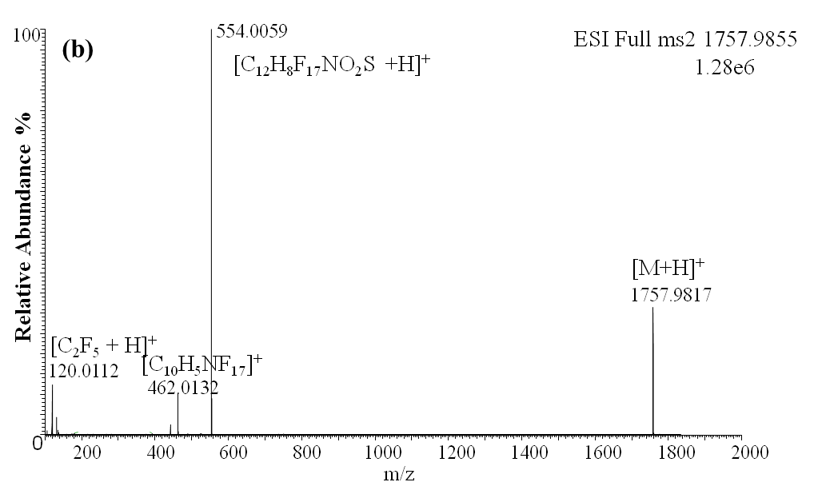

Fig. S3. Chromatogram (a) and spectrum (b) of the purified SAmPAP triester using UHPLC-Q-Orbitrap.
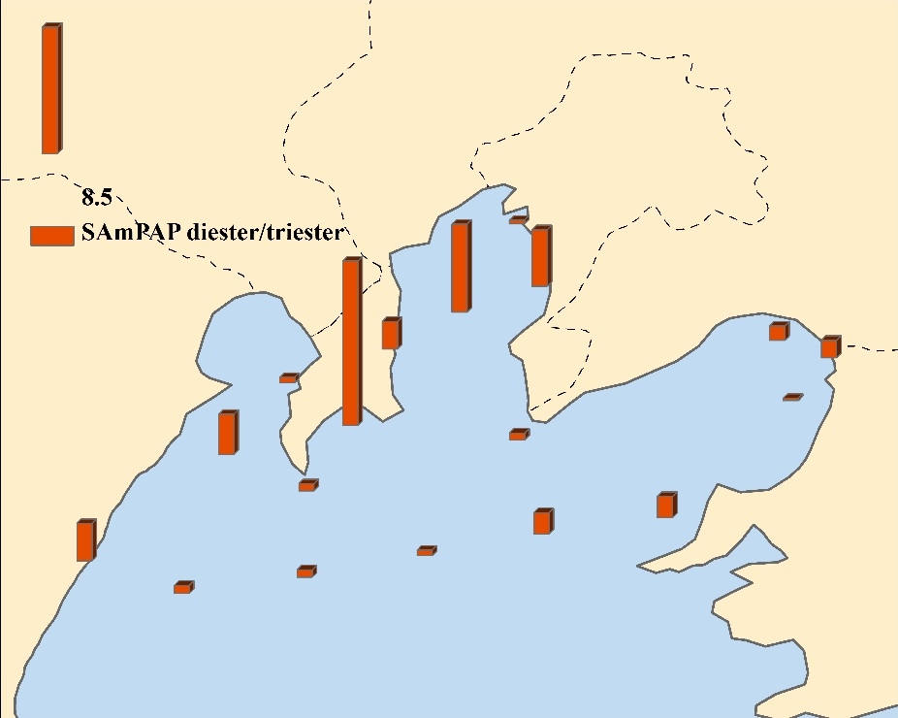

Fig. S4. Spatial distribution of the SAmPAP diester/triester ratios in sediments of Taihu Lake.
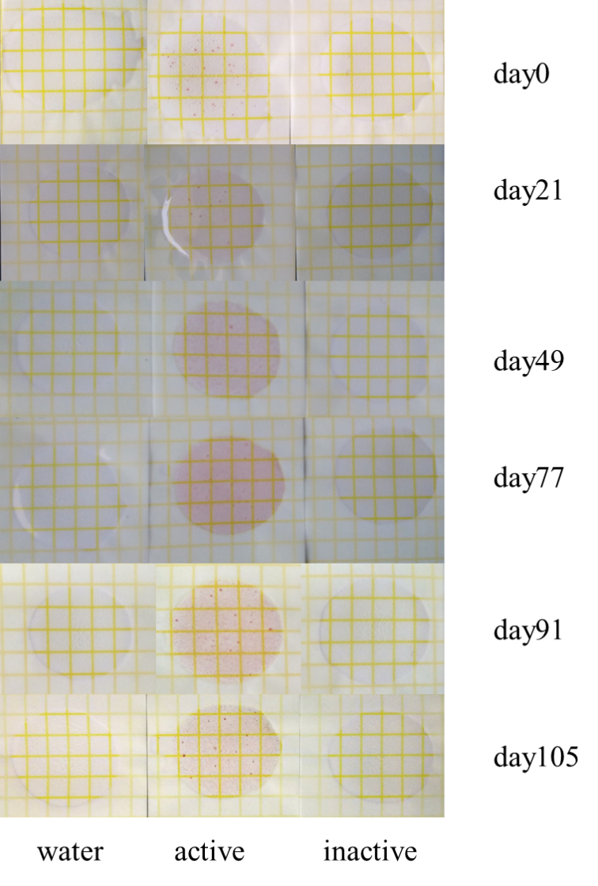

Fig. S5. Results of the PetrifilmTM plates taken on days 0, 21, 49, 77, 91 and 105. Note coloring of AC plates compared to deionized water control and inactive AC plates illustrating the presence of microbial activity in active sediments and absence in inactive sediments.
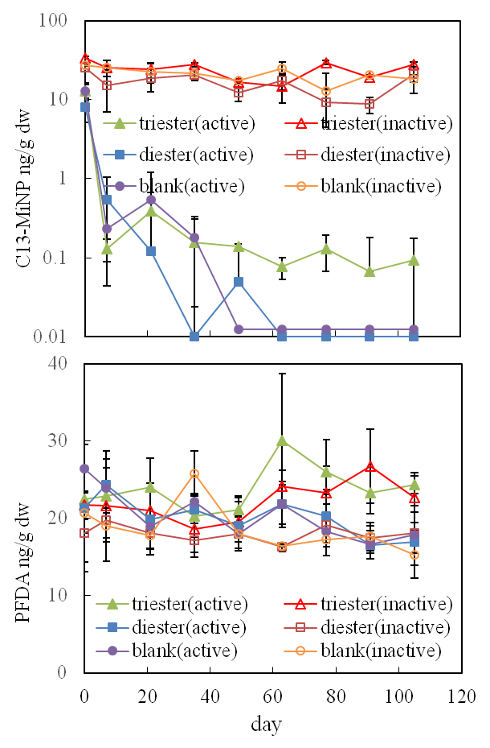

Fig. S6. The results of the internal positive control (¹³C-MiNP) and the negative contral (PFDA) in the incubation sediments.
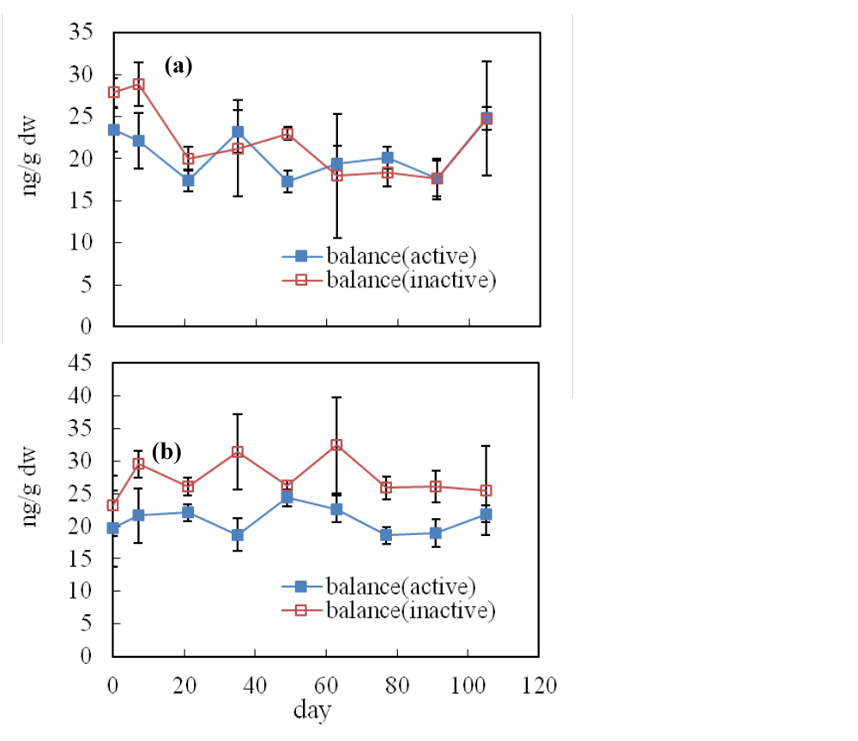

Fig. S7. Mass balance of the incubation experiments for SAmPAP diester (a) or SAmPAP triester (b).
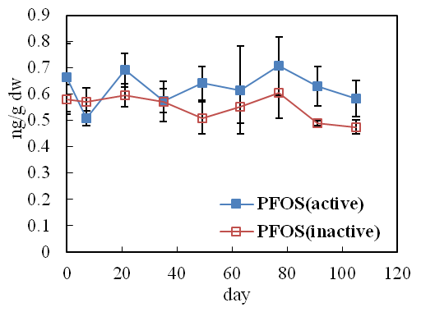

Fig. S8. Concentration of PFOS in the unspiked sediments over 105 days.

