Identification of the disinfection byproducts of bisphenol S induced by chlorination
Sai Zheng† ^{a,b}, Jiachen Shi^{†b}, Jing Zhang ^{b}, Yi Yang^{b}, Jianying Hu^{c}, , Bing Shao ^{a,b,d,*}

ª. Beijing Advanced Innovation Center for Food Nutrition and Human Health, China Agricultural University, Beijing 100193, China
^{b}. Beijing Key Laboratory of Diagnostic and Traceability Technologies for Food poisoning, Beijing Center for Disease Prevention and Control, 100013, China
^{c}. College of Urban and Environment sciences, Peking University, Beijing 1000871, China
^{d}. College of Public Health, Capital medical university, Beijing，100069，China

† These two authors contribute equally to this study.

*Corresponding Author：e-mail: shaobingch@sina.com

Supporting information: 24 figures, 1 table, totally 19 pages.

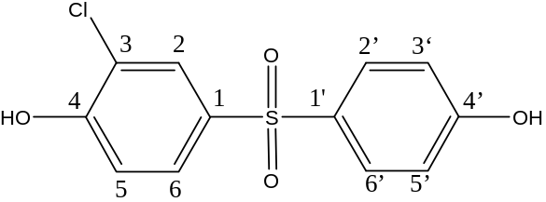
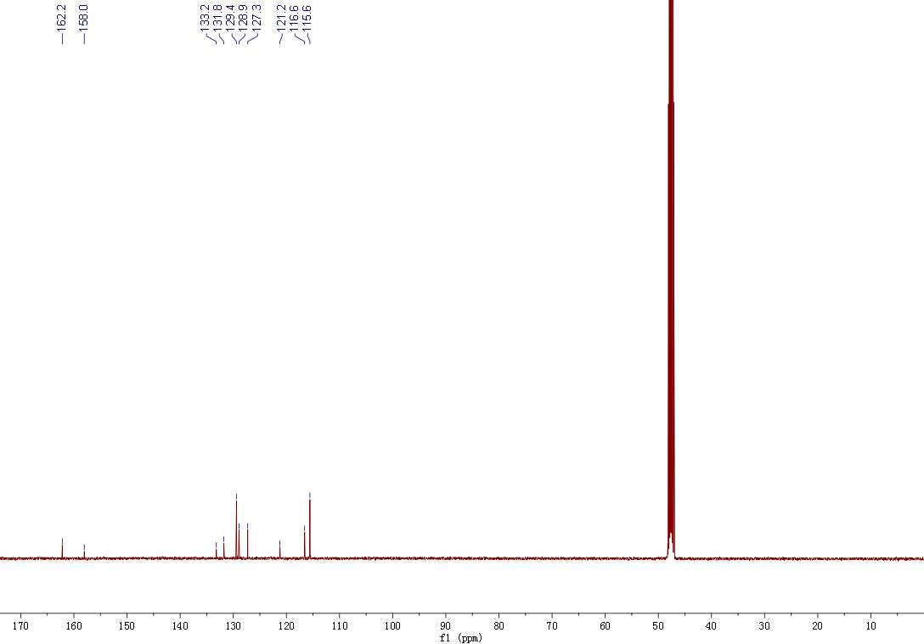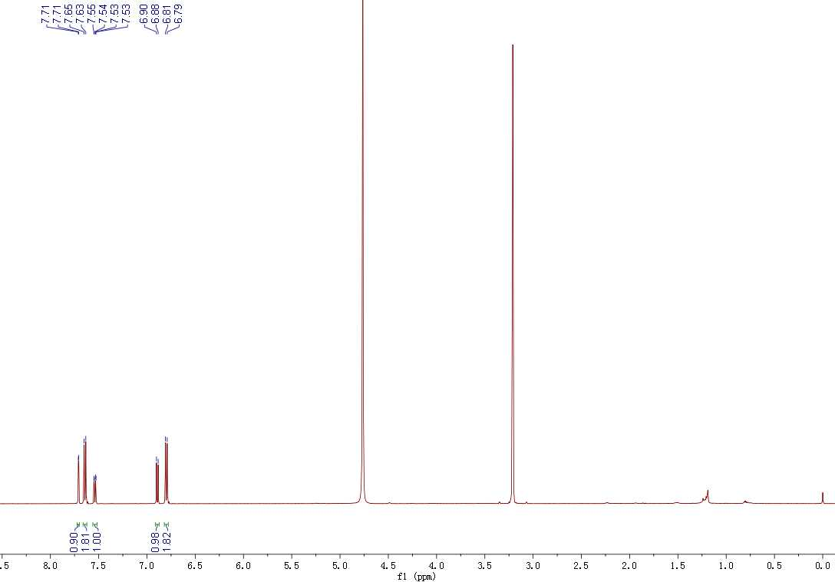

Figure. S1 ¹H NMR (500 MHz) and ¹³C NMR (125 MHz) spectra of mono-chloro-BPS

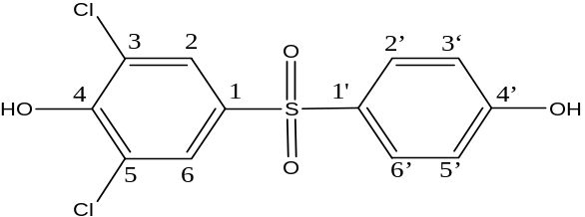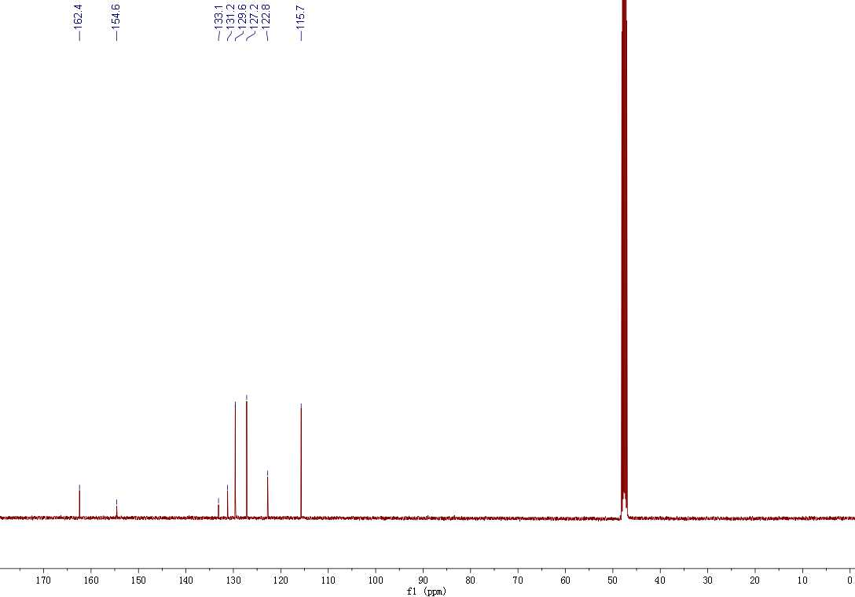
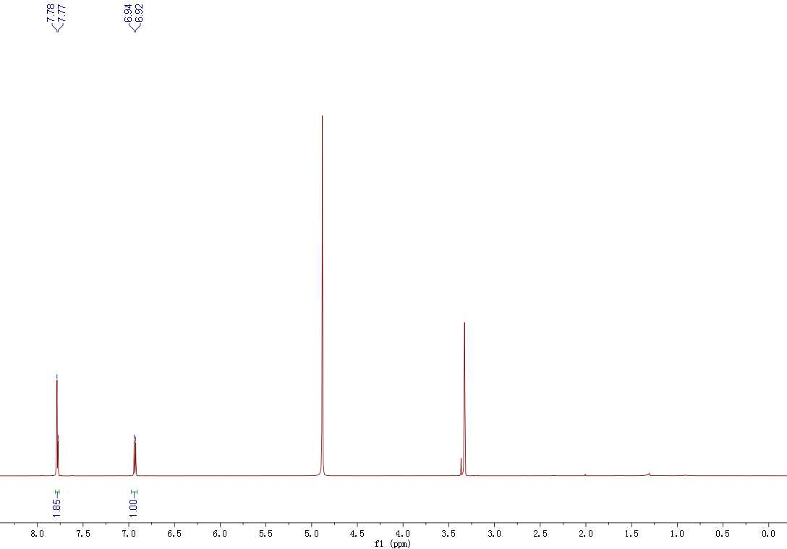

Figure. S2 ¹H NMR (500 MHz) and ¹³C NMR (125 MHz) spectra of di-chloro-BPS-1

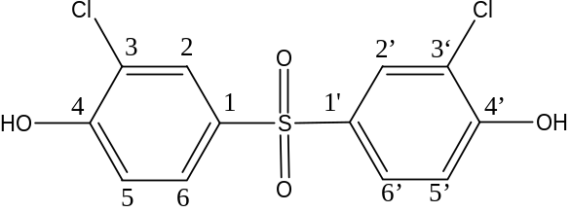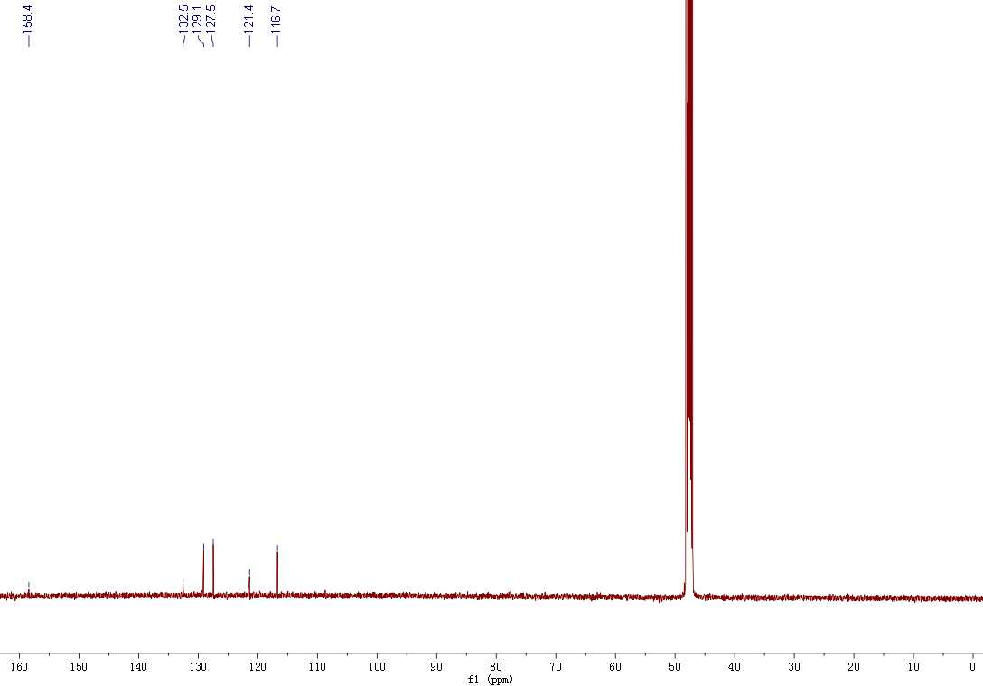
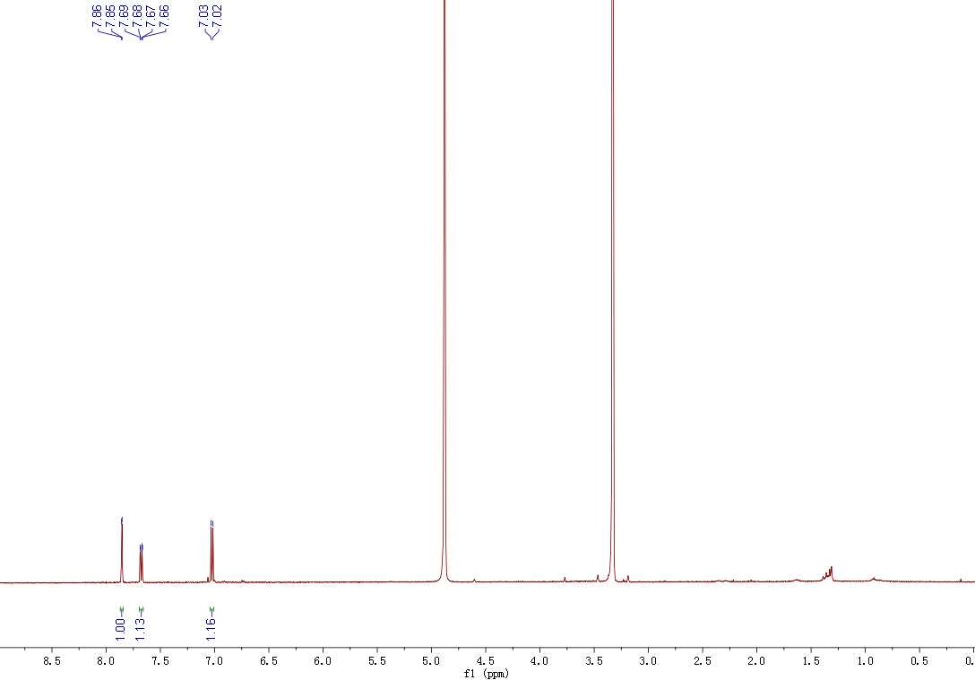

Figure. S3 ¹H NMR (500 MHz) and ¹³C NMR (125 MHz) spectra of di-chloro-BPS-2

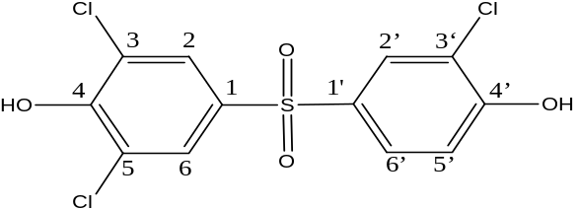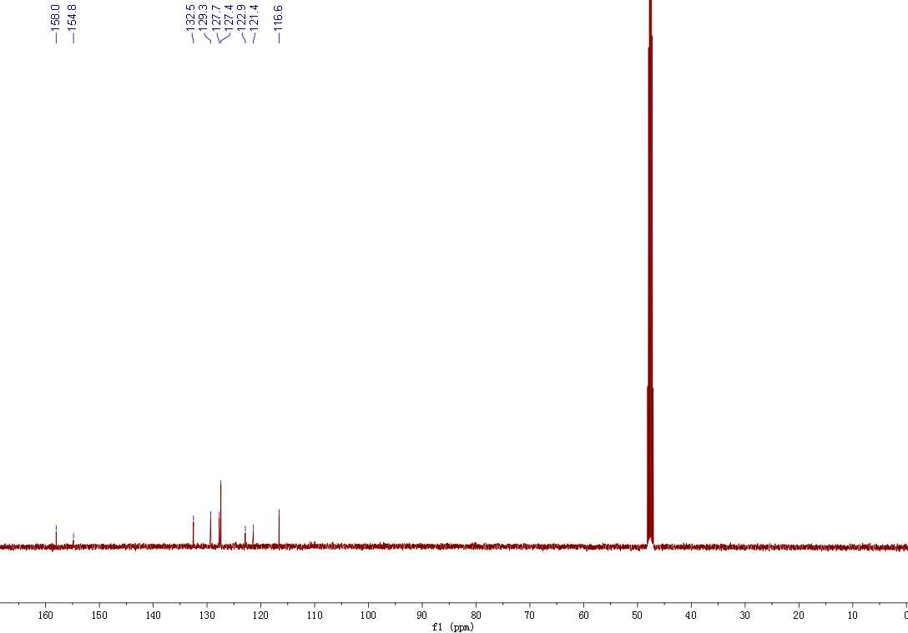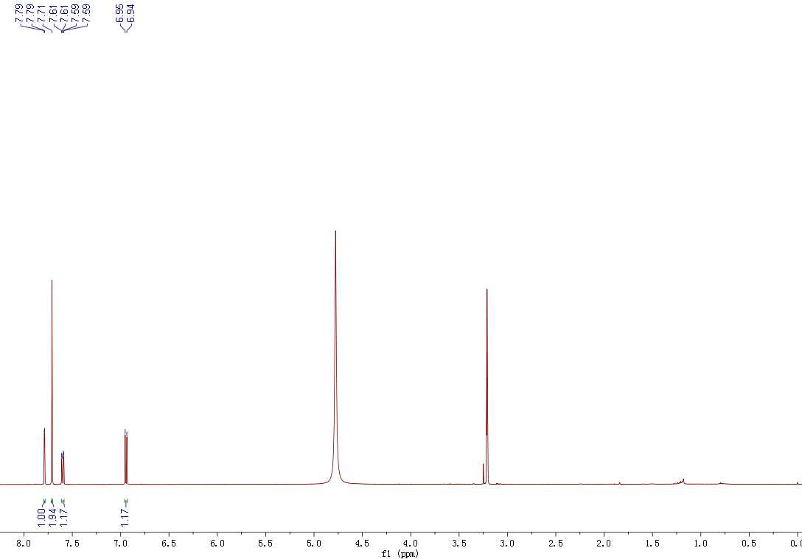

Figure. S4 ¹H NMR (500 MHz) and ¹³C NMR (125 MHz) spectra of tri-chloro-BPS

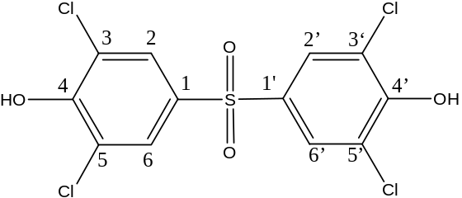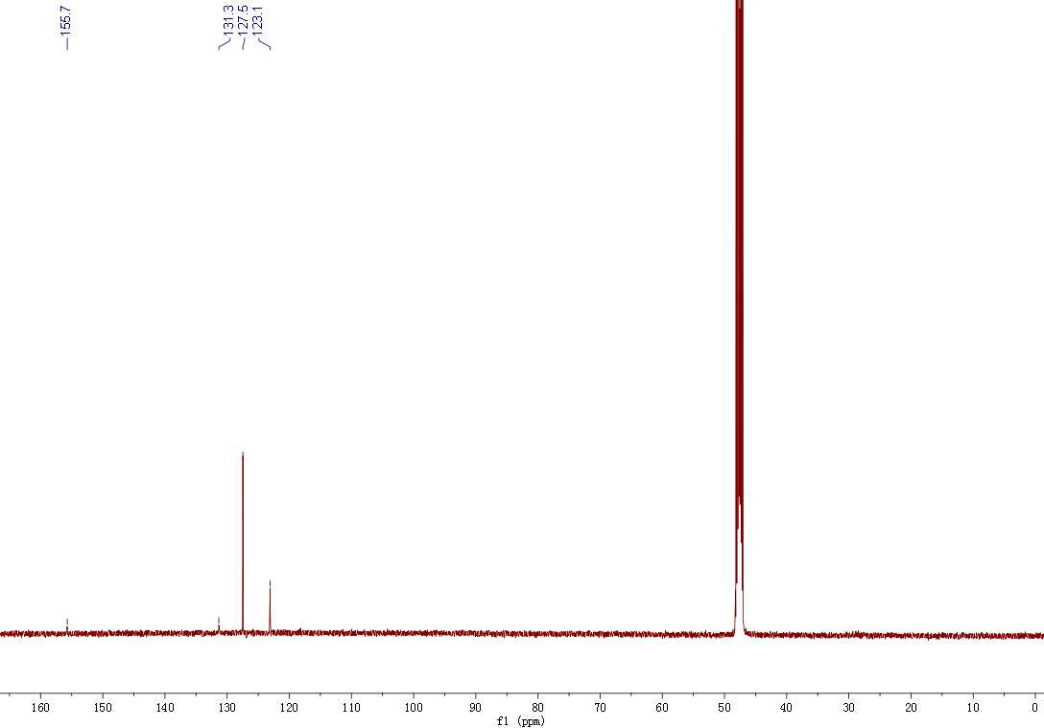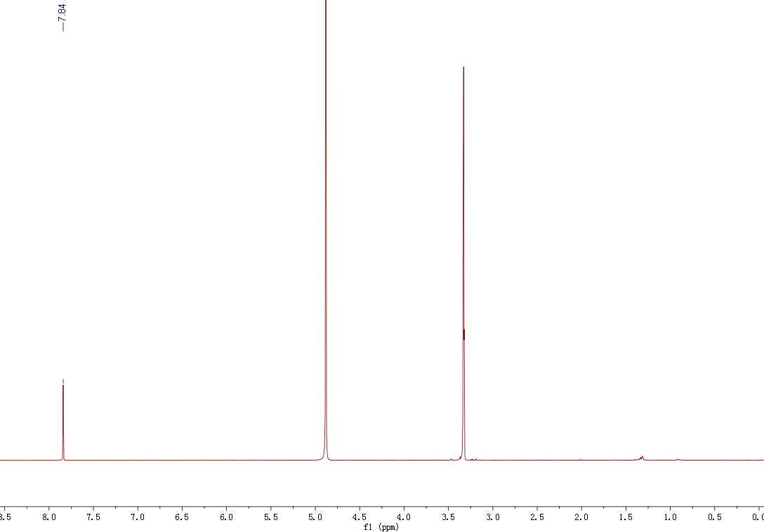

Figure. S5 ¹H NMR (500 MHz) and ¹³C NMR (125 MHz) spectra of tetra-chloro-BPS

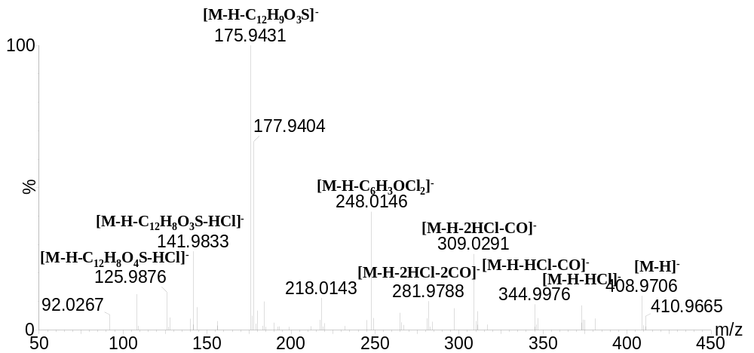
Figure S6. MS/MS spectra of BP-408
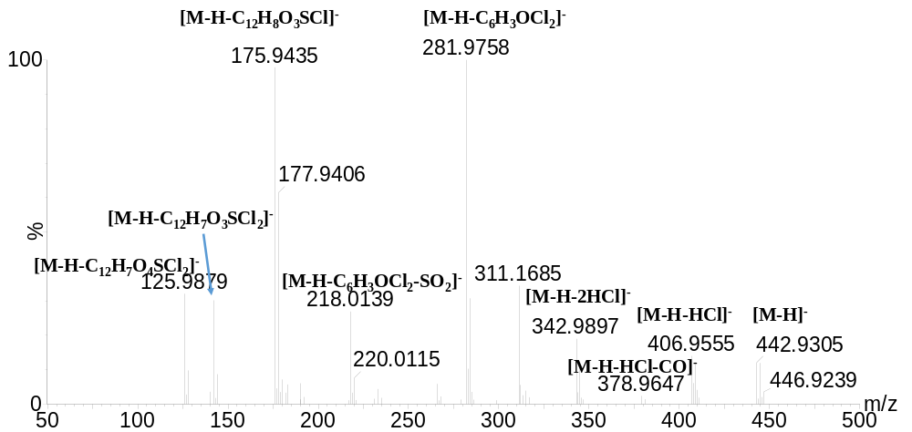
Figure S7. MS/MS spectra of BP-442
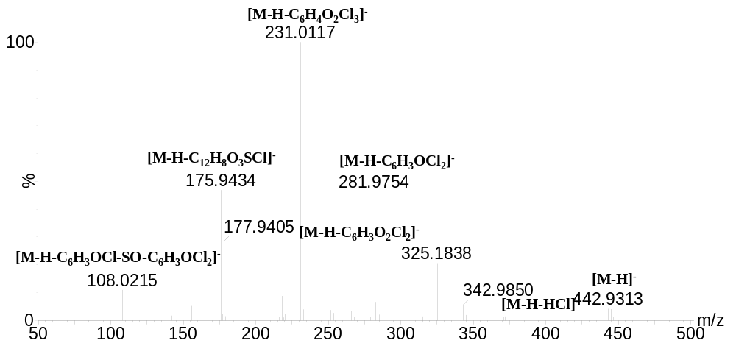
Figure S8. MS/MS spectra of BP-442

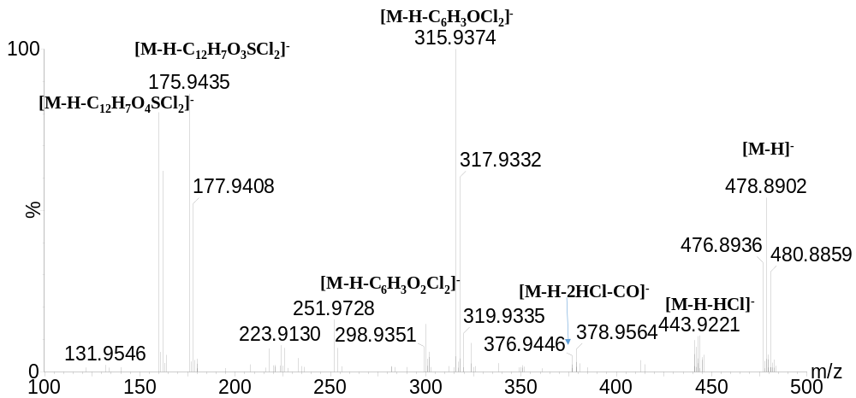
Figure s9. MS/MS spectra of BP-476
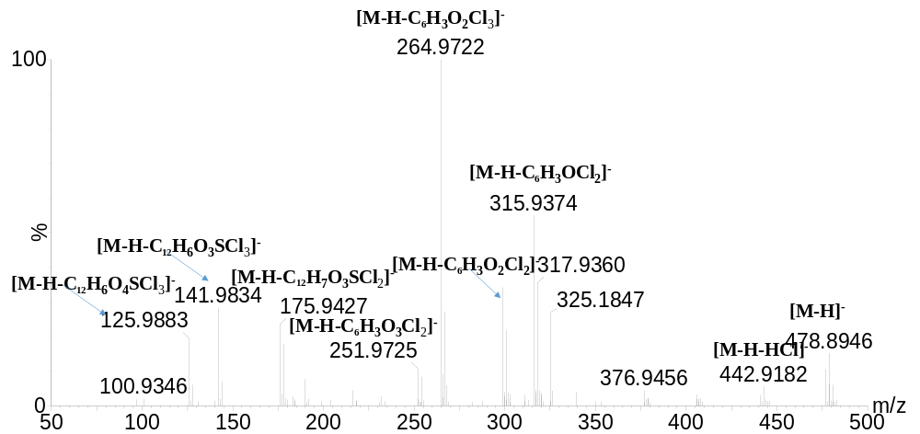
Figure S10. MS/MS spectra of BP-476
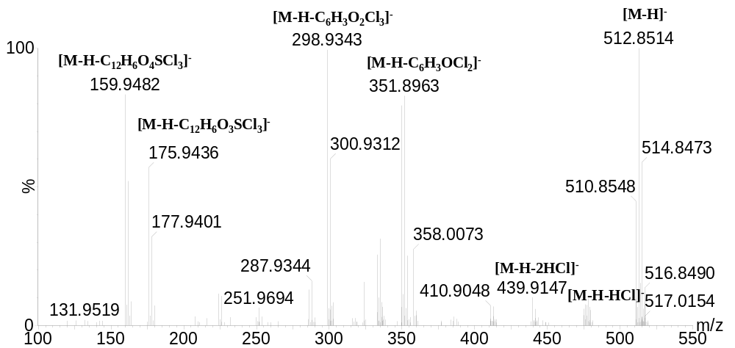
Figure S11. MS/MS spectra of BP-510
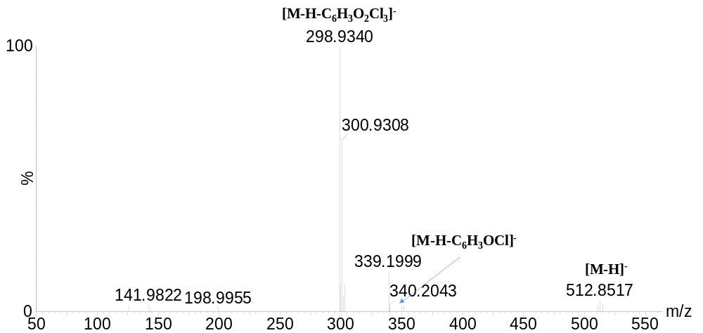
m/z
50
100
150
200
250
300
350
400
450
500
550
%
0
100
298.9340
141.9822
198.9955
300.9308
339.1999
512.8517
340.2043
[M
-
H]
-
[M
-
H
-
C
6
H
3
O
2
Cl
3
]
-
[
M
-
H
-
C
6
H
3
OCl
2
]
-
OH
Cl
Cl
O
O
Cl
O
OH
Cl
Cl
S
Figure S12. MS/MS spectra of BP-510
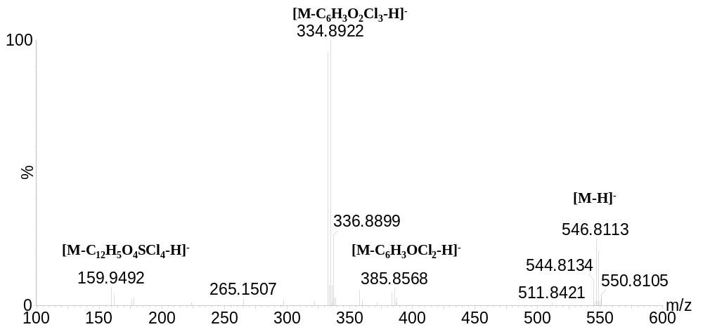
Figure S13 MS/MS spectra of BP-544

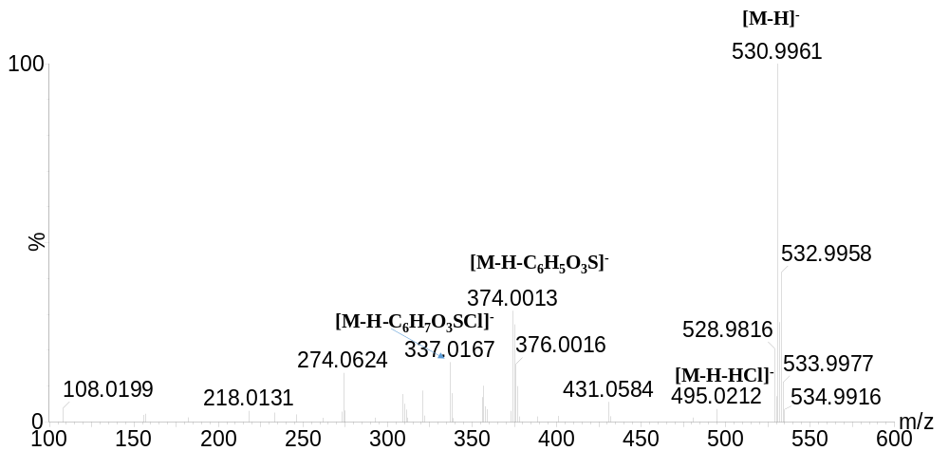
Figure S15. MS/MS spectra of BP-532

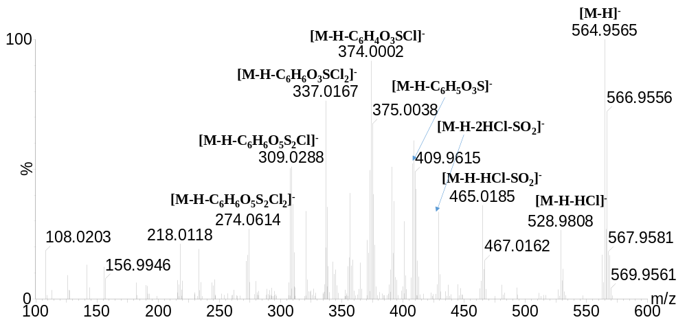
Figure S16. MS/MS spectra of BP-564
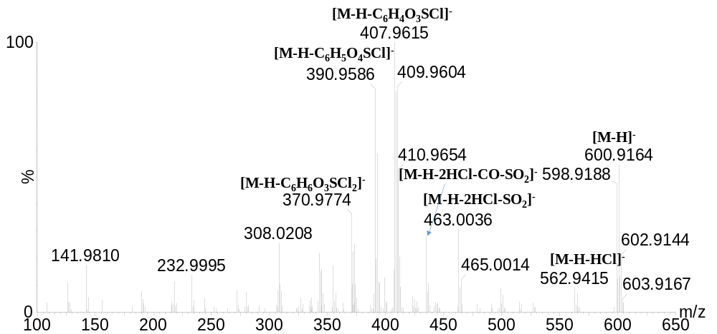
Figure S17. MS/MS spectra of BP-598
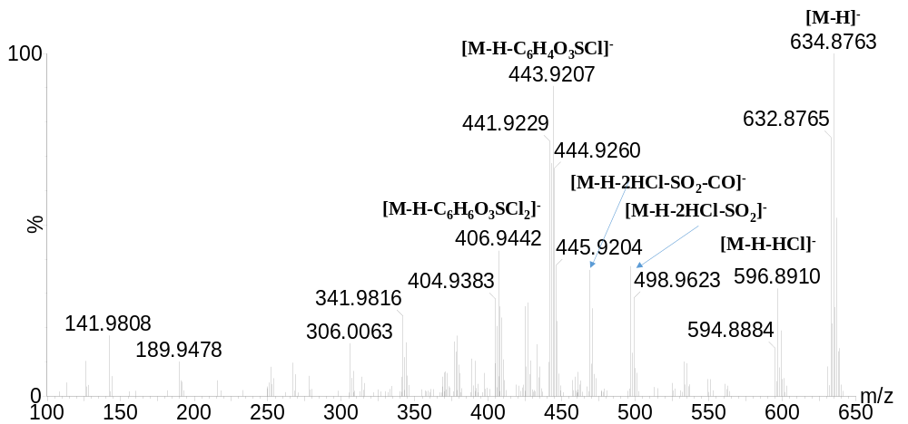
Figure S18 MS/MS spectra of BP-632

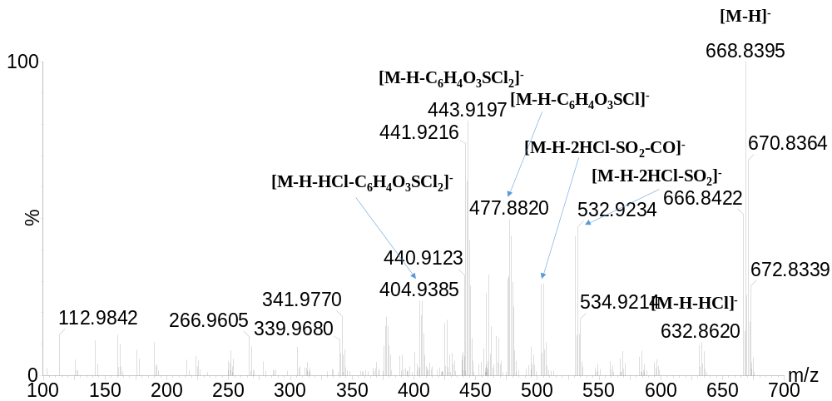
Figure S19. MS/MS spectra of BP-666
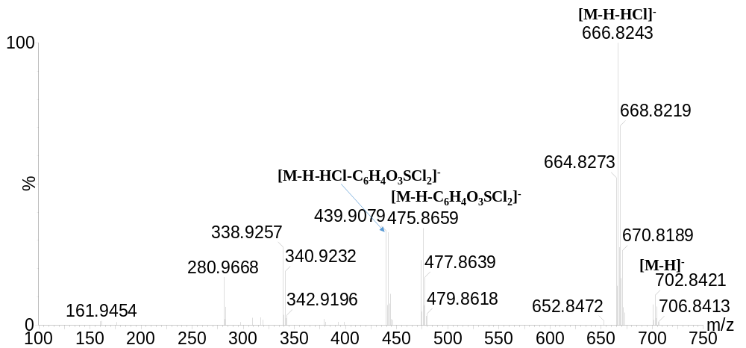
Figure S20. MS/MS spectra of BP-700
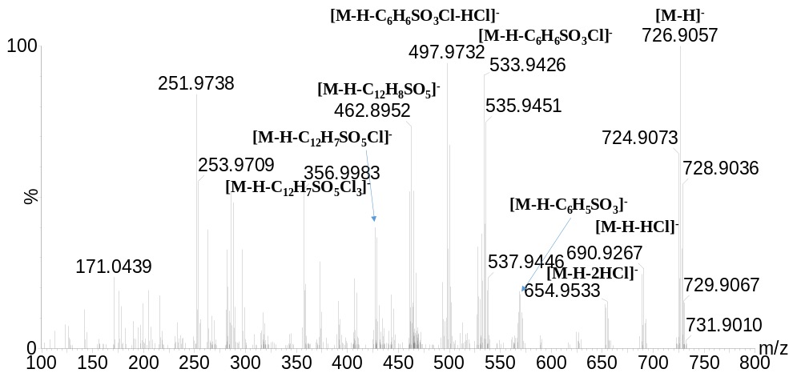
Figure S21. MS/MS spectra of BP-724
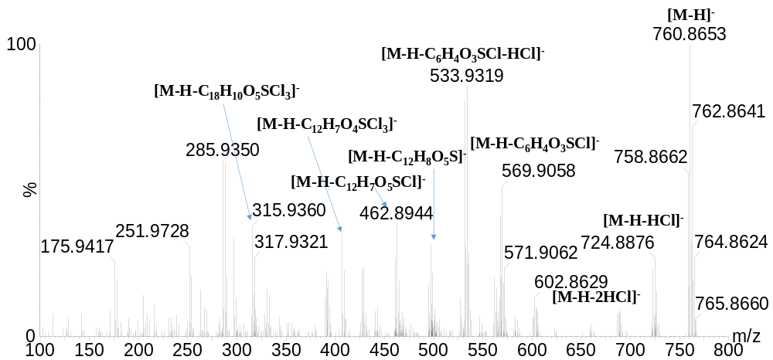
Figure S22. MS/MS spectra of BP-758
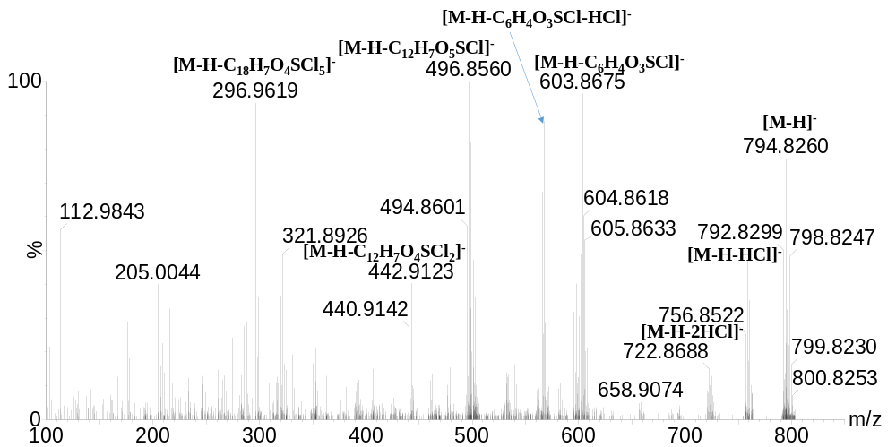
Figure S23. MS/MS spectra of BP-792

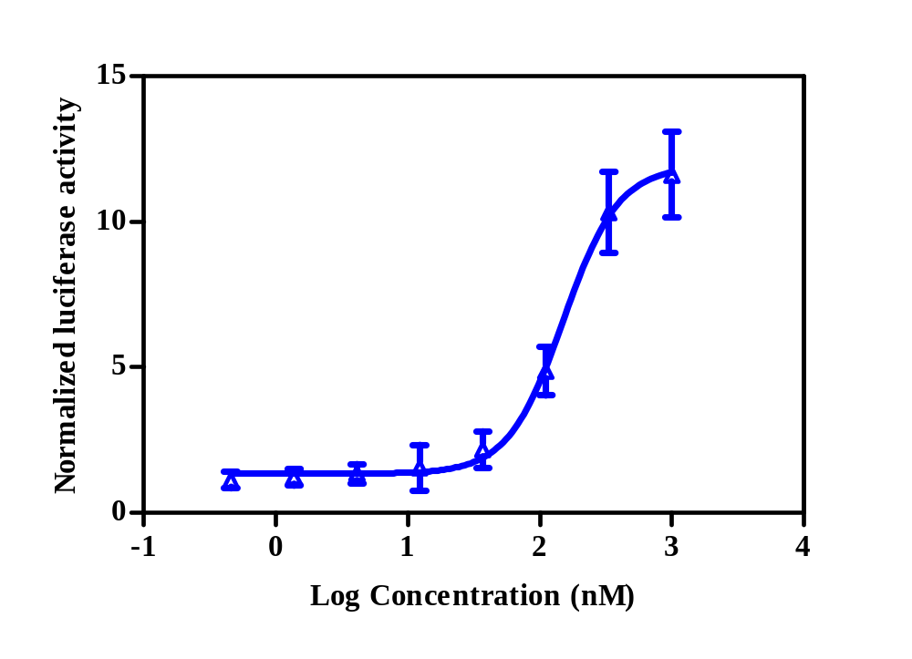
Figure S24. PPARγ activity of rosiglitazone using the dual-luciferase reporter assay. Values are presented as the mean±standard error of three separate experiments.

Table S1 .Retention times, measured accurate m/z, molecular formulas, mass measurement errors(△mDa), and MS/MS fragments of BPS-DBPs

 | t_{R}(min) | Full-scan |  |  |  | MS/MS
 | t_{R}(min) | Measured m/z | Formula | △mDa |  | Measured m/z | Formula | △mDa | CollisionEnergy(eV)
BPS  monochloro-BPS  dichloro-BPS-1  dichloro-BPS-2  trichloro-BPS  tetrachloro-BPS  BP-408  BP-442  BP-476  BP-510  BP-544  BP-532  BP-566  BP-598  BP-632  BP-666  BP-700  BP-724  BP-758  BP-792 | 3.39  4.05  2.86  4.86  3.58  2.93  5.80  6.25  6.08  5.38  6.50  5.57  6.46  5.78  3.32  3.57  3.86  3.88  4.29  4.53  5.79  5.95  6.03 | 249.0226  282.9836  316.9444  316.9445  350.9050  384.8663  408.9706  442.9313  442.9305  476.8936  476.8940  510.8548  510.8530  544.8134  530.9961  564.9565  598.9188  632.8765  666.8422  700.8214  724.9073  758.8662  792.8301 | C₁₂H₉O₄S  C₁₂H₈O₄SCl  C₁₂H₇O₄SCl₂  C₁₂H₇O₄SCl₂  C₁₂H₆O₄SCl₃  C₁₂H₅O₄SCl₄  C₁₈H₁₁O₅SCl₂  C₁₈H₁₀O₅SCl₃  C₁₈H₁₀O₅SCl₃  C₁₈H₉O₅SCl₄  C₁₈H₉O₅SCl₄  C₁₈H₈O₅SCl₅  C₁₈H₈O₅SCl₅  C₁₈H₇O₅SCl₆  C₂₄H₁₆O₈S₂Cl  C₂₄H₁₅O₈S₂Cl₂  C₂₄H₁₄O₈S₂Cl₃  C₂₄H₁₃O₈S₂Cl₄  C₂₄H₁₂O₈S₂Cl₅  C₂₄H₁₁O₈S₂Cl₆  C₃₀H₁₇O₉S₂Cl₄  C₃₀H₁₆O₉S₂Cl₅  C₃₀H₁₅O₉S₂Cl₆ | 0.4  0.4  0.2  0.3  -0.2  0  0.2  -0.2  -1.0  1.1  1.5  1.3  -0.5  -1.1  -1.4  -2.0  -0.8  -4.3  0.2  1.0  0.5  1.2 |  | 184.0525  155.9887  108.0215  92.0264  247.0061  189.9491  141.9822  125.9874  108.0211  92.0265  280.9682  223.9103  175.9434  159.9483  108.0215  92.0266  280.9680  189.0104  141.9821  125.9873  314.9286  222.9714  175.9434  159.9480  141.9821  125.9872  348.8896  256.9323  220.9566  175.9433  159.9482  372.9919  344.9976  309.0291  248.0146  175.9431  141.9833  125.9876  406.9547  281.9754  248.0146  231.0117  175.9434  108.0215  406.9555  378.9647  342.9897  281.9758  218.0139  175.9435  141.9821  125.9879  440.9160  376.9446  315.9374  298.9351  175.9435  159.9479  440.9152  376.9440  315.9359  264.9720  251.9731  175.9433  141.9823  125.9875  474.8769  439.9147  349.8975  298.9343  285.9365  175.9436  159.9482  298.9340  339.8975  298.9340  383.8581  332.8953  159.9492  374.0013  337.0167  528.9808  465.0185  429.0424  407.9622  390.9591  374.0002  337.0167  308.0227  274.0614  562.9415  463.0036  435.0094  407.9615  390.9586  370.9774  596.8910  496.9640  468.9687  441.9229  404.9383  630.8666  530.9251  502.9309  475.8846  440.9123  404.9391  339.9680  664.8260  473.8683  439.9079  338.9286  688.9288  652.9546  567.9116  531.9352  497.9732  460.8984  426.9356  356.9983  251.9738  722.8831  567.9014  531.9328  494.8582  460.8978  406.9534  315.9364  756.8522  720.8716  601.8709  565.8954  494.8601  440.9158  296.9619 | C₁₂H₈O₂  C₆H₄O₃S  C₆H₄O₂  C₆H₄O  C₁₂H₇O₄S  C₆H₃O₃SCl  C₆H₃O₂Cl  C₆H₃OCl  C₆H₄O₂  C₆H₄O  C₁₂H₆O₄SCl  C₆H₂O₃SCl₂  C₆H₂O₂Cl₂  C₆H₂OCl₂  C₆H₄O₂  C₆H₄O  C₁₂H₆O₄SCl  C₁₁H₆OCl  C₆H₃O₂Cl  C₆H₃OCl  C₁₂H₅O₄SCl₂  C₁₁H₅OCl₂  C₆H₂O₂Cl₂  C₆H₂OCl₂  C₆H₃O₂Cl  C₆H₃OCl  C₁₂H₄O₄SCl₃  C₁₁H₄OCl₃  C₁₁H₃OCl₂  C₆H₂O₂Cl₂  C₆H₂OCl₂  C₁₈H₁₀O₅SCl  C₁₇H₁₀O₄SCl  C₁₇H₉O₄S  C₁₂H₈O₄S  C₆H₂O₂Cl₂  C₆H₃O₂Cl  C₆H₃OCl  C₁₈H₉O₅SCl₂  C₁₂H₇O₄SCl  C₁₂H₆O₃SCl  C₁₂H₇O₃S  C₆H₂O₂Cl₂  C₆H₄O₂  C₁₈H₉O₅SCl₂  C₁₇H₉O₄SCl₂  C₁₈H₈O₅SCl  C₁₂H₇O₄SCl  C₁₂H₇O₂Cl  C₆H₂O₂Cl₂  C₆H₃O₂Cl  C₆H₃OCl  C₁₈H₈O₅SCl₃  C₁₇H₇O₄SCl₂  C₁₂H₆O₄SCl₂  C₁₂H₅O₃SCl₂  C₆H₂O₂Cl₂  C₆H₂OCl₂  C₁₈H₈O₅SCl₃  C₁₇H₇O₄SCl₂  C₁₂H₆O₄SCl₂  C₁₂H₆O₃SCl  C₁₂H₆O₂Cl₂  C₆H₂O₂Cl₂  C₆H₃O₂Cl  C₆H₃OCl  C₁₈H₇O₅SCl₄  C₁₈H₇O₅SCl₃  C₁₂H₅O₄SCl₃  C₁₂H₅O₃SCl₂  C₁₂H₅O₂Cl₃  C₆H₂O₂Cl₂  C₆H₂OCl₂  C₁₂H₅O₃SCl₂  C₁₂H₅O₄SCl₄  C₁₂H₅O₃SCl₂  C₁₂H₄O₄SCl₄  C₁₂H₄O₃SCl₃  C₆H₂OCl₂  C₁₈H₁₁O₅SCl  C₁₈H₉O₅S  C₂₄H₁₄O₈S₂Cl  C₂₄H₁₄O₆SCl  C₂₄H₁₃O₆S  C₁₈H₁₀O₅SCl₂  C₁₈H₉O₄SCl₂  C₁₈H₁₁O₅SCl  C₁₈H₉O₅S  C₁₈H₉O₃Cl  C₁₈H₁₀O₃  C₂₄H₁₃O₈S₂Cl₂  C₂₄H₁₂O₆SCl  C₂₃H₁₂O₅SCl  C₁₈H₁₀O₅SCl₂  C₁₈H₉O₄SCl₂  C₁₈H₈O₅SCl  C₂₄H₁₂O₈S₂Cl3  C₂₄H₁₁O₆SCl₂  C₂₃H₁₁O₅SCl₂  C₁₈H₉O₅SCl₃  C₁₈H₇O₅SCl₂  C₂₄H₁₁O₈S₂Cl₄  C₂₄H₁₀O₆SCl₃  C₂₃H₁₀O₅SCl₃  C₁₈H₈O₅SCl₄  C₁₈H₈O₅SCl₃  C₁₈H₇O₅SCl₂  C₁₈H₆O₃Cl₂  C₂₄H₁₀O₈S₂Cl₅  C₁₈H₆O₅SCl₄  C₁₈H₇O₅SCl₃  C₁₄H₅O₄SCl₂  C₃₀H₁₆O₉S₂Cl₃  C₃₀H₁₅O₉S₂Cl₂  C₂₄H₁₂O₆SCl₄  C₂₄H₁₁O₆SCl₃  C₂₄H₁₂O₆SCl₂  C₁₈H₉O₄SCl₄  C₁₈H₁₀O₄SCl₃  C₁₈H₁₀O₄SCl  C₁₂H₆O₂SCl₂  C₃₀H₁₅O₉S₂Cl₄  C₂₄H₁₂O₆SCl₄  C₂₄H₁₁O₆SCl₃  C₁₈H₈O₄SCl₅  C₁₈H₉O₄SCl₄  C₁₈H₉O₅SCl₂  C₁₂H₆O₄SCl₂  C₃₀H₁₄O₉S₂Cl₅  C₃₀H₁₃O₉S₂Cl₄  C₂₄H₁₁O₆SCl₅  C₂₄H₁₀O₆SCl₄  C₁₈H₈O₄SCl₅  C₁₈H₈O₅SCl₃  C₁₂H₆O₅SCl | 0.1  0.6  0.4  0.2  -0.4  0  0.1  0.2  0  0.3  0.7  0.1  0.2  0  0.4  0.4  0.5  -0.3  -0.1  0.1  0  -0.3  0.2  -0.3  -0.1  0  -0.4  -0.5  0.5  0.1  -0.1  -1.8  -1.2  6.9  0.3  -0.1  1.1  0.4  -0.1  0  0  0.1  0.2  0.4  0.7  4.8  4.5  0.4  0.4  0.3  -0.1  0.7  0.2  0.4  1.0  1.5  0.3  -0.4  -0.6  -0.2  -0.5  -0.6  -1..4  0.1  0.1  0.3  0.1  6.7  0.1  0.7  1.0  0.4  -0.1  0.4  0.2  0.4  -0.3  0.6  0.9  -0.3  -0.4  -1.1  -1.5  -0.9  -0.4  -0.8  -1.4  -0.4  -1.3  -1.6  -1.4  -0.7  -0.9  -1.1  -1.3  -0.7  4.8  -1.3  -1.7  -07  -0.8  1.7  -1.3  -0.6  -0.1  -3.5  -0.6  -1.4  1.3  -0.7  -0.1  2.9  -1.3  1.1  0.7  1.0  0  0.8  -0.9  -0.5  -0.7  3.0  1.0  -1.4  -0.4  0.2  -1.4  -0.5  0  -3.9  -1.0  0.2  1.5  -2.4  -0.5 | 20-35  20-40  20-40  20-40  20-40  15-40  15-40  15-30  15-30  15-30  15-30  15-30  15-30  15-30  15-30  15-30  15-30  15-30  15-30  15-30  15-30  15-30  15-30

