Supplementary Materials
for
Nontargeted Identification of Per- and Polyfluoroalkyl Substances in Human Follicular Fluid and their Blood-follicle Transfer

Qiyue Kang¹, Fumei Gao², Xiaohua Zhang¹, Lei Wang¹, Jiaying Liu¹, Min Fu², Shiyi Zhang¹, Yi Wan¹, Huan Shen², and Jianying Hu¹*

¹ MOE Laboratory for Earth Surface Process, College of Urban and Environmental Sciences, Peking University, Beijing 100871, China
² Reproductive Medical Center, Peking University People’s Hospital, Peking University, Beijing 100044, China

*Corresponding author:
Jianying HU, College of Urban and Environmental Sciences, Peking University, Beijing 100871, China, TEL & FAX: 86-10-62765520, e-mail: hujy@urban.pku.edu.cn

Chemicals and reagents. Standards of 13 perfluoroalkylcarboxylic acids (PFCAs) and perfluoroalkylsulfonates (PFSAs), including perfluoropentanoic acid (PFPeA), perfluorohexanoate (PFHxA), perfluoroheptanoate (PFHpA), perfluorooctanoate (PFOA), perfluorononanoate (PFNA), perfluorodecanoate (PFDA), perfluoroundecanoate (PFUnDA), perfluorododecanoate (PFDoDA), perfluorotridecanoate (PFTriDA), perfluorobutane sulfonate (PFBS), perfluorohexane sulfonate (PFHxS), perfluorooctane sulfonate (PFOS), and perfluorodecanoate sulfonate (PFDS), isotope-labeled internal standards of 8 PFCAs and PFSAs (¹³C₂-PFHxA, ¹³C₄-PFOA, ¹³C₅-PFNA, ¹³C₂-PFDA, ¹³C₂-PFUnDA, ¹³C₂-PFDoDA, ¹⁸O₂-PFHxS, and ¹³C₄-PFOS), and two chlorine-substituted perfluoroalkyl ether sulfonates (PFESAs), 6:2 and 8:2 Cl-PFESAs, were purchased from Wellington Laboratories Inc. (Guelph, Ontario, Canada). Hexafluoropropylene oxide trimer acid (HFPO-TA) was from Apollo Scientific (Stockport, Cheshire, UK). Optima grade methanol (MeOH), acrylonitrile (ACN), and HPLC grade methyl tert-butyl ether (MTBE) were purchased from Fisher Chemicals (New Jersey, U.S.A.). Tetra-n-butyl ammonium hydrogen sulfate (TBAS), sodium carbonate (Na₂CO₃), sodium chloride (NaCl), and magnesium sulfate (MgSO₄) were purchased from Sigma-Aldrich (St. Louis, MO, U.S.A.). Ammonium acetate (HPLC, 99.5%) was purchased from Dikma (Lake Forest, California, U.S.A.). Water was purified with a Millipore Milli-Q synthesis water purification system (Bedford, Massachusetts, U.S.A.).
Quality assurance and control for QuEChERS method in nontarget analysis. Procedural recoveries, matrix effects and absolute recoveries were evaluated for QuEChERS method. Mass-labeled internal PFAS standards (4 ng) were added to the 10 mL follicular fluid sample (20 ng/mL in the final extracts) before and after extraction procedure. Absolute recoveries were calculated by comparing responses of the internal standard which were added before extraction with these of a 20 ng/mL internal standard solution. Matrix effects were calculated by comparing responses of the internal standards which were added after extraction, with these of a 20 ng/mL isotope-labeled internal standard solution. The procedural recoveries were calculated by comparing the responses of internal standards which were added before extraction, with these of internal standards which were added after extraction. The procedural recoveries ranged from 69% to 93%, matrix effects ranged from -30% to 4%, and absolute recoveries ranged from 54% to 93% (Table S1).
Sample preparation and UPLC-MS/MS analysis. 28 paired follicular fluid and serum samples were extracted via ion-pair liquid–liquid extraction, as described previously (Zhang et al., 2019). An aliquot of follicular fluid or serum sample (0.2 mL) was spiked with 50 μL of isotopically labeled internal standards (1 ng/mL), after adding 1 mL TBAS and 2 mL Na₂CO_{3,} 5 mL MTBE were added. After vigorously shaking at 300 rpm for 15 min, sonicating for 15 min, and centrifuging at 3500rpm for 15 min, 4 mL supernatant extracts were transferred to a polypropylene (PP) tube. Then 5 mL MTBE was added and the extraction procedure was performed again, except that 5 mL MTBE supernatant were transferred to the PP tube. The extraction repeated 3 times totally and the supernatant extracts were combined and dried under a gentle stream of nitrogen and redissolved in 50 μL MeOH for further analysis.
The UPLC-MS/MS analysis was performed using an UltiMate 3000 UPLC system coupled to a TSQ Quantiva triple-quadrupole mass spectrometer (Thermo Fisher Scientific, San Jose, CA, U.S.A.), and the separation was performed on a BEH C18 column (100 × 2.1 mm, 1.7 μm particle size, Waters, Milford, MA, U.S.A.). The column temperature was 40 °C, with a flow rate of 0.3 mL/min, and an injection volume of 5 µL. MeOH and water containing 5 mM ammonium acetate were used as the mobile phases, and the elution conditions were same as the conditions used in UPLC-Q-Exactive high resolution mass spectrometry (HRMS) system. The TSQ Quantiva mass spectrometry was operated in negative electrospray ionization (ESI) and data were acquired in selected reaction monitoring (SRM) mode. The sheath gas and auxiliary gas were set at 40 and 10 arbs, respectively. The vaporizer temperature was maintained at 300 °C. The scan was performed in profile mode with peak widths of Q1 (FWHM) and Q3 (FWHM) were 0.70 and dwell time of 0.05 s per transition. Commercial standards were not available for some identified emerging PFAS. Therefore, semi-quantification was performed using legacy PFCAs and PFSAs, assuming that they had the same unit instrumental responses. For the analyte that MS/MS spectrum was available from HRMS, the precursor ion and two product ions in HRMS were used to establish the SRM transition, to get a better sensitivity, reproducibility, and dynamic range, as previously reported in metabolomics (Zha et al., 2018). Identification of the target analysts were accomplished by comparing the retention times of UPLC-Q-Exactive HRMS system with these of UPLC-MS/MS system (RT shift less than 20%). The precursor ions, product ions, cone voltage, and collision energy are summarized in Table S2, and all SRM peaks for the emerging PFAS are provided in Fig. S11.
The instrument was calibrated for each analyte at 0.005, 0.01, 0.02, 0.05, 0.1, 0.5, 1, 5, 10, 50 and 100, 500 ng/mL, with calibration curves of strong linearity (correlation coefficients > 0.99). For the PFAS with standards, the limits of quantitation (LOQs) were evaluated in matrix-spiked samples on the basis of signal-to-noise ratio (S/N = 10) of the transition reaction used for quantification. For HFPO-TA and PFOA, minor field blank responses were observed, therefore the LOQs were calculated as 10 times the standard deviations of the procedural blank, and final concentrations were calculated by subtracting the blank values. For the emerging PFAS, PFECAs were quantified by an authentic standard of branched chain 5:3 PFECA (C₅F₁₁OCF(CF₃)COOH, CAS: 504435-11-4), while H-PFECA, and Po-PFECAs were semi-quantified by PFOA (Table 5). PFESAs were semi-quantified by PFOS. For the emerging PFAS semi-quantified based on PFOA or PFOS, their LOQs were determined with that of PFOA (0.002 ng/mL, S/N = 10) or that of PFOS (0.005 ng/mL, S/N = 10), as shown in Table S5.
The recovery experiments were conducted by spiking the target analytes at low, medium, and high concentrations (0.2, 1, and 4 ng for PFOS, PFOA, and 6:2 Cl-PFESA; 0.1, 0.2, and 1 ng for other PFAS) into 200 μL serum (n = 6) or 200 μL follicular fluid samples (n = 6), and absolute recoveries were estimated. The matrix effect was evaluated by adding 10 μL mixed-external standard spiked with 0.1 ng of PFPeA, PFHxA, PFHpA, PFNA, PFDA, PFUnDA, PFDoDA, PFTriDA, PFBS, PFHxS, PFDS, 8:2 Cl-PFESA, and HFPO-TA, and spiked with 1 ng of PFOA, PFOS, and 6:2 Cl-PFESA into 90 μL sample extracts. The matrix effect was calculated according to the previous study (Chen et al., 2016), as follows:

For follicular fluid sample, the matrix effects ranged from -28% to 23% with a relative standard deviation (RSD) of 3–34%, and recoveries ranged from 45% to 95% with a RSD of 4–34%. For serum sample, the matrix effects ranged from -28% to 43% with a RSD of 3–22% and recoveries ranged from 48% to 90% with a RSD of 4–26% (Table S4). For the legacy PFAS, their isotope-labeled internal standards were used. For the emerging PFAS, ¹³C₄-PFOA and ¹³C₄-PFOS were used for the modified PFCA and the modified PFSA, respectively, as showed in Table S5.
Method performance. The method performance was evaluated by the PFAS, which had commercially available standards, in pooled follicular fluid sample. Through diagnostic fragment ions C₂F₅⁻, totally 7 PFCAs (PFHpA, PFOA, PFNA, PFDA, PFUnDA, PFDoDA, and PFTriDA) were found in the follicular fluid pooled sample, with the correlation coefficients ranging from 0.81 to 0.94 (Table S8). As for PFSAs, PFHxS and PFOS were found through diagnostic fragment ion C₂F₅⁻, and PFBS was found through SO₂F⁻, with the correlation coefficients ranging from 0.86 to 0.99. In addition, 6:2 Cl-PFSEA, 8:2 Cl-PFESA, and HFPO-TA were found by diagnostic ions of SO₂F⁻ and C₂F₅⁻ (Table S8). These PFAS were further confirmed with authentic standards by comparing the retention time and MS/MS spectra.
References
Chen, M., Fan, Z. L., Zhao, F. R., Gao, F. M., Mu, D., Zhou, Y. Y., Hu, J. Y., 2016. Occurrence and maternal transfer of chlorinated bisphenol a and nonylphenol in pregnant women and their matching embryos. Environ. Sci. Technol. 50, 970-977.
Zhang, S. Y., Kang, Q. Y., Peng, H., Ding, M. Y., Zhao, F. R., Zhou, Y. Y., Dong, Z. M., Zhang, H., Yang, M., Tao, S., Hu, J. Y., 2019. Relationship between perfluorooctanoate and perfluorooctane sulfonate blood concentrations in the general population and routine drinking water exposure. Environ. Int. 126, 54-60.
Zha, H., Cai, Y., Yin, Y., Wang, Z., Li, K., Zhu, Z. J., 2018. SWATHtoMRM: Development of high-coverage targeted metabolomics method using SWATH technology for biomarker discovery. Anal. Chem. 90, 4062-4070.

Table S1. Absolute recoveries, matrix effects, and procedural recoveries using QuEchERS method in follicular fluid.
 | Absolute recoveriy | Matrix effect | Procedural recovery
isPFHxA | 56% | -19% | 69%
isPFOA | 70% | -8% | 76%
isPFNA | 64% | -16% | 76%
isPFDA | 78% | -6% | 84%
isPFUnDA | 93% | 4% | 90%
isPFDoDA | 83% | -1% | 84%
isPFHxS | 54% | -30% | 77%
isPFOS | 79% | -15% | 93%

Table S2. Selected reaction monitoring (SRM) transitions and mass spectrometry parameters for identified PFAS using TSQ Quantiva triple-quadrupole mass spectrometer.
Analyte | RF Lens (V) | Collision Energy (V) | SRM transition
PFHpA | 45 | 9 | 363.0 > 319.0
 | 45 | 20 | 363.0 > 169.0
PFOA | 51 | 10 | 413.0 > 369.0
 | 51 | 18 | 413.0 > 169.0
PFNA | 48 | 11 | 463.0 > 419.0
 | 48 | 15 | 463.0 > 219.0
PFDA | 60 | 12 | 513.0 > 469.0
 | 60 | 15 | 513.0 > 219.0
PFUnDA | 60 | 13 | 563.0 > 519.0
 | 60 | 17 | 563.0 > 269.0
PFDoDA | 69 | 12 | 613.0 > 569.0
 | 69 | 17 | 613.0 > 169.0
PFTriDA | 69 | 12 | 663.0 > 619.0
 | 69 | 17 | 663.0 > 169.0
PFBS | 156 | 50 | 298.9 > 80.0
 | 156 | 50 | 298.9 > 99.0
PFHxS | 156 | 50 | 398.9 > 80.0
 | 156 | 50 | 398.9 > 99.0
PFOS | 150 | 50 | 498.9 > 80.0
 | 150 | 50 | 498.9 > 99.0
PFNS | 150 | 50 | 548.9 > 80.0
 | 150 | 50 | 548.9 > 99.0
PFDS | 150 | 55 | 598.9 > 80.0
 | 150 | 55 | 598.9 > 99.0
4:2 Cl-PFESA | 90 | 24 | 430.9 > 251.0
 | 90 | 35 | 430.9 > 83.0
5:2 Cl-PFESA | 90 | 24 | 480.9 > 300.9
 | 90 | 35 | 480.9 > 83.0
6:2 Cl-PFESA | 90 | 24 | 530.9 > 350.9
 | 90 | 35 | 530.9 > 83.0
8:2 Cl-PFESA | 90 | 30 | 630.9 > 450.9
 | 90 | 40 | 630.9 > 83.0
4:4 C₈ PFECA | 60 | 15 | 429.0 > 235.0
 | 60 | 15 | 429.0 > 169.0
1:8 PFECAª | 60 | 15 | 479.0 > 85.0
C₇ Po-PFECAª | 60 | 30 | 442.9 > 85.0
C₈ Po-PFECAª | 60 | 30 | 508.9 > 85.0
1:5 PFESA | 80 | 60 | 414.9 > 85.0
 | 80 | 30 | 414.9 > 135.0
3:4 PFESA | 80 | 50 | 464.9 > 119.0
 | 80 | 30 | 464.9 > 185.0
4:4 PFESA | 80 | 60 | 514.9 > 169.0
 | 80 | 20 | 514.9 > 235.0
1:8 PFESA | 80 | 50 | 564.9 > 85.0
 | 80 | 59 | 564.9 > 99.0
HFPO-TA | 65 | 20 | 185.0 > 69.1
 | 65 | 16 | 185.0 > 119.0
C₉ H-Po-PFECA | 80 | 30 | 415.0 > 113.0
 | 80 | 15 | 415.0 > 163.0
C₃ H-PFECA | 150 | 55 | 247.0 > 69.0
 | 150 | 45 | 247.0 > 99.0

ª analytes that had only one fragment ion in the HRMS MS/MS spectra, therefore only one fragment ion was used to establish the SRM transition.

Table S3. Limits of quantitation (LOQs) for UPLC- TSQ Quantiva triple-quadrupole mass spectrometer analysis.
Analyte | Limits of quantitation (LOQs)
PFPeA | 0.025
PFHxA | 0.006
PFHpA | 0.003
PFOA | 0.064 ª
PFNA | 0.002
PFDA | 0.003
PFUnDA | 0.003
PFDoDA | 0.002
PFTriDA | 0.002
PFBS | 0.007
PFHxS | 0.008
PFOS | 0.005
PFDS | 0.012
6:2 Cl-PFESA | 0.001
8:2 Cl-PFESA | 0.002
HFPO-TA | 0.050 ª
Branched chain 5:3 C₈ PFECA | 0.119

ª for HFPO-TA and PFOA, minor field blank responses were observed, therefore their LOQs were defined 10 times the standard deviations of the procedural blank, and final concentrations were calculated by subtracting the blank values.

Table S4. Absolute recoveries and matrix effects of ion pair liquid-liquid extraction in serum and follicular fluid samples.
Analyte |  | Martix effect (%, serum) |  | Recovery ± RSD (%, serum) |  |  |  | Analyte |  | Matrix effect (%, follicular fluid) |  | Recovery± RSD (%, follicular fluid)
 |  |  | low |  | medium | high |  |  |  |  | low |  | medium | high
PFPeA | -28 ± 6 |  | 86 ± 6 |  | 78 ± 14 | 64 ± 10 | PFPeA |  | -28 ± 7 |  | 71 ± 14 |  | 76 ± 7 | 59 ± 11
PFHxA | 17 ± 7 |  | 90 ± 26 |  | 87 ± 7 | 90 ± 3 | PFHxA |  | 8 ± 09 |  | 71 ± 17 |  | 77 ± 12 | 72 ± 2
PFHpA | 3 ± 4 |  | 64 ± 7 |  | 72 ± 6 | 73 ± 5 | PFHpA |  | -4 ± 6 |  | 68 ± 18 |  | 61 ± 7 | 68 ± 4
PFOA | 8 ± 22 |  | 59 ± 25 |  | 55 ± 12 | 63 ± 11 | PFOA |  | -4 ± 19 |  | 52 ± 16 |  | 95 ± 27 | 79 ± 4
PFNA | 10 ± 4 |  | 53 ± 11 |  | 57 ± 8 | 79 ± 7 | PFNA |  | -29 ± 34 |  | 45 ± 11 |  | 88 ± 34 | 88 ± 1
PFDA | 22 ± 10 |  | 75 ± 15 |  | 85 ± 14 | 82 ± 5 | PFDA |  | -17 ± 20 |  | 74 ± 23 |  | 84 ± 25 | 90 ± 12
PFUNDA | 7 ± 9 |  | 78 ± 15 |  | 86 ± 12 | 75 ± 7 | PFUNDA |  | -9 ± 19 |  | 99 ± 42 |  | 76 ± 18 | 82 ± 4
PFDODA | 34 ± 11 |  | 79 ± 6 |  | 85 ± 8 | 73 ± 14 | PFDODA |  | 23 ± 8 |  | 93 ± 26 |  | 70 ± 8 | 80 ± 5
PFTRIDA | 43 ± 11 |  | 71 ± 8 |  | 72 ± 8 | 71± 6 | PFTRIDA |  | 19 ± 8 |  | 60 ± 10 |  | 71 ± 5 | 81 ± 2
PFBS | -25± 3 |  | 75 ± 8 |  | 75 ± 9 | 69 ± 12 | PFBS |  | -26 ± 3 |  | 60 ± 9 |  | 70 ± 7 | 61 ± 9
PFHxS | -11 ± 8 |  | 56 ± 11 |  | 64 ± 7 | 70 ± 5 | PFHxS |  | -3 ± 15 |  | 67 ± 29 |  | 65 ± 18 | 66 ± 5
PFOS | -8 ± 9 |  | 51 ± 16 |  | 69 ± 17 | 64 ± 9 | PFOS |  | -19 ± 13 |  | 53 ± 15 |  | 66 ± 11 | 63 ± 5
PFDS | 22 ± 7 |  | 69 ± 6 |  | 74 ± 8 | 72 ± 6 | PFDS |  | 2 ± 6 |  | 66 ± 11 |  | 73 ± 8 | 64 ±11
6:2 Cl-PFESA | 28 ± 16 |  | 67 ± 23 |  | 64 ± 16 | 66 ± 9 | 6:2 Cl-PFESA |  | 7 ± 19 |  | 52 ± 11 |  | 69 ± 24 | 72 ± 4
8:2 Cl-PFESA | 10 ± 9 |  | 59 ± 6 |  | 64 ± 7 | 64 ± 8 | 8:2 Cl-PFESA |  | -2 ± 6 |  | 60 ± 11 |  | 68 ± 6 | 61 ± 10
HFPO-TA | 16 ± 6 |  | 52 ± 8 |  | 59 ± 6 | 54 ± 5 | HFPO-TA |  | -4 ± 9 |  | 56 ± 24 |  | 62 ± 7 | 58 ± 8

Table S5. Quantification and semi-quantification for identified PFAS by commercial external internal standards and internal standards in the follicular fluid or serum samples.
Analyte | Formula | CAS | External Standard | Internal Standard
PFHpA | C₆F₁₃CO₂H | 375-85-9 | PFHpA | ¹³C₄-PFOA
PFOA | C₇F₁₅CO₂H | 335-67-1 | PFOA | ¹³C₄-PFOA
PFNA | C₈F₁₇CO₂H | 375-95-1 | PFNA | ¹³C₅-PFNA
PFDA | C₉F₁₉CO₂H | 335-76-2 | PFDA | ¹³C₂-PFDA
PFUnDA | C₁₀F₂₁CO₂H | 2058-94-8 | PFUnDA | ¹³C₂-PFUnDA
PFDoDA | C₁₁F₂₃CO₂H | 307-55-1 | PFDoDA | ¹³C₂-PFDoDA
PFTriDA | C₁₂F₂₅CO₂H | 72629-94-8 | PFTriDA | ¹³C₂-PFDoDA
PFHxS | C₆F13SO₃H | 355-46-4 | PFHxS | ¹⁸O₂-PFHxS
PFOS | C₈F₁₇SO₃H | 2795-39-3 | PFOS | ¹³C₄-PFOS
4:2 Cl-PFESA | C₆F₁₂SO₄HCl | - | 6:2 Cl-PFESA | ¹³C₄-PFOS
5:2 Cl-PFESA | C₇F₁₄SO₄HCl | - | 6:2 Cl-PFESA | ¹³C₄-PFOS
6:2 Cl-PFESA | C₈F₁₆SO₄HCl | 756426-58-1 | 6:2 Cl-PFESA | ¹³C₄-PFOS
8:2 Cl-PFESA | C₁₀F₂₀SO₄HCl | - | 8:2 Cl-PFESA | ¹³C₄-PFOS
HFPO-TA | C₉F₁₇O₄H | 13252-14-7 | HFPO-TA | ¹³C₄-PFOA
1:5 PFESA | C₆F₁₃SO₄H | - | PFOS | ¹³C₄-PFOS
3:4 PFESA | C₇F₁₅SO₄H | - | PFOS | ¹³C₄-PFOS
4:4 PFESA | C₈F₁₇SO₄H | 754925-54-7 | PFOS | ¹³C₄-PFOS
1:8 PFESA | C₉F₁₉SO₄H | - | PFOS | ¹³C₄-PFOS
C₃ H-PFESA | C₃F₆SO₄H₂ | - | PFOS | ¹³C₄-PFOS
4:4 C₈ PFECA | C₈F₁₅O₃H | 174767-06-7 | 5:3 branched chain PFECAª | ¹³C₄-PFOA
1:8 C₉ PFECA | C₉F₁₇O₃H | - | 5:3 branched chain PFECAª | ¹³C₄-PFOA
C₇ Po-PFECA | C₇O₇F₁₃H | - | PFOA | ¹³C₄-PFOA
C₈ Po-PFECA | C₈O₈F₁₅H | - | PFOA | ¹³C₄-PFOA
C₉ H-Po-PFECA | C₉F₁₆O₆H₂ | - | PFOA | ¹³C₄-PFOA

ª Specially, a commercially available standard of 5:3 branched chain C₈ PFECA (C₅F₁₁OCF(CF₃)COOH, CAS: 504435-11-4) was used as the external standard for PFECAs.

Table S6. PFAS detection frequencies and concentrations in 28 serum samples (the columns represent detection frequency, concentrations (minimum, 25%, 50%, 75%, maximum), geometric mean value (GM), and geometric standard deviation value (GSD), respectively).
Analyte | Concentrantions (ng/mL)
 |  | Detection frequency | Minimun | 25% | 50% |  | 75% |  | Maximum | GM | GSD

Legacy PFAS
PFHpA |  | 75% | ND | 0.003 | 0.011 |  | 0.029 |  | 1.99 | 0.012 | 4.15
PFOA |  | 100% | 0.879 | 2.51 | 3.70 |  | 8.36 |  | 571 | 5.52 | 4.22
PFNA |  | 100% | 0.246 | 0.425 | 0.614 |  | 0.894 |  | 3.37 | 0.677 | 1.30
PFDA |  | 100% | 0.098 | 0.282 | 0.422 |  | 0.635 |  | 1.31 | 0.417 | 1.17
PFUnDA |  | 100% | 0.089 | 0.217 | 0.336 |  | 0.574 |  | 1.19 | 0.358 | 1.21
PFDoDA |  | 100% | 0.006 | 0.017 | 0.028 |  | 0.043 |  | 0.088 | 0.028 | 1.20
PFTriDA |  | 100% | 0.006 | 0.020 | 0.041 |  | 0.070 |  | 0.165 | 0.037 | 1.29
PFBS |  | 29% | ND | ND | ND |  | 0.005 |  | 0.012 | - | -
PFHxS |  | 100% | 0.197 | 0.440 | 0.614 |  | 0.878 |  | 1.88 | 0.611 | 1.13
PFOS |  | 100% | 1.07 | 3.54 | 6.40 |  | 9.78 |  | 26.4 | 5.77 | 1.22

Emerging PFAS
4:2 Cl-PFESAª |  | 100% | 0.001 | 0.001 |  | 0.002 |  | 0.004 | 0.009 | 0.002 | 1.25
5:2 Cl-PFESAª |  | 100% | 0.003 | 0.006 |  | 0.009 |  | 0.015 | 0.036 | 0.009 | 1.24
6:2 Cl-PFESA |  | 100% | 0.448 | 1.00 |  | 1.55 |  | 2.04 | 4.34 | 1.44 | 1.16
8:2 Cl-PFESA |  | 100% | 0.005 | 0.014 |  | 0.017 |  | 0.028 | 0.105 | 0.020 | 1.31
HFPO-TA |  | 25% | ND | ND |  | ND |  | 0.051 | 0.482 | - | -
C₇ Po-PFECAª |  | 39% | ND | ND |  | ND |  | 0.002 | 0.004 | - | -
C₈ Po-PFECAª |  | 64% | ND | ND |  | 0.002 |  | 0.003 | 0.010 | 0.002 | 1.32
4:4 C₈ PFECA^{b} |  | 86% | ND | 0.180 |  | 0.370 |  | 0.871 | 130 | 0.415 | 4.86
1:8 C₉ PFECA^{b} |  | 18% | ND | ND |  | ND |  | ND | 11.4 | - | -
1:5 PFESAª |  | ND | ND | ND |  | ND |  | ND | ND | - | -
3:4 PFESAª |  | 4% | ND | ND |  | ND |  | ND | 0.229 | - | -
4:4 PFESAª |  | 61% | ND | ND |  | 0.010 |  | 0.017 | 6.16 | 0.012 | 4.98
1:8 PFESAª |  | 4% | ND | ND |  | ND |  | ND | 0.040 | - | -
C₃ H-PFESAª |  | 4% | ND | ND |  | ND |  | ND | 0.012 | - | -
C₉ H-Po-PFECAª |  | ND | ND | ND |  | ND |  | ND | ND | - | -
ª Because the authentic standards were commercially unavailable, they were semi-quantified using legacy PFAS as described in Table S5.
^{b} A commercially available standard of 5:3 branched chain C₈ PFECA (C₅F₁₁OCF(CF₃)COOH, CAS: 504435-11-4) was used as the external standard when determining the concentrations of PFECAs.

Table S7. The blood-follicle transfer efficiencies (median values) of PFAS. Blood-follicle transfer efficiencies of PFCAs and modified PFCAs were compared to PFOA, and those of PFSAs and modified PFSAs were compared to PFOS using Mann Whitney U test.
Analyte | Blood-follicle transfer | Mann Whitney U test (p value)
PFHpA | 0.96 | 0.733
PFOA | 0.76 | -
PFNA | 0.71 | 0.224
PFDA | 0.65 | 0.420
PFUnDA | 0.59 | 0.067
PFDoDA | 0.47 | 0.010*
PFTriDA | 0.56 | 0.243
4:4 C₈ PFECA | 0.78 | 0.0004*
C₈ Po-PFECA | 0.73 | 0.745
PFHxS | 0.84 | 0.088
PFOS | 0.70 | -
4:2 Cl-PFESA | 0.73 | 0.028*
5:2 Cl-PFESA | 0.77 | 0.891
6:2 Cl-PFESA | 0.75ª | 0.026*
8:2 Cl-PFESA | 0.91 | 0.002*
4:4 C₈ PFESA | 0.86 | 0.868

* indicates p < 0.05

ª The transfer efficiency for 6:2 Cl-PFESA was corrected by the correction factor, a ratio of matrix effect in follicular fluid and matrix effect in serum.

Table S8. Correlation coefficients of PFAS in the pooled follicular fluid using diagnostic fragment ions.
Analyte | Diagnostic ion | Correlation coefficient
PFHpA | C₂F₅⁻ | 0.92
PFOA | C₂F₅⁻ | 0.94
PFNA | C₂F₅⁻ | 0.87
PFDA | C₂F₅⁻ | 0.81
PFUnDA | C₂F₅⁻ | 0.94
PFDoDA | C₂F₅⁻ | 0.93
PFTriDA | C₂F₅⁻ | 0.90
PFBS | SO₂F⁻ | 0.86
PFHxS | C₂F₅⁻ | 0.99
PFOS | C₂F₅⁻ | 0.95
6:2 Cl-PFESA | SO₂F⁻ | 0.94
8:2 Cl-PFESA | SO₂F⁻ | 0.97
HFPO-TA | C₂F₅⁻ | 0.95

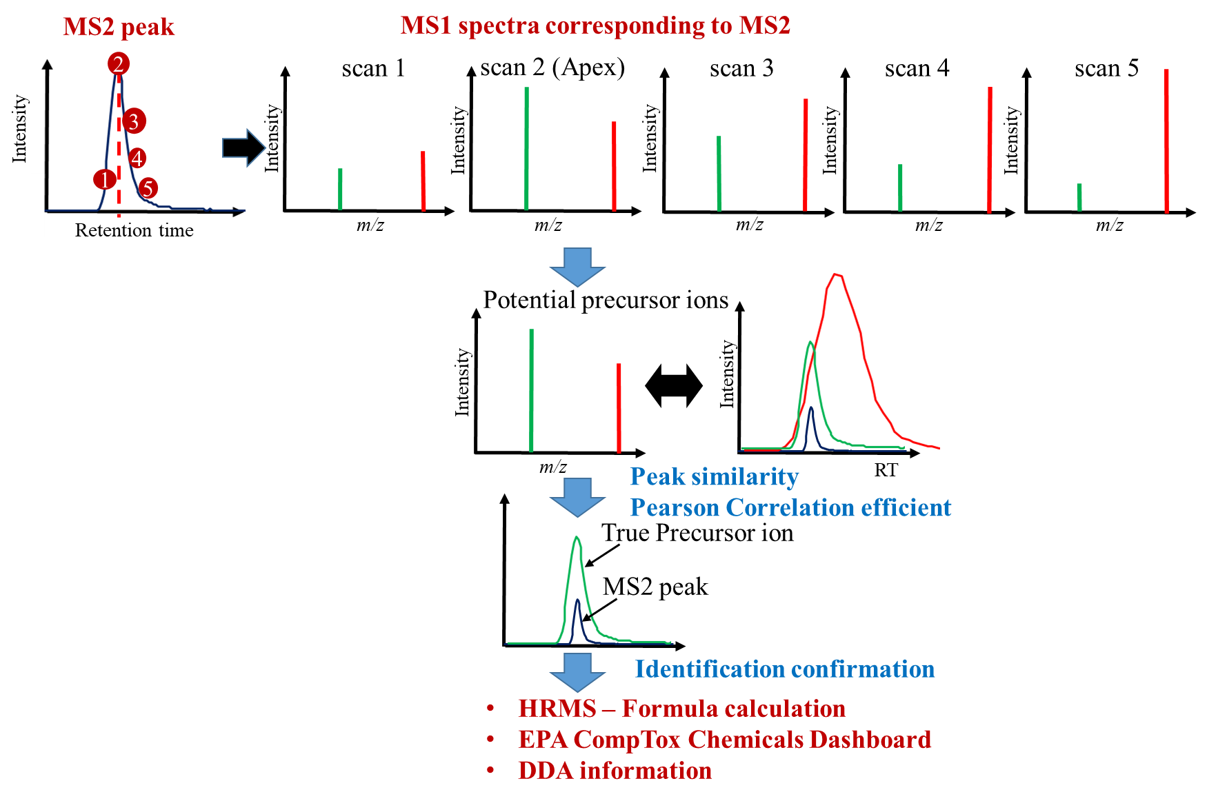
Fig. S1. Identification workflow for PFAS using DIA method.
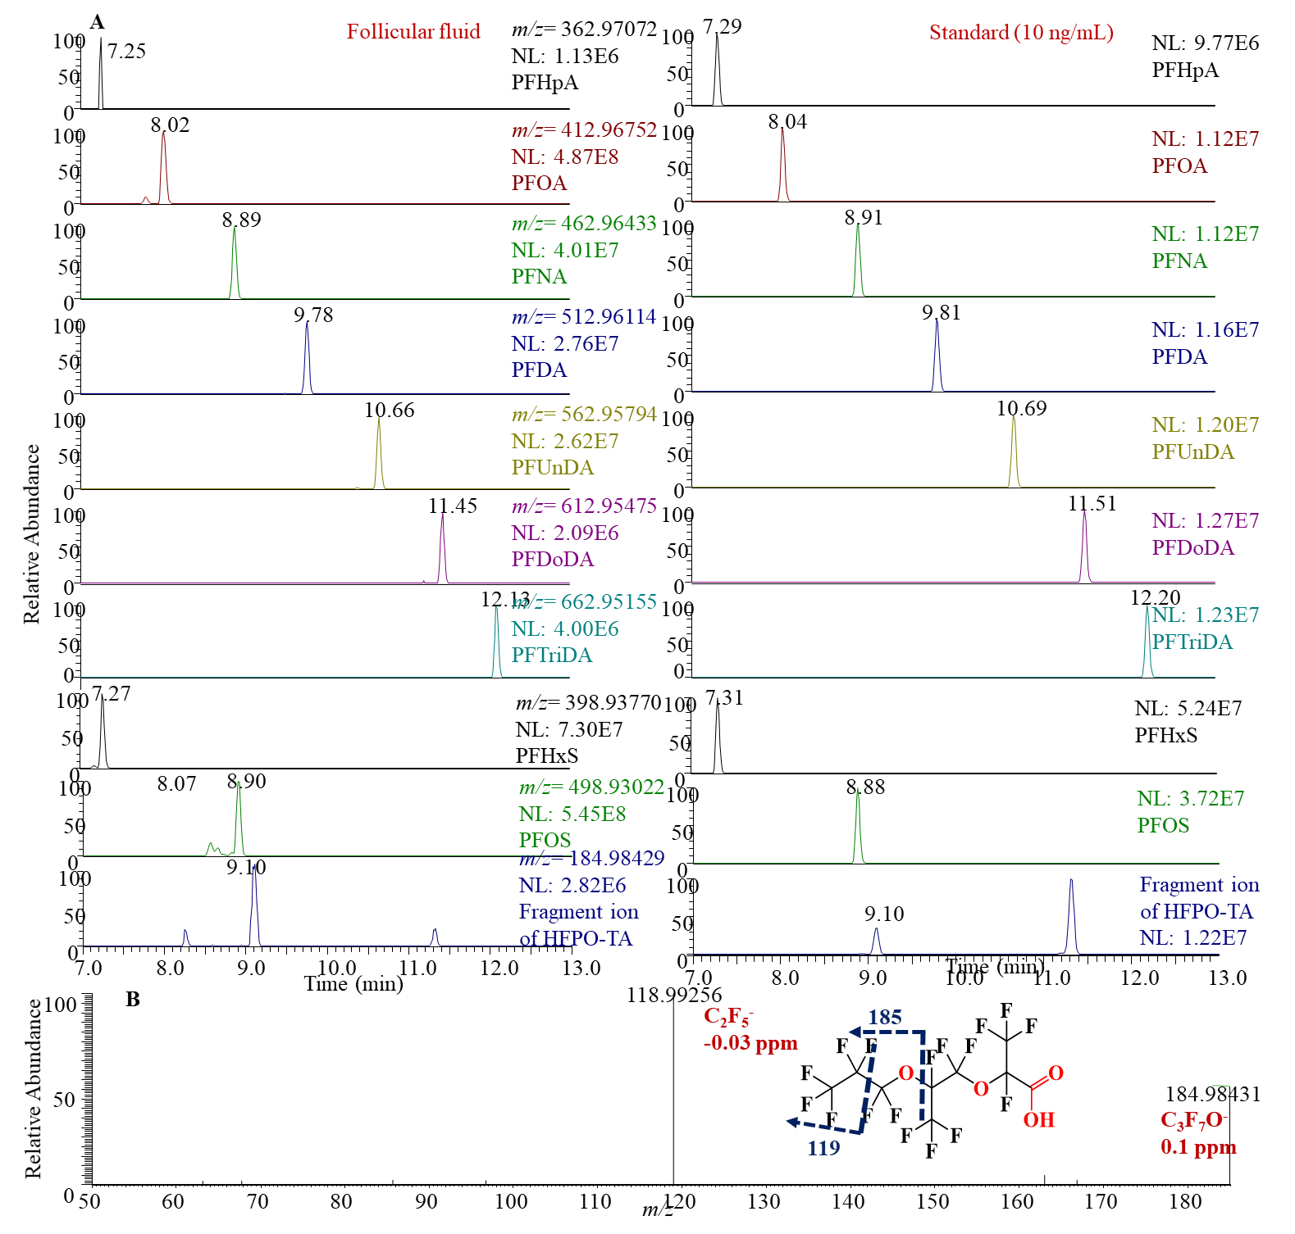
Fig. S2. Chromatograms of PFCAs, PFSAs and HFPOAs in the pooled follicular sample and in authentic standards (10 ng/mL, except that PFHpA didn’t have an authentic standard). (A) Chromatograms of PFHpA, PFOA, PFNA, PFDA, PFUnDA, PFDoDA, PFTriDA, PFHxS, PFOS, and HFPO-TAin pooled follicular fluid sample and authentic standard (10 ng/mL); (B) MS/MS spectrum of m/z 184.98429 (C₃F₇O⁻, fragment ion of HFPO-TA in ESI source).
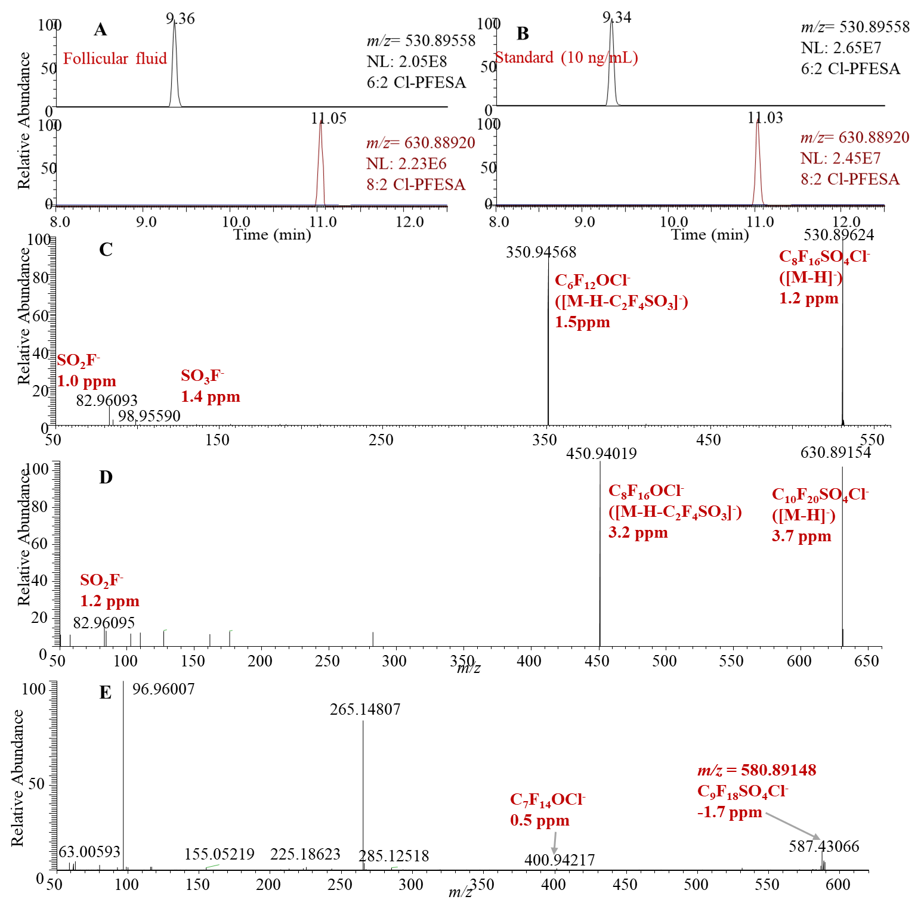
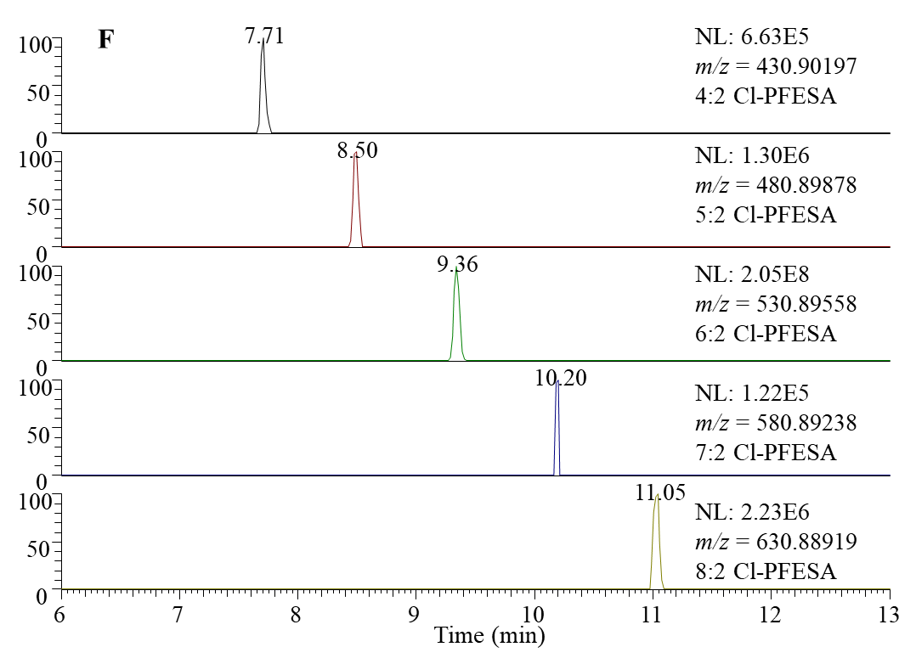
Fig. S3. The chromatograms and MS/MS spectra of Cl-PFESAs. (A) Chromatograms of 6:2 Cl-PFESA and 8:2 Cl-PFESA in pooled follicular fluid sample; (B) Chromatograms of 6:2 Cl-PFESA and 8:2 Cl-PFESA in authentic standard (10 ng/mL); (C) MS/MS spectrum of 6:2 Cl-PFESA; (D) MS/MS spectrum of 8:2 Cl-PFESA; (E) DIA multiplexed MS/MS spectrum of 7:2 Cl-PFESA from DIA window m/z 580–590; (F) Chromatograms of 4:2 Cl-PFESA, 5:2 Cl-PFESA, 6:2 Cl-PFESA, 7:2 Cl-PFESA, and 8:2 Cl-PFESA.
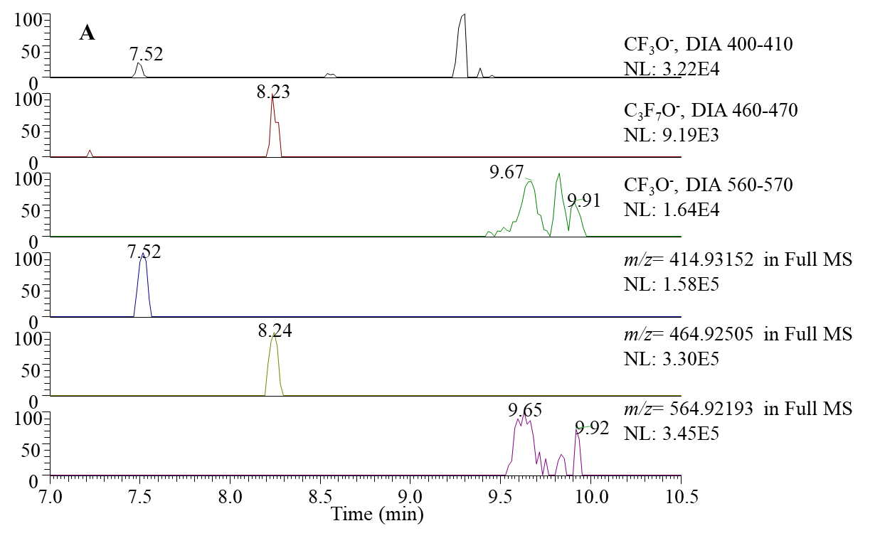
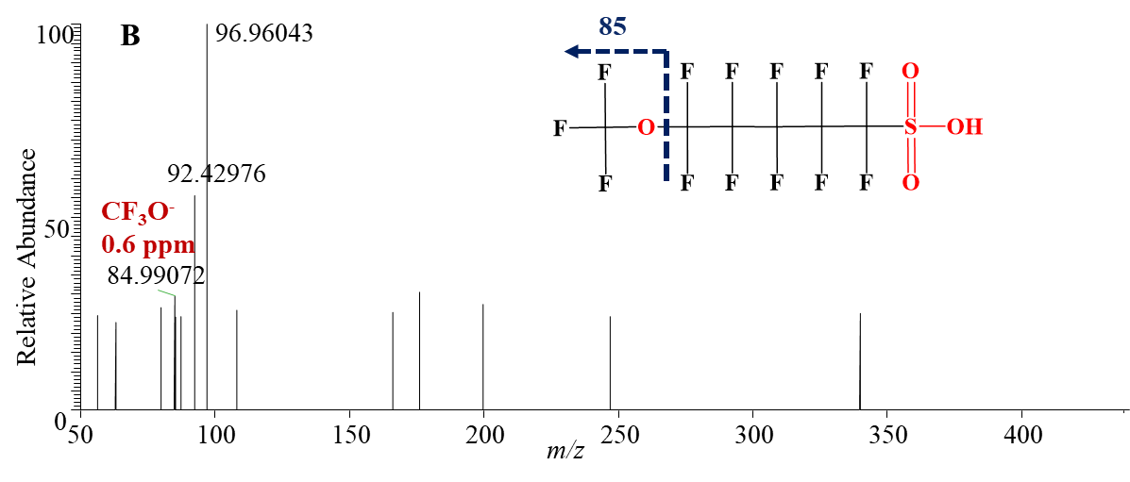
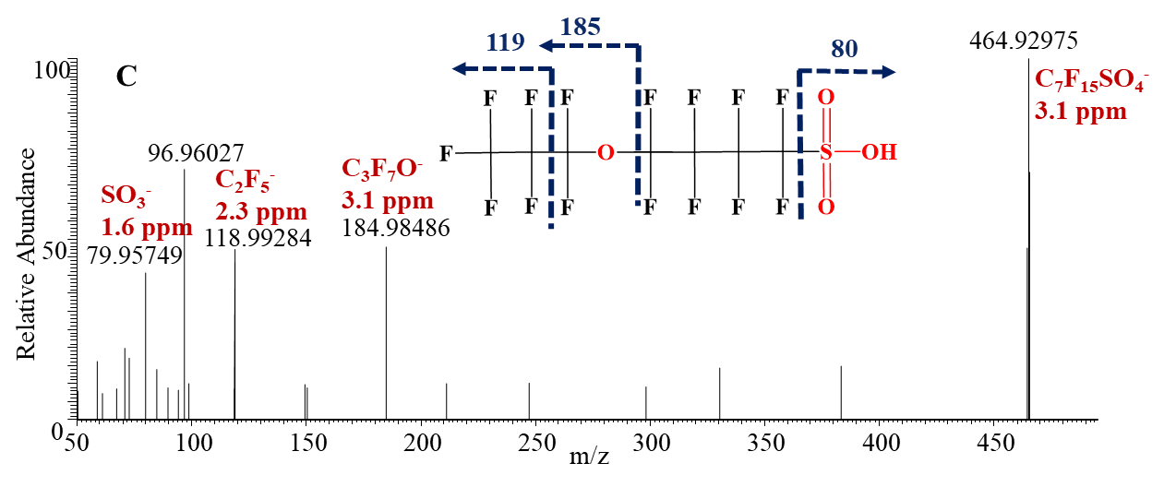
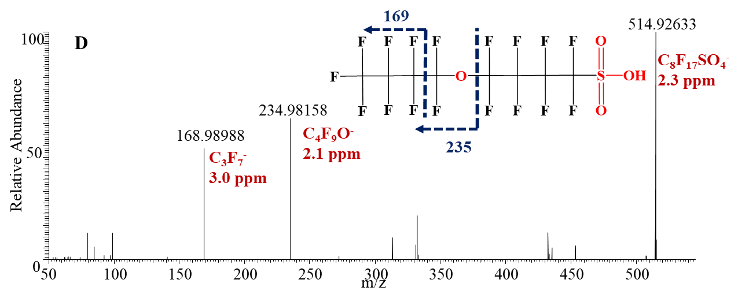
Fig. S4. The chromatograms and MS/MS spectra of PFESAs. (A) Chromatograms of diagnostic fragment ions in FF pooled sample and their precursors; (B) MS/MS spectrum of m/z 414.93091 (C₆ PFESA); (C) MS/MS spectrum of m/z 464.92780 (C₇ PFESA); (D) MS/MS spectrum of m/z 564.92200 (C₉ PFESA).
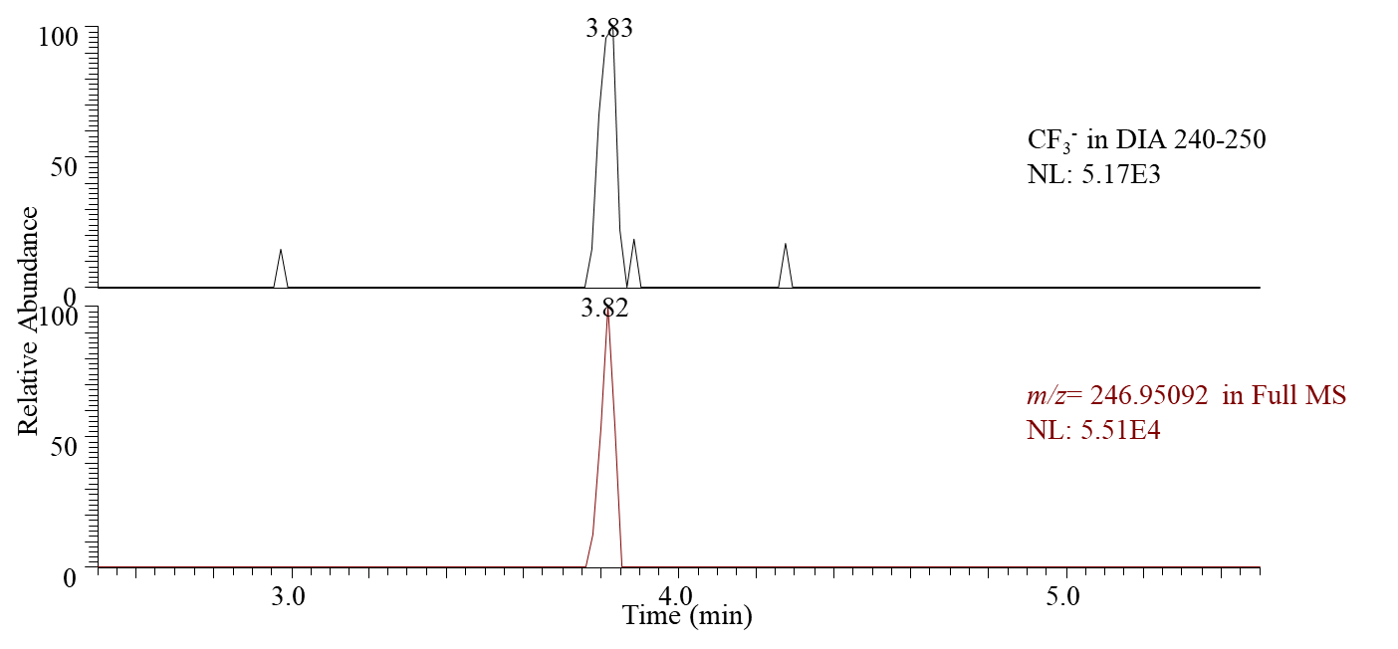
Fig. S5. Chromatograms of diagnostic fragment ion (CF₃⁻) in pooled follicular fluid sample and its corresponding precursor at m/z 246.95092.

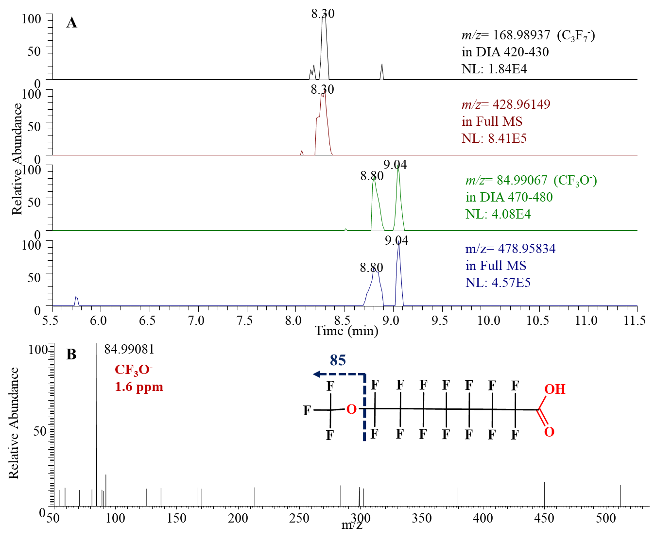
Fig. S6. The chromatograms and MS/MS spectra of PFECAs. (A) Chromatograms of diagnostic fragment ions (C₃F₇⁻, CF₃O⁻) in FF pooled sample and their corresponding precursors; (B) MS/MS spectrum of 1:8 PFECA.

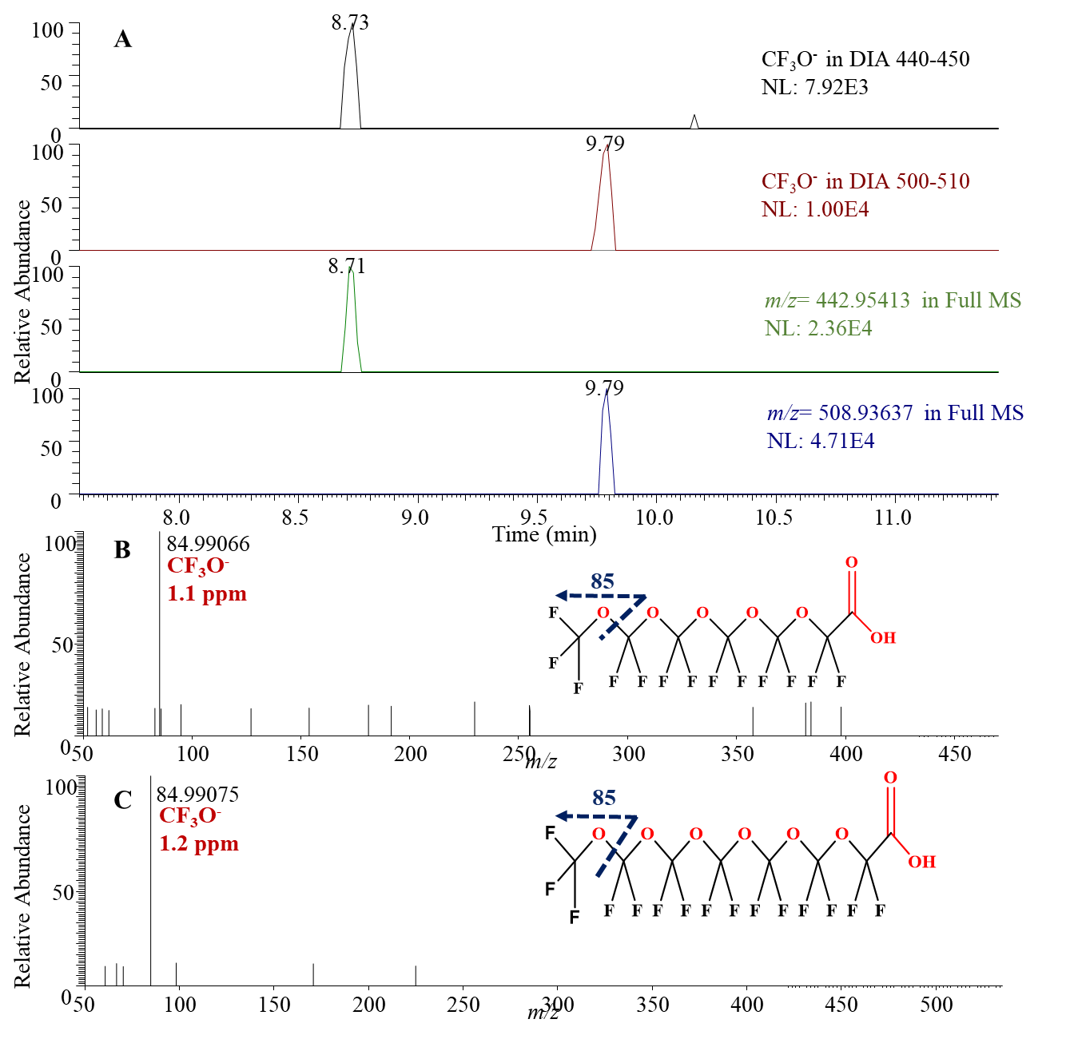
Fig. S7. Chromatograms and MS/MS spectra of Po-PFECAs. (A) Chromatograms of diagnostic fragment ions (C₃F₇⁻ and CF₃O⁻) in the pooled follicular fluid sample and their corresponding precursors; (B) MS/MS spectrum of C₇ Po-PFECA; (C) MS/MS spectrum of C₈ Po-PFECA.

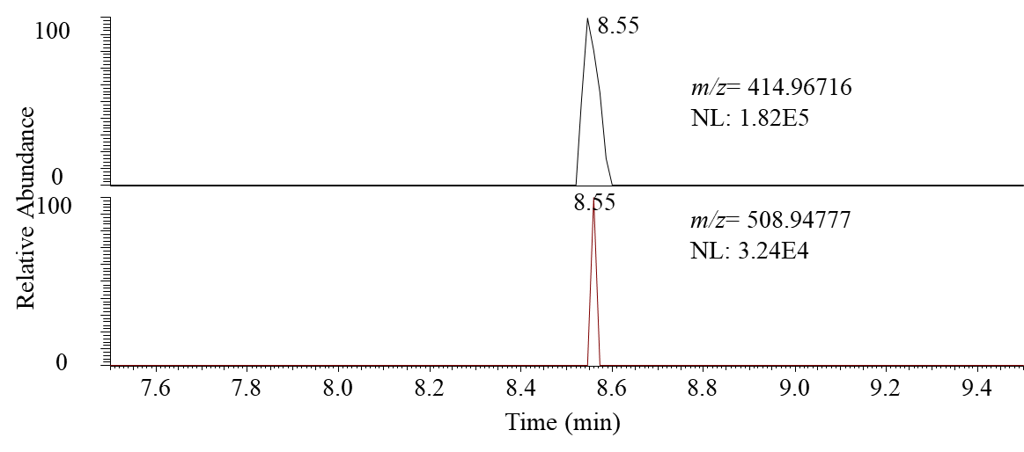
B
A
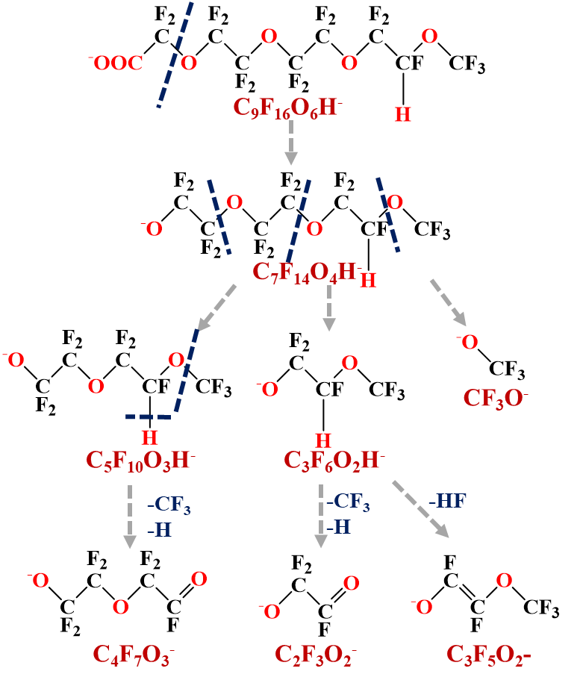
Fig. S8. (A) Chromatogram of m/z 414.96716 (fragment ion of C₉ H-Po-PFECA , C₇F₁₄O₄H⁻, 3.6 ppm) and m/z 508.94977 (precursor ion of [M-H]⁻, C₉F₁₆O₆H⁻, -5 ppm); (B) Detailed fragment pathway of C₉ H-Po-PFECA.
A
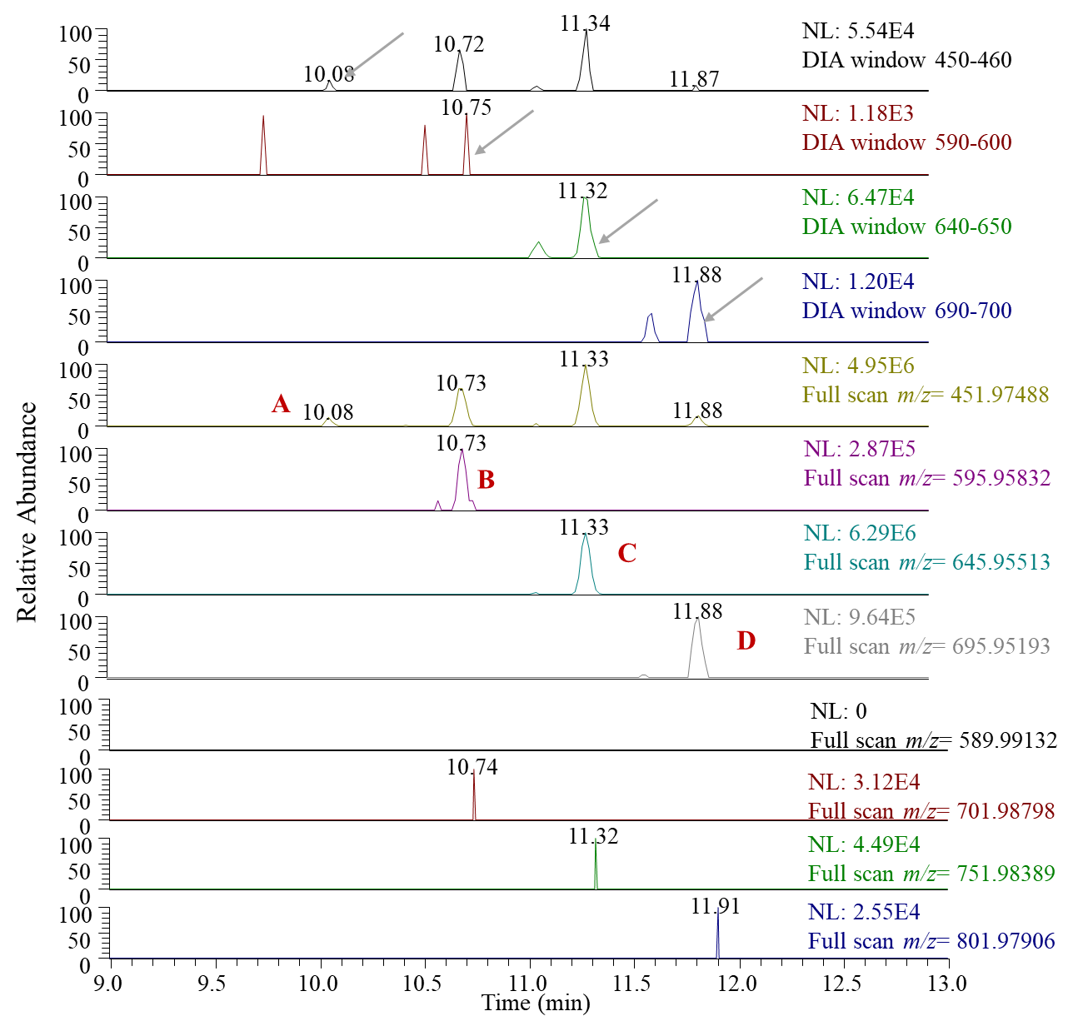
B
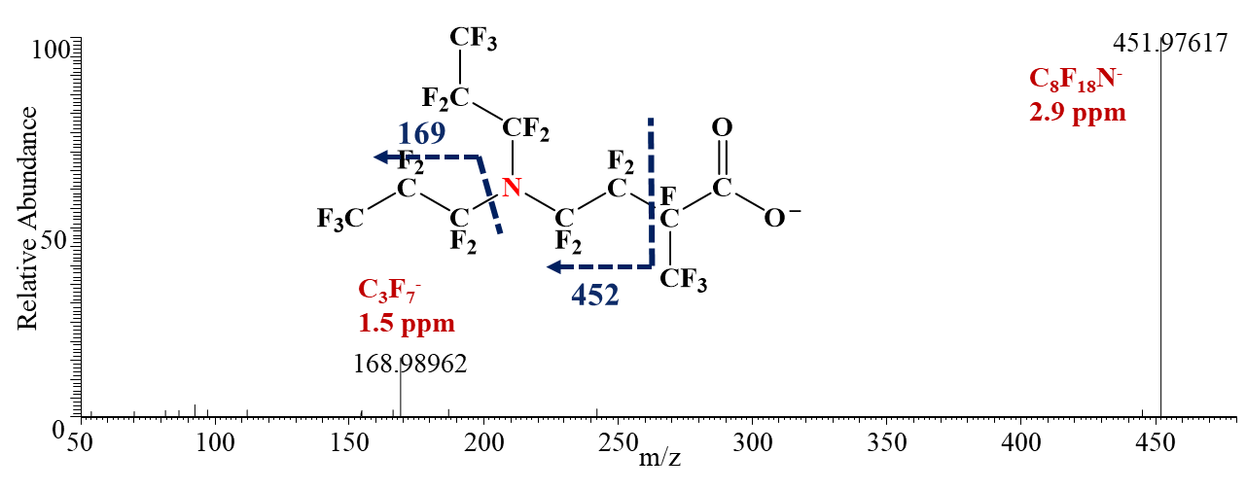
C
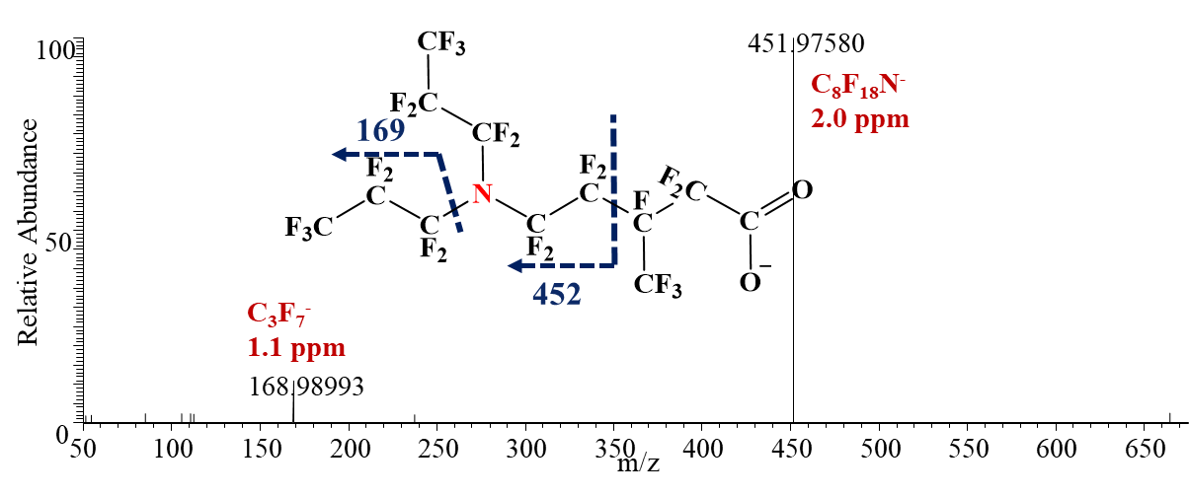
Fig. S9. Chromatograms and MS/MS spectra of PFNCEs. (A) Diagnostic fragment ion C₃F₇⁻ in multiple DIA windows and the corresponding precursors in Full scan. (B)MS/MS spectrum for m/z 451.97488 at 10.73 min; (C) MS/MS spectrum for m/z 645.95577 at 11.33 min.

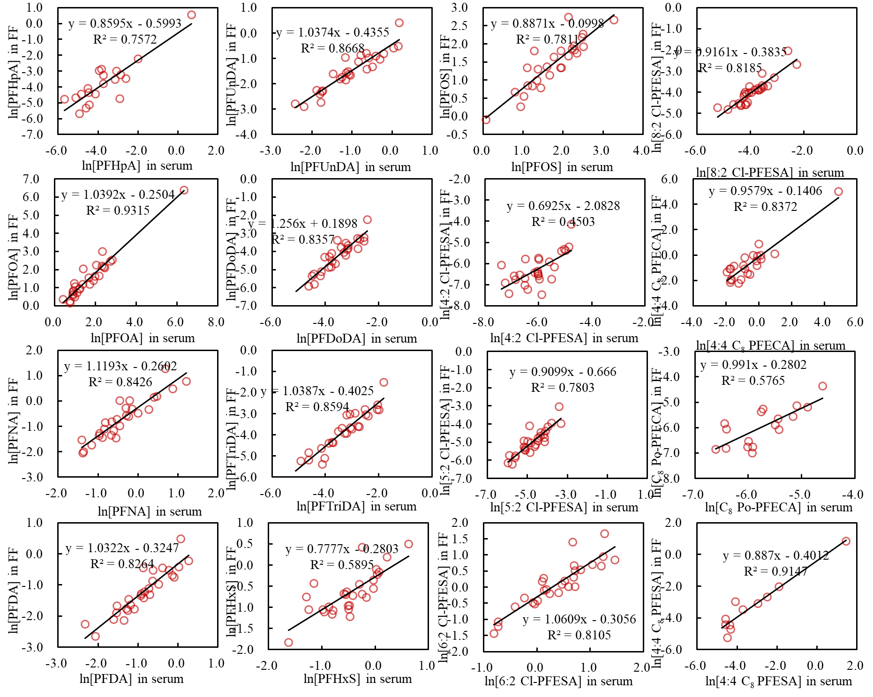
Fig. S10. Correlations and regressions of PFAS between follicular fluid and serum samples.
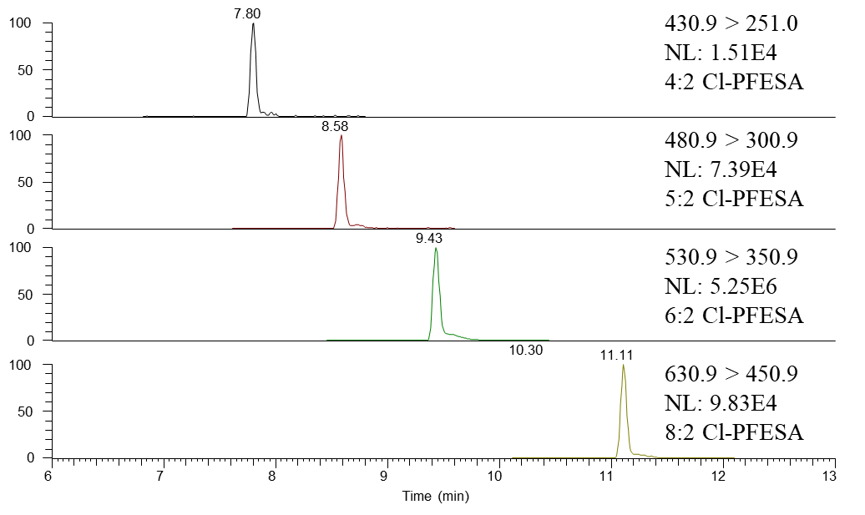
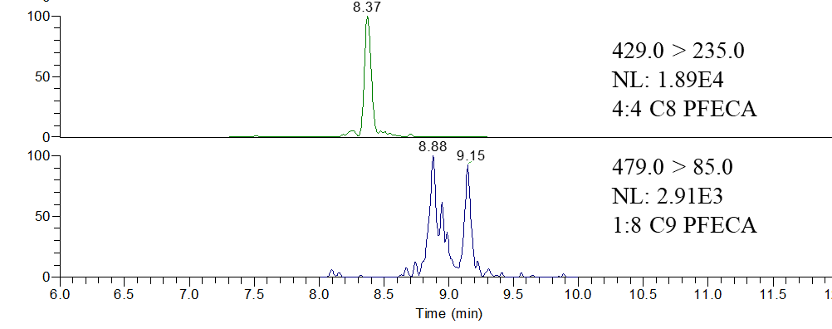
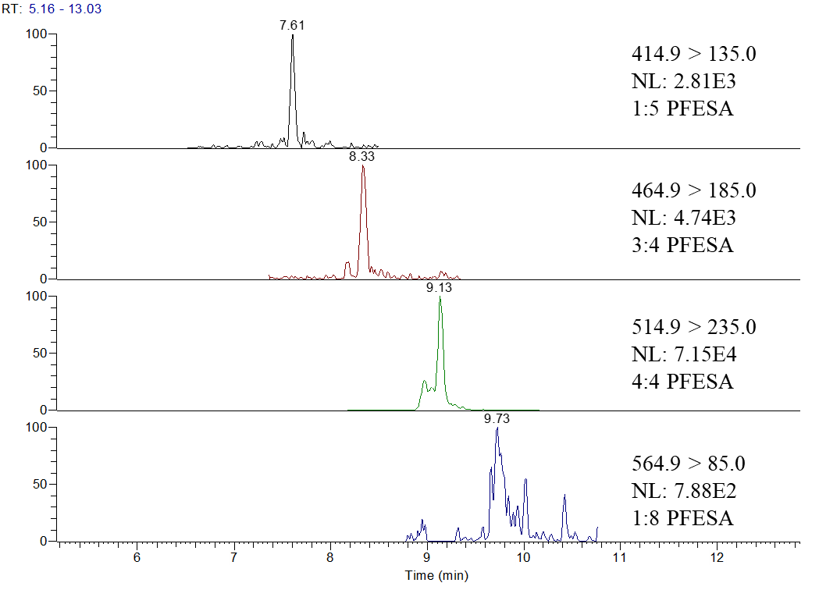
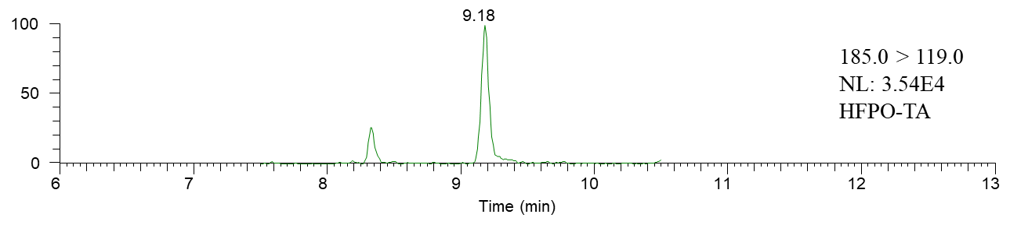
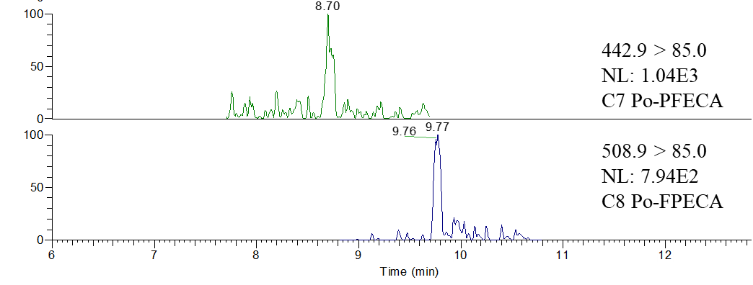

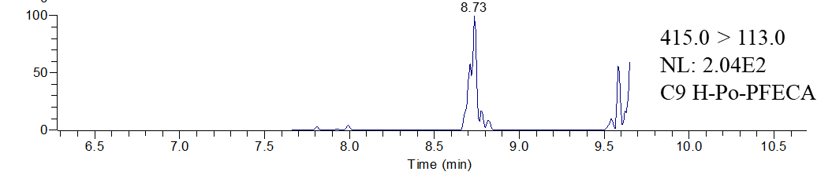
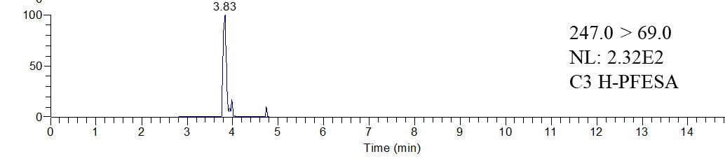
Fig. S11. UPLC-MS/MS chromatograms of discovered PFAS in the pooled follicular fluid sample.

