Supplementary material for
Simultaneous determination of primary and secondary phthalate monoesters in Taihu Lake: Exploration of sources

Analysis of metabolites of PAEs
An Acquity Ultra Performance LC with a Waters Acquity UPLC BEH C18 column (100 × 2.1 mm, 1.7 μm particle size) (Waters, Milford, MA, USA) was used to separate the primary and secondary phthalate monoesters. The column was maintained at 40 °C and a flow rate of 0.3 mL/min, and the injection volume was 5 μL. Methanol (A) and water containing 0.1% acetic acid (B) were used as mobile phases: 10% A was increased to 40% in 0.5 min, and then to 50% in 1.5 min, and then to 60% in 3.5 min, and then to 70% in 4.5 min, and then to 80% in 7 min, and then to 100% in 8.5 min and kept for 1.5 min, followed by a decrease to initial conditions of 10% in 12 min to allow for equilibration. A Premier XE tandem quadrupole mass spectrometer equipped with a Z-Spray ionization (ESI) source (Waters, Milford, MA, USA) was used for determining the phthalate primary and secondary monoesters and operated in the negative ion mode. The optimized conditions for LC-MS-MS were listed in Supplementary Table 1. The solution was dried under a gentle stream of nitrogen and redissolved with 200 μL of methanol prior to analysis of UPLC-MS/MS (Waters, Milford, Massachusetts, U.S.). The detailed information on mass spectrometry (MS) parameters and multiple reaction monitoring (MRM) conditions is shown in Supplementary Table 1.
Analytical method of PAEs.
Identification and quantification of PAEs were performed by a gas chromatograph-mass spectrometer (GC-MS) (Agilent 6890N) equipped with 5975C mass spectrometer (Agilent Technologies) in EI (electron impact) mode. A HP-5MS capillary column (30 cm × 0.25 mm × 0.25 μm film thickness; J&W Scientific) were used for separating PAEs. A splitless injector was used at 250°C. The temperature program increased from 70°C (4 min) to 160°C at 20°C/min, to 230°C at 2°C/min, and then to 300°C (10 min) at a rate of 30°C/min. The ion source temperature was maintained at 280°C, and helium was as the carrier gas at a constant flow rate of 5 mL/min. The ion used for quantification of the phthalates except for DMP was m/z 149. The ion for DMP was m/z163, and each molecular ion peak was used for confirmation. Recovery tests were conducted by analyzing lake water samples which were spiked with 100 ng/L for PAEs (n = 3). Recoveries were calculated by subtracting background concentrations in nonspiked samples from spiked samples according to the following equation.
Recovery (%) = (Observed – Background) / Spiked Concentration) ×100%;
where “Observed” is the “determined concentration of a PAE in the spiked sample”; “Background” is the determined background concentration of a PAE in nonspiked sample. The average recoveries of PAEs were 76-110% in the lake water, and LODs were from 0.001 μg/L (DnOP) to 0.08 μg/L (DiBP).
Supplementary Table 1. General information of the target chemical
Chemicals | CAS number. | Formula | Structure
phthalates
Dimethyl phthalate (DMP) | 131-11-3 | C₁₀H₁₀O₄ | 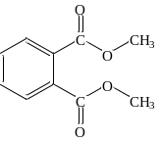
Diethyl phthalate(DEP) | 84-66-2 | C₁₂H₁₄O₄ | 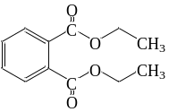
Di-n-butyl phthalate(DnBP) | 84-74-2 | C₁₆H₂₂O₄ | 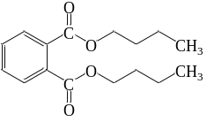
Di-iso-butyl phthalate (DiBP) | 84-69-5 | C₁₆H₂₂O₄ | 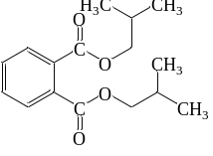
Di-(2-ethylhexyl) phthalate (DEHP) | 117-81-7 | C₂₄H₃₈O₄ | 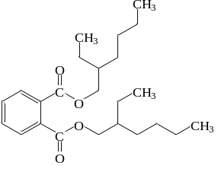
Di-n-octyl phthalate(DnOP) | 117-84-0 | C₂₄H₃₈O₄ | 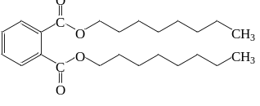
Butyl benzyl phthalate(BBP) | 85-68-7 | C₁₉H₂₀O₄ | 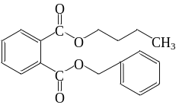
Di-iso-nonyl phthalate(DiNP) | 28553-12-0 | C₂₆H₄₂O₄ | 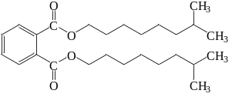
phthalate monoesters
monomethyl phthalate(MMP) | 4376-18-5 | C₉H₈O₄ | 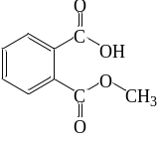
monoethyl phthalate(MEP) | 2306-33-4 | C₁₀H₁₀O₄ | 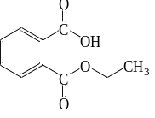
mono-iso-butyl phthalate(MiBP) | 30833-53-5 | C₁₂H₁₄O₄ | 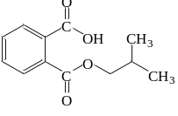
mono-n-butyl phthalate(MnBP) | 131-70-4 | C₁₂H₁₄O₄ | 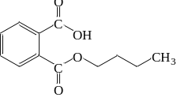
mono-(2-ethylhexyl) phthalate(MEHP) | 4376-20-9 | C₁₆H₂₂O₄ | 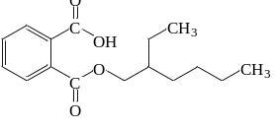
monobenzyl phthalate (MBzP) | 2528-16-7 | C₁₅H₁₂O₄ | 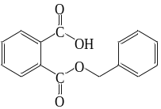
mono-iso-nonyl phthalate (MiNP) | 297182-83-3 | C₁₇H₂₄O₄ | 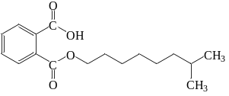
mono-n-octyl phthalate (MnOP) | 5393-19-1 | C₁₆H₂₂O₄ | 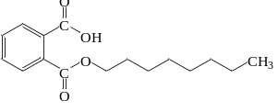
Secondary phthalate monoesters
mono (3-carboxypropyl) phthalate (MCPP) | 66851-46-5 | C₁₂H₁₂O₆ | 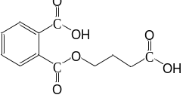
mono (2-ethyl-5-hydroylhexyl) phthalate (MEHHP) | 40321-99-1 | C₁₆H₂₂O₅ | 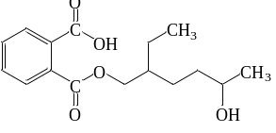
mono (2-ethyl-5-oxo-hexyl) phthalate (MEOHP) | 40321-98-0 | C₁₆H₂₀O₅ | 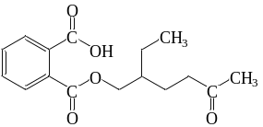
mono (2-ethyl-5-carboxypentyl) phthalate (MECPP) | 40809-41-4 | C₁₆H₂₀O₆ | 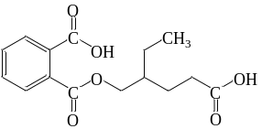
mono-(4-methyl-7-carboxyheptyl) phthalate(7cx-MMeHP) | 936022-02-5 | C₁₇H₂₂O₆ | 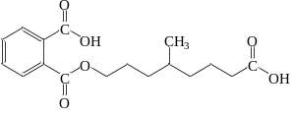

Supplementary Table 2. Optimized conditions for LC-MS-MS.
Compounds | MRM transition | Cone voltage (V) | Collision energy (eV)
MMP | 177.8>106.8 | 20 | 10
 | 177.8>76.8 | 20 | 18
MMP-¹³C4 | 182.8>109 | 20 | 10
 | 182.8>79 | 20 | 19
MEP | 192.8>76.7 | 19 | 16
 | 192.8>120.8 | 19 | 12
MEP-¹³C4 | 196.7>79 | 19 | 16
 | 196.7>122.8 | 20 | 10
MCPP | 251.1>103 | 10 | 10
 | 251.1>165 | 10 | 12
MCPP-¹³C4 | 255.1>103 | 10 | 20
 | 255.1>168.9 | 10 | 12
MiBP | 220.9>76.8 | 21 | 16
 | 220.9>70.8 | 21 | 12
MnBP | 220.9>76.8 | 21 | 16
 | 220.9>70.8 | 21 | 12
MnBP-¹³C4 | 224.9>76.8 | 21 | 20
 | 224.9>150.8 | 20 | 10
MBzP | 255>182.9 | 21 | 12
 | 255>76.8 | 21 | 20
MBzP-¹³C4 | 259>106.7 | 20 | 14
 | 259>76.6 | 20 | 24
MEHHP | 293.1>120.5 | 28 | 19
 | 293.1>142.6 | 25 | 13
MEHHP-¹³C4 | 297.1>123.8 | 25 | 20
 | 297.10>144.8 | 25 | 16
MEOHP | 291.1>120.6 | 25 | 19
 | 291.1>142.6 | 25 | 13
MECPP | 307.1>158.8 | 15 | 14
 | 307.10>120.8 | 15 | 24
MECPP-¹³C4 | 311.1>159.8 | 15 | 12
 | 311.1>112.8 | 15 | 30
MEHP | 277.1>133.8 | 25 | 16
 | 277.1>126.8 | 25 | 16
MEHP-¹³C4 | 281.1>136.6 | 26 | 16
 | 281.1>126.6 | 26 | 16
MnOP | 277.1>126.8 | 25 | 16
 | 277.1>76.8 | 25 | 16
MoC6 | 249.1>76.8 | 25 | 18
 | 249.1>205.1 | 25 | 12
MiNP | 291>76.7 | 40 | 20
 | 291>140.8 | 40 | 16
MiNP-¹³C4 | 295.1>140.9 | 30 | 22
 | 295.1>78.8 | 30 | 30
7cx-MMeHP | 321.3>172.8 | 25 | 12
 | 321.3>76.7 | 25 | 40
7cx-MMeHP-d4 | 325.3>172.8 | 25 | 12
 | 325.3>80.7 | 25 | 40
Common MS parameters: capillary voltage, 3.2 kV (ESI-); source temperature, 110°C; desolvation temperature, 450°C; source gas flow, 50 L/h; and desolvation gas flow, 800 L/h.
Supplementary Table 3. Concentrations of phthalates and their primary and secondary phthalate monoesters in the Taihu Lake.
 |  | Phthalate |  |  |  |  | Primary and secondary phthalate monoesters
 | Sites* | DMP | DEP | DiBP | DnBP | DEHP | MMP | MEP | MiBP | MnBP | MEHP
South Region | S1  S2  S3  S4  S5  S6  S7  S8  S9  S10  S11  S12  S13  S14  S15  S16  S17  S18  S19  S20  S21  S22  S23 | 3.151  <LOD  <LOD  13.59  5.894  5.149  <LOD  <LOD  7.904  6.931  16.86  <LOD  <LOD  <LOD  10.02  9.752  1.016  7.308  34.69  1.798  6.375  <LOD  5.341 | 13.82  8.137  8.146  13.49  6.552  10.17  3.727  0.255  9.895  11.93  17.12  3.073  5.968  5.136  7.314  1.201  <LOD  7.962  19.07  15.85  14.14  <LOD  0.923 | 106.9  102.2  111.4  94.98  74.89  280.4  47.52  43.61  85.33  277.2  425.7  108.2  193.4  290.7  214.9  202.3  49.62  18.54  149.2  104.7  115.2  211.8  68.89 | 120.5  146.8  195.8  159.4  355.4  389.5  73.5  103.3  68.53  168.0  443.1  324.8  49.92  156.7  254.9  304.6  153.2  56.47  265.6  247.1  141.1  152.1  192.4 | 39.12  311.9  91.41  135.1  245.6  79.02  198.9  30.52  43.57  305.8  528.2  95.45  478.2  <LOD  282.4  13.18  <LOD  42.60  983.6  134.4  217.0  <LOD  125.4 | 34.7  39.4  26.7  23.0  25.6  36.4  38.4  26.1  20.0  36.9  44.9  52.9  46.3  43.7  40.7  35.1  42.9  41.0  44.9  51.7  42.3  28.7  58.1 | <LOD  <LOD  <LOD  <LOD  <LOD  <LOD  <LOD  <LOD  <LOD  <LOD  <LOD  <LOD  <LOD  6.71  6.88  <LOD  <LOD  <LOD  <LOD  <LOD  <LOD  <LOD  <LOD | 12.2  17.7  10.3  7.78  7.70  8.01  27.7  7.40  12.7  10.3  19.5  14.7  6.81  4.79  17.1  9.75  6.97  6.30  9.02  10.3  6.67  9.87  25.3 | 7.66  17.2  8.13  10.8  20.3  17.0  23.5  13.4  8.27  13.1  40.8  23.5  9.74  13.4  22.7  21.1  17.1  8.55  6.82  16.7  5.51  12.9  48.7 | 6.74  9.56  9.03  6.22  5.18  10.3  12.5  10.6  56.3  12.4  7.47  14.0  12.4  24.6  9.64  12.0  11.7  17.8  5.87  7.81  8.32  22.1  16.6
Estuary | S-e  N-e1  N-e2  N-e3  N-e4  N-e5  N-e6  N-e7 | 18.71  122.47  203.83  33.17  109.1  94.24  117.59  133.78 | 16.79  151.2  374.9  31.51  59.57  139.3  7.786  146.3 | 10.48  94.82  167.8  56.15  44.32  94.89  138.9  127.5 | 12.35  695.9  187.1  205.3  116.0  213.1  186.2  1228 | 62.85  338.0  303.7  164.5  <LOD  278.1  4.237  <LOD | 35.9  61.3  47.2  48.1  45.2  52.1  74.9  25.8 | <LOD  <LOD  <LOD  <LOD  <LOD  39.5  15.5  4.24 | 9.59  23.1  15.2  13.2  8.99  30.7  26.7  6.21 | 24.0  42.8  20.1  15.7  16.8  60.0  185  12.8 | 51.5  20.7  43.0  32.4  34.1  112  42.9  12.7
Gonghu Bay | N4  N5  N11  N12  N13  N14  N15  N16 | 112.1  17.53  125.19  90.81  140.5  83.27  68.17  10.62 | 261.8  35.57  124.3  108.4  142.4  164.6  129.1  100.1 | 125.5  77.82  100.2  406.3  64.38  85.93  35.39  63.35 | 375.1  600.7  338.4  1151  366.5  538.7  120.5  224.3 | 338.1  202.9  311.7  90.04  277.0  279.4  178.7  142.3 | 45.4  62.2  40.9  65.9  74.1  38.9  39.4  70.3 | <LOD  <LOD  <LOD  8.76  <LOD  <LOD  <LOD  <LOD | 14.3  18.9  14.5  44.3  16.0  13.3  9.86  12.0 | 63.6  87.7  30.5  32.8  16.2  24.7  32.1  20.1 | 14.4  6.77  19.5  15.9  13.1  11.2  9.39  19.1
Zhushan Bay | N1  N2  N6  N7  N8  N17  N18  N19  N20  N21  N22  N23  N24  N25 | 37.88  16.86  28.78  28.27  14.50  41.00  54.17  42.41  49.34  32.13  48.81  54.51  53.01  24.36 | 85.35  22.01  58.02  27.60  2.493  54.63  10.87  44.98  37.67  23.55  60.87  24.02  28.54  4.232 | 1238  1221  967.7  630.5  99.07  1009  138.5  1063  873.3  1040  568.9  491.6  58.77  141.3 | 1332  1046  1099  663.4  1651  859.2  529.9  1167  870.6  880.5  668.4  364.8  91.27  3384 | <LOD  <LOD  <LOD  122.6  938.9  <LOD  247.5  48.13  100.6  67.85  <LOD  27.78  <LOD  209.7 | 47.3  37.4  61.7  34.4  31.5  144.9  181.7  56.7  62.5  88.3  60.9  55.7  66.1  53.3 | 6.99  7.06  <LOD  7.57  <LOD  9.38  9.26  5.62  10.7  5.33  <LOD  <LOD  <LOD  <LOD | 18.0  39.1  29.9  31.7  91.5  35.9  29.7  9.65  29.8  11.3  11.9  15.0  23.0  13.8 | 50.7  36.1  62.6  38.8  463  78.8  204  32.1  52.4  24.3  23.7  39.5  25.8  37.8 | 25.6  46.7  41.0  107  54.0  115  69.3  28.1  40.4  35.0  53.2  40.6  63.5  19.1
Meiliang Bay | N3  N9  N10  N26  N27  N28  N29  N30  N31  N32  N33  N34  N35 | 17.73  13.17  18.10  13.23  21.20  19.71  28.58  22.84  14.74  17.58  12.79  45.02  23.46 | 4.884  11.37  10.65  24.06  8.553  10.85  19.88  3.018  6.774  9.868  9.314  22.76  9.718 | 301.7  19.06  199.3  126.1  182.8  272.2  214.2  18.08  86.18  52.21  101.7  45.85  59.96 | 1369  40.28  494.9  228.9  367.9  160.9  458.9  116.7  1779  419.1  2209  707.4  592.2 | 433.4  389.4  273.7  240.6  136.4  343.4  510.5  106.8  69.49  508.7  868.2  648.1  87.42 | 44.7  48.6  45.5  45.0  48.0  43.9  36.3  58.7  53.7  56.6  80.2  69.5  92.7 | 10.6  <LOD  <LOD  <LOD  <LOD  <LOD  <LOD  8.45  <LOD  <LOD  10.9  13.0  8.45 | 30.5  15.7  15.6  12.0  22.0  18.6  47.1  20.6  33.8  15.1  31.8  33.9  63.3 | 72.6  12.2  11.3  15.9  9.66  16.9  83.1  6.17  145  19.0  32.1  47.8  75.9 | 59.1  22.3  25.9  17.9  15.0  23.2  249  19.3  13.2  25.4  43.0  92.2  66.4
*see Fig.1
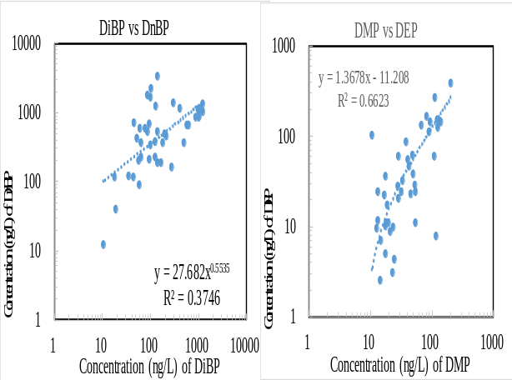
Supplementary Fig. 1. Relationship between DiBP and DnBP.

