Supplementary materials
for
High inter-species differences of 12378-Polychlorinated Dibenzo-p-Dioxin between humans and mices
Zhaomin Dong ^{1,2†}, Yujie Ben^{1†}, Yu Li¹, Tong Li¹, Yi Wan¹, and Jianying Hu^{1*}
¹ College of Urban and Environmental Sciences, Peking University, Beijing, 100871, China.
² Beijing Advanced Innovation Center for Big Data-Based Precision Medicine, Beihang University, Beijing, 100191, China
†These authors contributed equally to this work.
*Address for Correspondence
Dr. Jianying HU, College of Urban and Environmental Sciences, Peking University
Beijing 100871, China.
TEL & FAX: 86-10-62765520;
Email: hujy@urban.pku.edu.cn.
Section 1 The determination of PCDD/F levels in blood samples.
Materials and methods
Chemicals. ¹³C-labeled surrogate standards of EDF-533, injection standards of EDF-5333, and calibration standard solutions: CS1, CS2, CS3, CS4 and CS5 of EDF-5331-L-E were obtained from Cambridge Isotope Laboratories (Andover, USA). Hexane, dichloromethane and toluene were ultra-residues analysis grade and purchased from J.T. Baker Co. Ltd. (Phillipsburg, USA). Sodium sulfate was pesticide analysis grade and purchased from ANPEL Laboratory Technologies Inc. (Shanghai, China). Ammonium sulfate was high-purity level and obtained from Sinopharm Co. Inc (Beijing, China). Silica gel and activated carbon dispersed silica gel were purchased from Kanto Chemical Co. Inc (Tokyo, Japan).
Laboratory Analysis. The dioxin analysis in human blood was conducted according a previous study (Nakamura et al. 2008). In brief, approximately 7 mL human blood was spiked with ¹³C₁₂-labeled PCDD/DFs internal standard before liquid-liquid extraction with saturated ammonium sulfate and 1:3 v/v ethanol: hexane. The upper organic layer was separated and combined with the extraction of the residue using hexane for twice. The combined extract was rinsed with ultrapure water and dehydrated with anhydrous sodium sulfate. Then the extract was evaporated and purified by multilayer silica gel column chromatography, which compose of anhydrous sodium sulfate, silica gel, silica gel impregnated with sulfuric acid (50% mass), silica gel, silica gel impregnated with potassium hydroxide (2% mass), silica gel from top to bottom. The eluate was further purified by active carbon dispersed silica gel column chromatography, which was eluted with 1:3 dichloromethane: hexane and toluene in sequence. The toluene eluent was concentrated to 20 μL and added with injection internal standard for further instrument analysis.
Instrumental analysis. The PCDD/Fs analysis in blood was performed in the HRGC/HRMS, equipped with the solvent cut large volume (SCLV) injection system (SGE Ltd, Australia) to improve the sensitivity of measurement, which could achieve dioxin analysis with 10 μL injection volume of extract and has been used in detection of analysis in human blood in Japan. The SCLV injection system consists a pre-column (BPX5, 6m×0.25mm×0.25μm, SGE Ltd, Australia) tandem with an analytical column (BPX-Dioxin-1, 30m×0.15mm, SGE Ltd, Australia) (Figure S1). A pre-separation of solvent and analytical PCDD/F congeners was realized in the pre-column, and the target compounds are held in front of the analytical column with cooling gas (CO₂) released through the cold trap valve, and thus reducing the interference of large volumes of solvents for chromatographic analysis. The carrier gas used was high purity helium with a flow rate of 3.0 mL/min, and carbon dioxide was used as cooling gas. The temperature program was as follows: the initial temperature was 160 ℃ for 2.75 min, which was increased at a rate of 20 ℃/min to 300 °C and maintained for 10 min; then the temperature was decreased to 195 °C at a rate of 70 °C/min and maintained for 0.5 min; and finally, the temperature was increased at a rate of 3 °C/min to achieve the final temperature of 300 °C, which was maintained for 10 min. The injection volume of each sample was 10 μL. Limits of detection (LOD) of PCDD/Fs in human blood were 0.0013~0.0028pg/g wet weight, and recovery of the clean-up spike for each sample was from 45% to 70%.
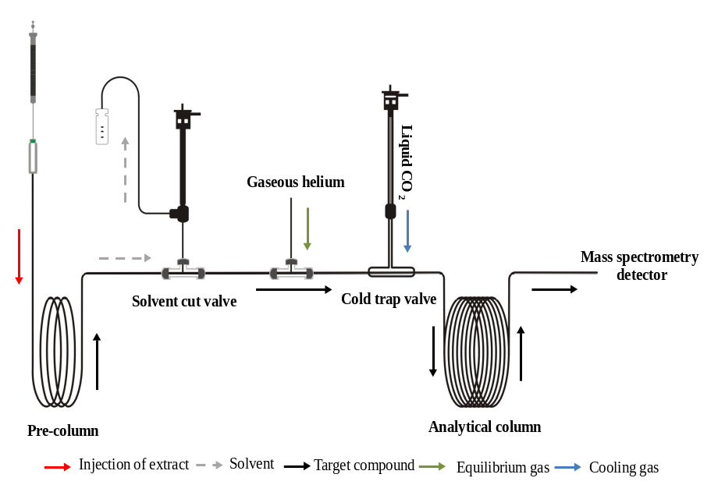
Figure S1. A schematic of the solvent cut large volume injection system (SGE Ltd, Australia).
Blood Level of PCDD/Fs in the Studied Participants. The concentrations of 17 PCDD/F congeners were analyzed in all blood samples. Except the two congeners with low detection rate (2378-T₄CDD and 2378-T₄CDF), the blood levels of 12378-P₅CDD, 123478-H₆CDD, 123678-H₆CDD, 123789-H₆CDD, 1234678-H₇CDD, 23478-P₅CDF, 123478-H₆CDF, 123678-H₆CDF, 123789-H₆CDF,1234678-H₇CDF, 1234789-H₇CDF, and O₈CDF were significantly increased with age in the studied population (p<0.05), while 1234678-H₇CDD, OCDD, 12378-P₅CDF, and 234678-H₆CDF were not significantly correlated with age (p>0.05) (Figure S2).
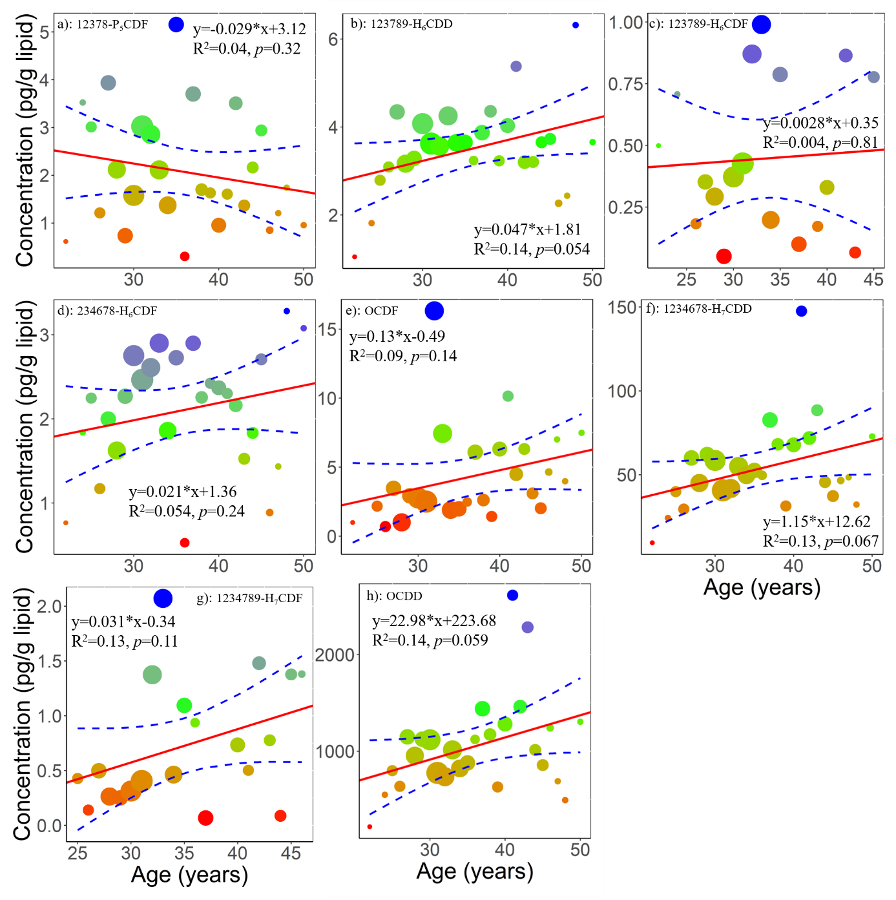
Figure S2. Non-significant relationship between age and specific dioxins (pg/g lipid) in the blood. The size of bubbles represents the sample size for each age. The red line is the fitness based on linear regression, and the blue dashed lines are the 95% confidence interval of predictions.
Section 2 Assessment of Human Exposure to PCDD/Fs.
PCDD/F Levels in air and food Samples. During August, 2013-August, 2014, 48 air samples and 150 food samples were collected from a commercial market where the studied population mainly acquired food. Detailed information on laboratory analysis of PCDD/Fs in food samples has been described in the previous study (Ben et al. 2017). The concentrations of 17 PCDD/F congeners were detected in all air and food samples.
The average concentrations of PCDD/F congeners in air samples were from 0.016 to 0.95 pg/m³, and the concentration of ΣPCDD/Fs in air samples was 4.5 ±3.4 pg/m³ in (0.29 ±0.21pg TEQ_{12378-P5CDD}/m³). The average concentration of PCDD/F congeners in food samples was in the range of ND-5.6 pg/g wet weight, and the concentration of ΣPCDD/Fs was 0.035 ± 0.089pg/g ww (0.00063 ± 0.0011 pg TEQ_{12378-P5CDD} /g ww)in cereal, 0.36 ±0.40 pg/ww (0.050 ± 0.046 pg TEQ/g ww)in milk, 2.1±1.8 pg/g ww (0.20 ± 0.23 pg TEQ_{12378-P5CDD}/g ww) in fish and shrimp, 2.8± 5.2 pg/g ww (0.060 ± 0.070 pg TEQ_{12378-P5CDD}/g ww) in eggs, 6.8± 9.5 pg/g ww (0.11 ± 0.10 pg TEQ_{12378-P5CDD}/g ww) in poultry meat, 1.0±1.1 pg/g ww (0.16 ± 0.28 pg TEQ_{12378-P5CDD}/g ww) in beef, 1.0±1.1pg/g ww (0.050 ± 0.050 pg TEQ_{12378-P5CDD}/g ww) in pork, 0.014±0.030 pg/g ww (0.00033 ± 0.00087 pg TEQ_{12378-P5CDD} /g ww) in fruit, and 0.25±0.35 pg/g ww (0.020 ± 0.030 pg TEQ_{12378-P5CDD}/g ww) in vegetables.
Based on the PCDD/Fs concentration in air and food, the total daily intake of each PCDD/F was calculated and plotted as Figure S3.
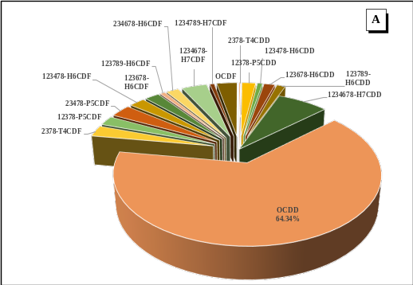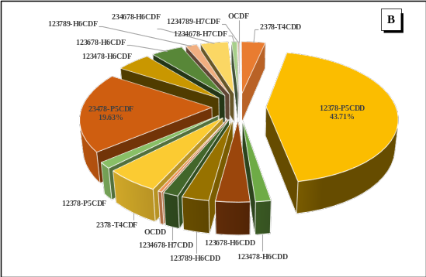
Figure S3. Percentage of PCDD/F congeners contributed to the total daily intake of PCDD/Fs in Shenzhen, China. The contributions were presented as pg/kg day (A) and pg TEQ12378-P5CDD/kg day.

Section 3 The estimation of half-lives of PCDD/F congeners at different age.
Optimization of elimination models. A log-transformed algorithm-based error function as the following was used to estimate parameters k₁ and k₂ in the three elimination models: constant model, linear model and exponential model. The parameters were optimized by the exhaustive attack method:
The parameters with minimum error were selected as the optimum parameters. After the parameter optimization for each model, the model with the lowest Akaike’s information criterion (AIC) was selected as the optimal model (Akaike 1998):

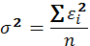
where n presents the sample size; k presents the parameter number; presents the standardized residual of the model; is the residual of the model corresponding with the concentration of the i^{th} PCDD/F congener in human blood.
Age-dependent human elimination half-life of PCDD/Fs. The elimination model was selected with the minimal AIC value for each PCDD/F congener to simulate their elimination rates at different age, except 2378-T₄CDD and 2378-T₄CDF due to the especially low detection rate in human blood. The exponential model was selected for 12378-P₅CDD, the linear model was selected for 123678-H₆CDD, 1234789-H₇CDF, and OCDF, while the constant model was selected for most of the PCDD/F congeners including 123478-H₆CDD, 123789-H₆CDD, 1234678-H₇CDD, 23478-P₅CDF, 123478-H₆CDF, 123678-H₆CDF, 234678-H₆CDF, and 1234678-H₇CDF (Table S1).
By using the optimized elimination, the elimination half-lives of each PCDD/F congeners were determined. The average simulated age-dependent half-lives of PCDD/F congeners was 5.20 years (from 3.39 years for a 24-year old to 8.31 years for a 50-year old) for 12378-P₅CDD, 7.49 years (from 6.91 to 7.96) for 123478-H₆CDD, 7.46 years (from 5.92 to 9.20) for 123678-H₆CDD, 6.29 years (from 5.88 to 6.62) for 123789-H₆CDD, 12.23 years (from 10.74 to 13.52) for 1234678-H₇CDD, 29.48 years (from 17.05 to 46.80) for OCDD, 2.48 years (from 2.41 to 2.52) for 12378-P₅CDF, 6.84 years (from 5.99 to 7.69) for 23478-P₅CDF, 6.60 years (from 5.65 to 7.56 years) for 123478-H₆CDF, 6.15 years (from 5.75 to 6.47 years) for 123678-H₆CDF, 1.60 years (from 1.57 to 1.63 years) for 123789-H₆CDF, 3.49 years (from 3.21 to 3.76 ) for 234678-H₆CDF, 6.69 years (from 6.22 to 7.06) for 1234678-H₇CDF, 4.69 years (from 2.66 to 7.50) for 1234789-H₇CDF, and 4.37 years (from 2.77 to 7.25) for OCDF (Table S1), respectively.
Table S1. Elimination model optimization for each PCDD/F congener and the simulated average half-life.
 | Elimination model | k₁ | k₂ | AICª | RMSE^{b}  (pg/g) | Average half-life (year) | Reported half-life from the literature  (Milbrath et al. 2009)
12378-P₅CDD | k_{elim}(t_{age})=k₁×(1-k₂×t_{age}) | 7.75×10⁻⁴ | 1.47×10⁻² | 93.88 | 1.02 | 5.06 | 0.28-15.7
123478-H₆CDD | k_{elim}(t_{age})=k₁ | 2.17×10⁻⁴ |  | 58.13 | 0.54 | 7.44 | 7.8-19
123678-H₆CDD | k_{elim}(t_{age})=k₁×e^(-k₂×t_{age}） | 3.64×10⁻⁴ | 1.36×10⁻² | 102.91 | 1.20 | 7.35 | 0.33-70
123789-H₆CDD | k_{elim}(t_{age})=k₁ | 2.67×10⁻⁴ |  | 87.14 | 0.93 | 6.22 | 4.6-9.2
1234678-H₇CDD | k_{elim}(t_{age})=k₁ | 1.18×10⁻⁴ |  | 264.11 | 24.68 | 12.12 | 0.28-8.8
OCDD | k_{elim}(t_{age})=k₁×e^(-k₂×t_{age}） | 1.39×10⁻⁴ | 4.00×10⁻² | 437.42 | 588.92 | 28.55 | 0.42-22
12378-P₅CDF | k_{elim}(t_{age})=k₁ | 7.30×10⁻⁴ |  | 102.87 | 1.25 | 2.47 | 0.4-7.5
23478-P₅CDF | k_{elim}(tage) k₁×(1-k₂×t_{age}) | 2.89×10⁻⁴ | 4.44×10⁻³ | 127.78 | 1.90 | 6.77 | 0.23-19.6
123478-H₆CDF | k_{elim}(t_{age})=k₁×e^(-k₂×t_{age}） | 3.31×10⁻⁴ | 7.33×10⁻³ | 111.29 | 1.40 | 6.52 | 1.5-9.9
123678-H₆CDF | k_{elim}(t_{age})=k₁ | 2.72×10⁻⁴ |  | 98.85 | 1.16 | 6.12 | 3.5-24
123789-H₆CDF | k_{elim}(tage)= k₁×(1-k₂×t_{age}) | 1.17×10⁻³ | 4.44×10⁻⁴ | 21.28 | 0.32 | 1.60 | -
234678-H₆CDF | k_{elim}(tage)= k₁×(1-k₂×t_{age}) | 5.80×10⁻⁴ | 3.33×10⁻³ | 73.11 | 0.69 | 3.46 | 1.5-9.9
1234678-H₇CDF | k_{elim}(t_{age})=k₁ | 2.47×10⁻⁴ |  | 163.37 | 3.81 | 6.64 | 1.4-6.8
1234789-H₇CDF | k_{elim}(t_{age})=k₁×e^(-k₂×t_{age}） | 1.71×10⁻⁴ | 4.00×10⁻² | 129.35 | 2.22 | 4.54 | 3.2-10
OCDF | k_{elim}(tage)= k₁×(1-k₂×t_{age}) | 9.82×10⁻⁴ | 1.51×10⁻² | 157.29 | 3.35 | 4.25 | 0.2-2.1
ª: AIC (Akaike’s information criterion); calculated as n*Ln(Residuals)+2*p (p is the number of parameters and n is the number of observations) ^{b}: RMSE (Root Mean Square Error).

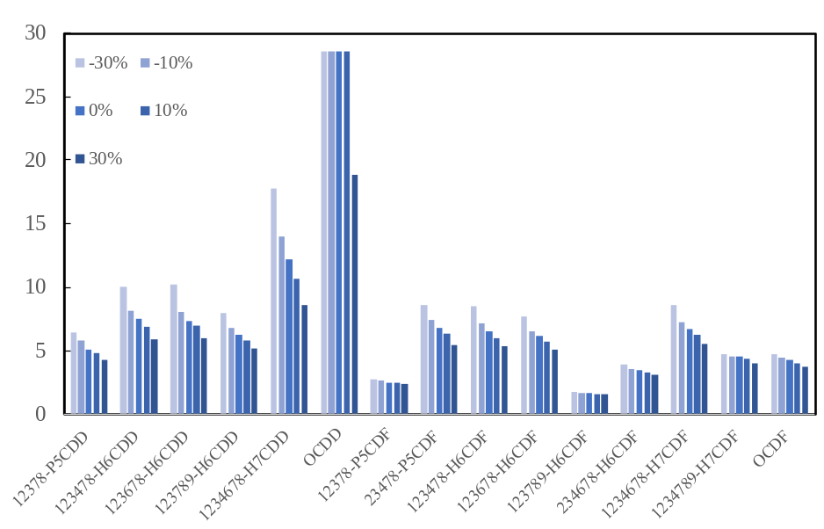
Figure S4. Sensitivity analysis of estimated half-lives based on changes of k_{dec} in Equation (2) for specific dioxin congeners.
Section 4 Development of PBPK model for 12378-P₅CDD in C57BL/6J mice.
Chemicals. The standard of 12378-P₅CDD ( D-501N，>98%) was purchased from AccuStandard Inc. (New Haven, CT, USA), and the isotope labeled standards (DF-LCS-B) was obtained from Wellington Laboratories (Guelph, Canada).
Laboratory Analysis. After spiked with isotope internal standard, blood or urine sample was added with saturated ammonium sulfate solution, and then was exacted with 1:3 v/v ethanol: hexane for 30 minutes. The aqueous phase was further extracted with hexane for 30 min. The combined organic extracts were washed ultrapure water, and dried by passing through anhydrous sodium sulfate in a glass funnel. The solution was concentrated by rotary evaporation and sequentially subjected to a multilayer silica gel packed glass column (anhydrous sodium sulfate, silica gel, silica gel impregnated with sulfuric acid (50% mass), and silica gel from top to bottom) and eluted with hexane. The eluent was concentrated to 20μL for further instrument analysis. The other tissue sample was ground with anhydrous sodium sulfate and fortified with the internal standard, and then was extracted by Soxhlet extraction with toluene for 24 hours. The extract was concentrated and transferred to the multilayer silica gel packed glass column, and eluted with hexane. The eluent was concentrated to 20~200 μL for further instrument analysis.
Instrument analysis. Quantification of 12378-PCDD was performed by using GC-ECNI-MS (Shimadzu QP 2010 Ultra, Japan) equipment with a DB-5MS fused silica capillary column (30 m ×0.25 mm×0.25 mm, J&W Scientific, USA). The temperature of inlet, interface and ion source were set at 280 ℃. The GC oven temperature was programmed as the following: the initial temperature was 110 °C (0.5 min), which was increased to 180 °C at a rate of 22 °C/min, and then the temperature was increased at a rate of 2 °C/min to achieve the final temperature of 310 °C, which was maintained for 12 min. The carrier gas flow rate was 1.5 mL/min. There was no detection of 12378-PCDD in blank samples. Recoveries of the internal standard ranged from 85% to 110% in all the samples.
Structure and equations used in the PBPK model for 12378-P₅CDD in C57BL/6J mice. The structure and equations used in 12378-P₅CDD PBPK model was initially based on the 2378-T₄CDD PBPK model in rats (Emond et al. 2006).
However, based according the experimental data in our study, we modified the adsorption and the excretion pathways to establish a 12378-P₅CDD PBPK model in mice. The detailed information about the equations used in the PBPK model for adult mice described as the following：
Following a single oral dose, the uptake of 12378-P₅CDD from gastrointestinal (A_{GI}) tract was assumed to be a first-order kinetic model:
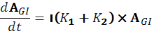
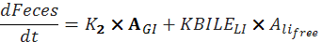
where A is the amount absorbed by GI tract, K₁ represents the absorption rate of GI tract; GI represents the amount of 12378-P₅CDD remaining in the GI tract; KBILE_LI is an inducible elimination rate in liver, and A_{li_free} is termed as the free 12378-P₅CDD concentration in liver.
For the fat and the rest of body compartment, a mass balance model is adopted:
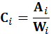
where A_{i} and C_{i} are the amount and level of 12378-P₅CDD in tissue i (include fat and the rest of body), Q_{i} is the blood flow to tissue i, W_{i} is the weight of tissue i and P_{i} is the partition coefficient between tissue i and blood. CB is defined as the blood concentration of 12378-P₅CDD.
For the liver compartment, Michaelis-Menten equation is additionally utilized to describe the concentrations of 12378-P₅CDD interacting with the Ah receptor (CYP1A2 induction) and bounding to the hepatic inducible CYP1A2, and the elimination of 12378-P₅CDD is assumed to increase proportionately to CYP1A2 induction:

=


where A_{li} represents the amount of 12378-P₅CDD in liver tissue; Q_{li} is liver tissue blood flow; C_{li} is liver tissue blood concentration; P_{li} is partition coefficient between tissue i and blood; C_{li_free} is free 12378-P₅CDD concentration in liver; W_{li} is the weight of liver; LIBMAX is the bounding capacity of 12378-P₅CDD to AhR and KDLI is the corresponding Michaelis constant; similarly, CYP1A2 is the bounding capacity of 12378-P₅CDD to CYP1A2 and KDLI1A2 is the corresponding Michaelis constant; KBILE_LI is the elimination rate, CYP1A2_{basal} and CYP1A2_{induced} is the basal and induced concentration of CYP1A2 in liver, respectively; Kelv is the adjustment constant for elimination rate.
The bounding capacity of 12378-PCDD to CYP1A2 is calculated as:
_[
where CYP1A2_1OUTZ is degradation process CYP1A2; CYP1A2_1KOUT is first-order rate for degradation; CYP1A2_1EMAX is maximal induction of CYP1A2; and CYP1A2_1EC50 is dissociation constant during induction.
Since 12378-P₅CDD is a nonvolatile compound and does not seem to metabolize in the lung, the blood concentrations of 12378-P₅CDD entering and leaving the lung are likely to be equivalent. Therefore, the blood concentration of 12378-P₅CDD is estimated in the lung as:
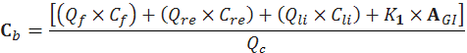
where Q_{c} represents the cardiac output.
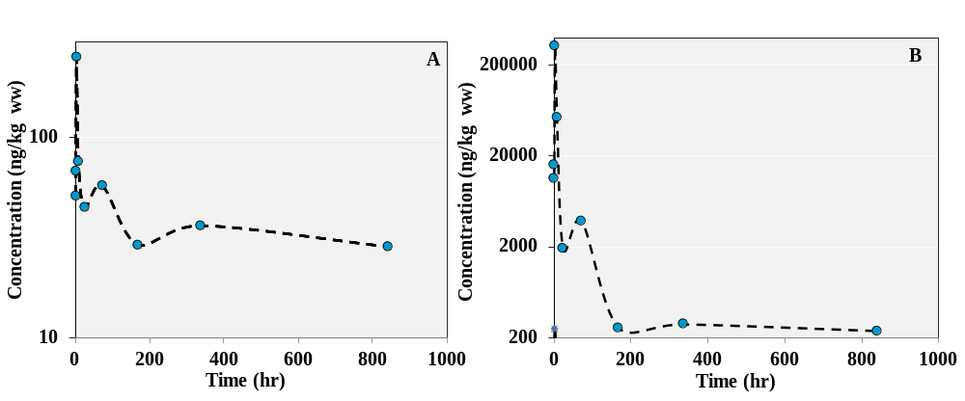
Figure S5. Time-concentration curves of 12378-P₅CDD in urine (A) and feces (B) after a single oral dosing of 20µg/kg.bw.

References for Supplementary Materials
Akaike H. 1998. Information theory and an extension of the maximum likelihood principle:Springer.
Ben Y, Li T, Wan Y, Dong Z, Hu J. 2017. Exposure assessment of pcdd/fs for the population living in the vicinity of municipal waste incinerator: Additional exposure via local vegetable consumption. Environ Pollut 224:532-540.
Emond C, Birnbaum LS, DeVito MJ. 2006. Use of a physiologically based pharmacokinetic model for rats to study the lnfluence of body fat mass and induction of cyp1a2 on the pharmacokinetics of tcdd. Environ Health Perspect 114:1394-1400.
Milbrath MOG, Wenger Y, Chang C-W, Emond C, Garabrant D, Gillespie BW, et al. 2009. Apparent half-lives of dioxins, furans, and polychlorinated biphenyls as a function of age, body fat, smoking status, and breast-feeding. Environ Health Perspect 117:417.
Nakamura T, Nakai K, Matsumura T, Suzuki S, Saito Y, Satoh H. 2008. Determination of dioxins and polychlorinated biphenyls in breast milk, maternal blood and cord blood from residents of tohoku, Japan. Sci Total Environ 394:39-51.

