Supplemental Materials
for
Urinary Biomarkers for Assessment of Human Exposure to Monomeric Aryl Phosphate Flame Retardants

Fanrong Zhao, Qiyue Kang, Xiaohua Zhang, Jiaying Liu, and Jianying Hu*
Laboratory for Earth Surface Processes, College of Urban and Environmental Sciences, Peking University, Beijing 100871, China

Corresponding author:
Jianying Hu, College of Urban and Environmental Sciences, Peking University, Beijing 100871, China, TEL & FAX: 86-10-62765520, e-mail: hujy@urban.pku.edu.cn

Synthesis of 5-OH-EHDPP and 3-OH-EHDPP. Triethylamine (1 mL) was added to 1 mmol of 2-ethylhexane-1,5-diol in tetrahydrofuran (10 mL) for synthesis of 5-OH-EHDPP or 1 mmol of 2-ethylhexane-1,3-diol for synthesis of 3-OH-EHDPP in tetrahydrofuran (10 mL). Then 5 mL of diphenyl phosphorochloridate (1.2 mmol) was added dropwise to the mixed solution. The reaction solution was stirred for 3 h at 0 °C and then ice water was added. The mixture was extracted with 40 mL of tetrahydrofuran for 3 times. The organic layers were combined, dried over anhydrous sodium sulfate, and evaporated to dryness. The extract was loaded on a silica gel column, eluted with methanol/dichloromethane (v/v) 1:20 and concentrated. The products with the purity of > 99% were obtained as shown in the NMR spectra (5-OH-EHDPP in Fig. S3-A and 3-OH-EHDPP in Fig. S3-B).

Synthesis of 3-OH-MDTP and 4-OH-MDTP. Triethylamine (6 mmol) was added to a 20-mL nitrogen-protected anhydrous tetrahydrofuran solution containing 1 mmol triphenylphosphine oxide at -20 °C, and then p-methylphenol (2 mmol) in 5 mL of tetrahydrofuran was added dropwise to the mixed solution. The mixed solution was slowly warmed to room temperature, and then reacted for 12 hours. The temperature of the reaction solution was decreased to 0°C, and 5 mL of tetrahydrofuran containing 1 mmol of 3-hydroxy-4-methylphenol for synthesis of 3-OH-MDTP or p-hydroxymethylphenol for synthesis of 4-OH-MDTP was added dropwise to the reaction solution. After reacting at room temperature for 12 hours, 200 mL of ethyl acetate and 200 mL of water were added to the reaction mixture to stop reaction. After liquid-liquid extraction, the organic phase was washed with water, dried over anhydrous sodium sulfate, and evaporated to dryness. The extract was loaded on a silica gel column, elution with ethyl acetate. The products with the purity of > 99% were obtained as shown in the NMR spectra of 3-OH-MDTP (Fig. S3-C) and 4-OH-MDTP (Fig. S3-D).

Synthesis of 4-OH-TPHP-d₁₀. Triethylamine (6 mmol) was added to 20-mL nitrogen-protected anhydrous tetrahydrofuran solution containing 1 mmol of phosphoryl trichloride at -20 °C and then phen-2,3,4,5,6-d₅-ol-d (2 mmol) in 5 mL of tetrahydrofuran was added dropwise to the mixed solution. The mixed solution was slowly warmed to room temperature, and then reacted for 12 hours. The temperature of the reaction solution was decreased to 0°C, and 5 mL of tetrahydrofuran containing 1 mmol of hydroquinone was added dropwise to the reaction solution. After reacting at room temperature for 12 hours, 200 mL of ethyl acetate and 200 mL of water were added to the reaction mixture to stop reaction. After liquid-liquid extraction, the organic phase was washed with water, dried over anhydrous sodium sulfate, and evaporated to dryness. The extract was loaded on a silica gel column, elution with ethyl acetate. The product with the purity of > 99% was obtained as shown in the NMR spectrum of 4-OH-TPHP-d₁₀ (Fig. S3-E).
Standards and reagents. Solvents including LC-MS grade of n-hexane, acetonitrile, and methanol (MeOH) and pesticide residue grade of ethyl acetate and dichloromethane were obtained from Fisher Chemicals (New Jersey, USA). Formic acid (HPLC grade) was from Dikma Technologies Inc. (California, USA). Sep-Pak® Silica (3 cm³, 200 mg), Sep-Pak® C18 (3 cm³, 200 mg), and Oasis WAX (3 cm³, 60 mg) solid phase extraction (SPE) cartridges were purchased from Waters (Milford, MA, USA). β-Glucuronidase/aryl sulfatase enzyme was obtained from Merck (KGaA, Darmstadt, Germany). Ultrapure water was prepared using a Milli-Q Synthesis water purification system (Millipore, Bedford, MA, USA).
UPLC-ESI-MS/MS Analysis. Analysis of m-aryl-OPFRs was performed using an UltiMate 3000 UPLC system coupled to a TSQ Quantiva Ultra mass spectrometer (Thermo Fisher Scientific, San Jose, CA, USA). An ACQUITY UPLC BEH C8 column (1.7 μm × 2.1 mm × 50 mm) from Waters (Millford, MA, USA) was used for the separation of m-aryl-OPFR metabolites at 40 °C. The mobile phases were MeOH (A) and 10 mM ammonium acetate in water (B). A linear gradient was used as follows: 0 min, 90% B; 0.5 min, 85% B; 3 min, 60% B; 4.5 min, 60% B; 8 min, 5% B; 8.5 min, 0% B; 11.5 min, 90% B and 14 min, 90% B. The flow rate was set at 300 μL min⁻¹, and the injection volume was 5 μL. The ESI spray voltage was set at 3.0 kV and the capillary temperature was maintained at 320 °C. Nitrogen was used as the sheath gas (40 Arb) and auxiliary gas (15 Arb) for nebulization and desolvation. The vaporizer temperature was maintained at 320 °C. Argon was used as the collision gas (1.5 mTorr) for collision-induced dissociation. The scan was performed in profile mode with scan width (m/z) of 0.1, and peak widths of Q1 (FWHM) and Q3 (FWHM) were 0.70. The dwell time was set at 0.05 s per transition. Selected reaction monitoring (SRM) mode was used to monitor the precursor-to-product ion transitions. The MS/MS parameters for the analytes, including their precursors and product ions, cone voltage, and collision energy are summarized in Table S4.

Table S1. Limits of quantification (LOQs), recoveries, and matrix effects of m-aryl-OPFR metabolites in urine samples.
Analyte | LOQs (ng/mL) | Recovery ± RSD (%) |  |  | Matrix effectª
Analyte | LOQs (ng/mL) | Low (n = 6) | Medium (n = 6) | High (n = 6) | Matrix effectª
DPHP  DCrP  5-OH-EHDPP  3-OH-EHDPP  4-OH-TPHP  3-OH-MDTP  4-OH-MDTP | 0.15  0.21  0.001  0.001  0.05  0.008  0.007 | 88 ± 4  81 ± 6  83 ± 8  80 ± 5  82± 8  76 ± 9  81 ± 12 | 91 ± 5  88 ± 4  90 ± 5  88 ± 6  84 ± 9  81 ± 6  84 ± 15 | 92 ± 5  83 ± 4  84 ± 6  81± 2  85± 3  78 ± 5  88 ± 8 | -8.3%  -8.4%  -10.8%  -9.9%  -8.8%  -14.2%  -9.7%
ª The matrix effects were calculated according to the following equation.
Matrix Effect =

Table S2. Limits of quantification (LOQs), recoveries and matrix effects of m-aryl-OPFR and their metabolites in blood samples.
Analyte | LOQs (ng/mL) | Recovery ± RSD (%) |  |  | Matrix effectª
Analyte | LOQs (ng/mL) | Low (n = 6) | Medium (n = 6) | High (n = 6) | Matrix effectª
TPHP | 0.14 | 85±8 | 83±2 | 91±4 | -8.8%
EHDPP | 0.10 | 85±3 | 87±4 | 90±5 | -3.5%
TCrP | 0.10 | 80±10 | 84±4 | 89±4 | -9.1%
DPHP | 0.12 | 81 ± 13 | 80 ± 10 | 82 ± 7 | -11.3%
DCrP | 0.08 | 80 ± 8 | 73 ± 8 | 84 ± 5 | -9.2%
5-OH-EHDPP | 0.001 | 85 ± 6 | 85 ± 3 | 87 ± 2 | -6.3%
3-OH-EHDPP | 0.001 | 78 ± 4 | 74 ± 2 | 80 ± 6 | -2.1%
4-OH-TPHP | 0.05 | 88 ± 9 | 88 ± 6 | 92 ± 4 | 1.9%
3-OH-MDTP | 0.01 | 78 ± 6 | 74 ± 2 | 80 ± 6 | -12.1%
4-OH-MDTP | 0.01 | 86 ± 8 | 80 ± 7 | 89 ± 7 | -8.7%
ª The matrix effects were calculated according to the following equation.
Matrix Effect =

Table S3. Pearson correlations between concentrations of urinary m-aryl-OPFR metabolites.
 |  | 5-OH-EHDPP | 4-OH-TPHP | DPHP | 3-OH-MDTP | 4-OH-MDTP
5-OH-EHDPP | r_{p} | 1.000
 | p | -
4-OH-TPHP | r_{p} | 0.148 | 1.000
 | p | 0.067 | -
DPHP | r_{p}ª | 0.220** | 0.451** | 1.000
 | p | 0.003 | 0.000 | -
3-OH-MDTP | r_{p} | 0.180* | 0.021 | -0.118 | 1.000
 | p | 0.011 | 0.788 | 0.098 | -
4-OH-MDTP | r_{p} | 0.200** | 0.053 | -0.040 | 0.275** | 1.000
 | p | 0.002 | 0.499 | 0.576 | 0.000 | -
ªStatistically significant (*p < 0.05, **p < 0.01).

Table S4. Optimized Instrumental and MRM Conditions of Target Analytes and Surrogate Standards.
Compound | Precursor (m/z) | Product (m/z) | Collision Energy (V) | RF Lens (V)
DPHP | 251.1 | 152.0 | 28.5 | 78.2
 | 251.1 | 153.0 | 19.9 | 78.2
 | 251.1 | 215.0 | 21.1 | 78.2
DPHP-d10 | 261.4 | 159.1 | 28.5 | 78.2
 | 261.4 | 160.1 | 19.9 | 78.2
 | 261.4 | 161.1 | 21.1 | 78.2
DCrP | 279.1 | 91.1 | 28.2 | 77.7
 | 279.1 | 165.0 | 31.0 | 77.7
 | 279.1 | 166.0 | 21.8 | 77.7
4-OH-TPHP | 343.1 | 141.0 | 29.3 | 94.0
 | 343.1 | 215.0 | 28.7 | 94.0
 | 343.1 | 230.9 | 27.0 | 94.0
4-OH-TPHP-d10 | 353.2 | 221.0 | 29.3 | 94.0
 | 353.2 | 236.0 | 28.7 | 94.0
 | 353.2 | 274.0 | 27.0 | 94.0
5-OH-EHDPP/  3-OH-EHDPP | 379.2 | 153.0 | 32.6 | 41.4
5-OH-EHDPP/  3-OH-EHDPP | 379.2 | 215.0 | 35.4 | 41.4
5-OH-EHDPP/  3-OH-EHDPP | 379.2 | 251.0 | 14.2 | 41.4
3-OH-MDTP | 385.2 | 181.8 | 31.4 | 98.0
 | 385.2 | 259.3 | 29.5 | 98.0
 | 385.2 | 278.8 | 25.3 | 98.0
4-OH-MDTP | 385.2 | 242.9 | 31.3 | 85.0
 | 385.2 | 355.0 | 21.4 | 85.0
 | 385.2 | 367.0 | 16.4 | 85.0

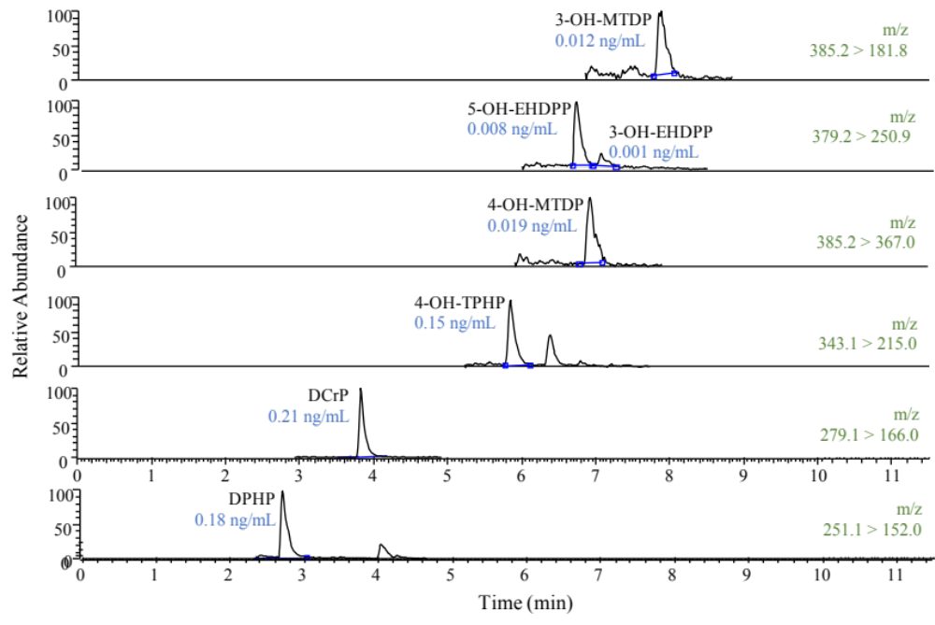
Fig. S1. UPLC−MS/MS SRM chromatograms of the ions selected for identification of analytes detected in urine samples.

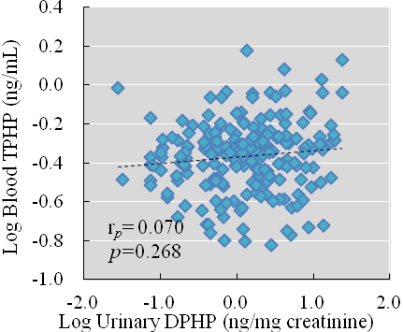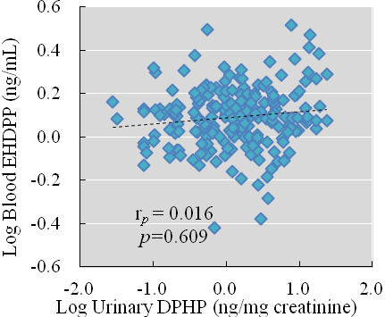
Fig. S2. Correlation between the log-transformed concentrations of urinary m-aryl-OPFR metabolites (ng/mg creatinine) and blood m-aryl-OPFRs (ng/mL) in 259 participants.

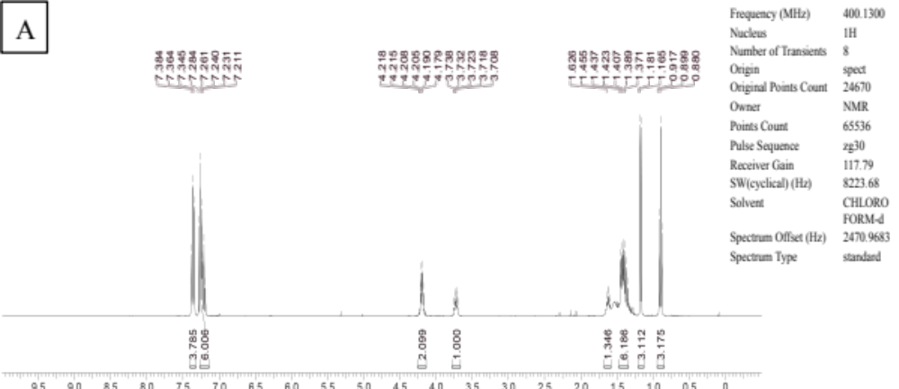
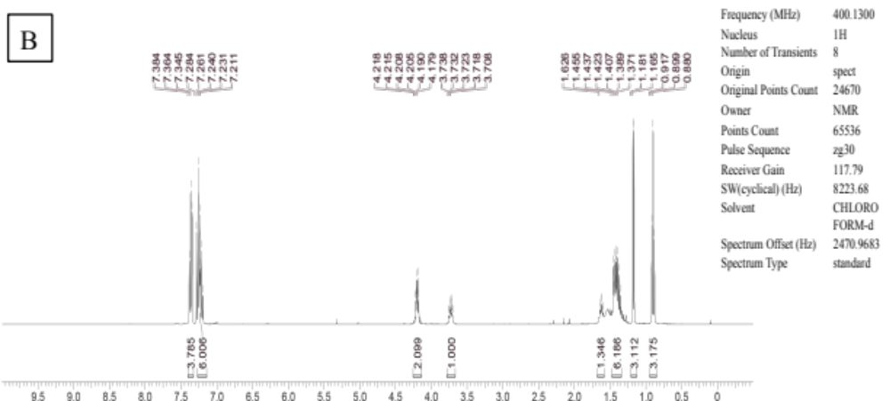
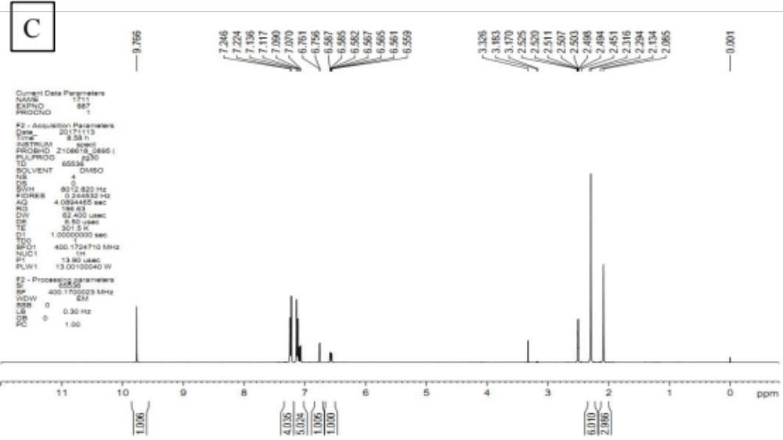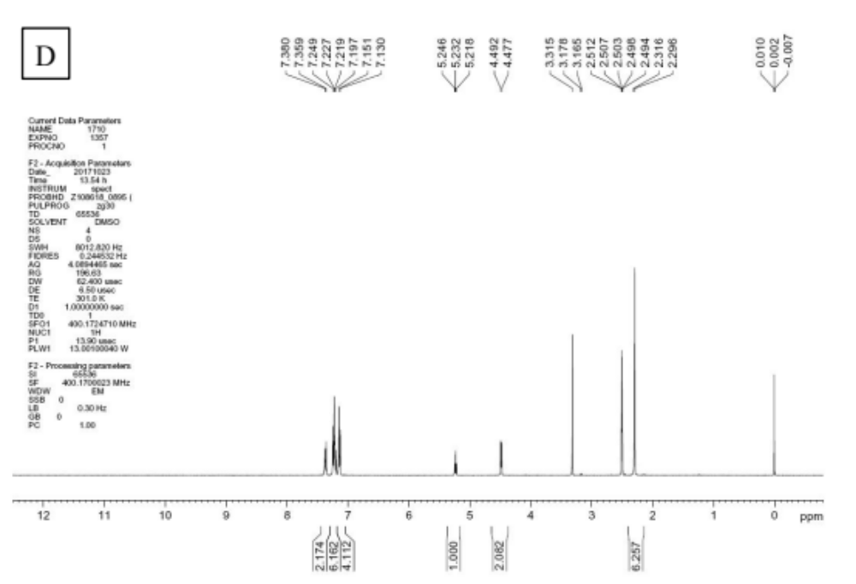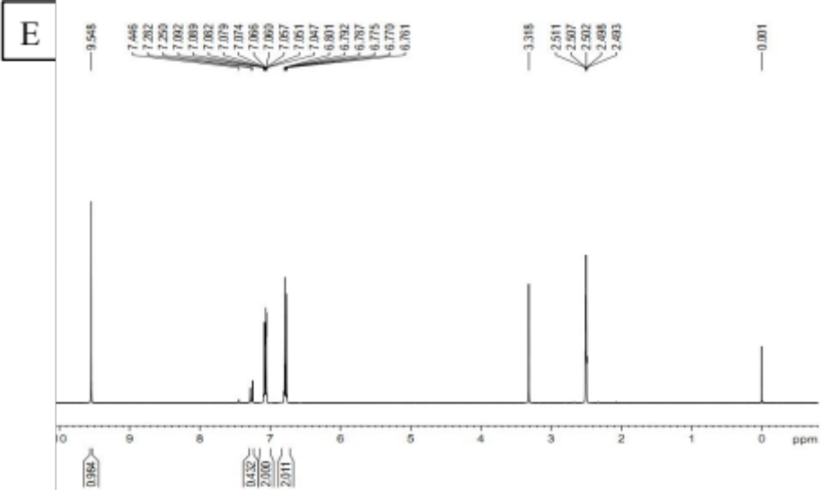
Fig. S3. NMR spectra of (A) 5-OH-EHDPP, (B) 3-OH-EHDPP, (C) 3-OH-MDTP, (D) 4-OH-MDTP, and (E) 4-OH-TPHP-d₁₀.

