Supplementary Material
Trophic transfer of organophosphorus flame retardants in a lake food web

Haoqi ZHAO¹, Fanrong ZHAO¹, Jixuan LIU¹, Shiyi ZHANG¹, Di MU¹, Lihui AN², Yi Wan¹, and Jianying HU^{1*}

¹ Laboratory for Earth Surface Processes, College of Urban and Environmental Sciences, Peking University, Beijing 100871, China
² State Key Laboratory of Environmental Criteria and Risk Assessment, Chinese Research Academy of Environmental Sciences, Beijing 100012, China

Corresponding author:

Jianying HU, College of Urban and Environmental Sciences, Peking University, Beijing 100871, China, TEL & FAX: 86-10-62765520, e-mail: hujy@urban.pku.edu.cn

Stable carbon and nitrogen isotope analysis
To determine the trophic levels of the food web species, three samples were randomly picked up for each species to measure the stable carbon and nitrogen isotope ratios. Freeze-dried and ground tissue was soaked in 50 mL methanol for 36 h, with solvent changed every 12 hours to reduce lipids. The sample was then dried at 70 °C for 12 h, homogenized, and passed through 180 ìm mush net. Subsequently, about 0.3 mg tissue was wrapped into Sn capsule and introduced into the elemental analyzer (Thermo Flash 2000, Massachusetts, USA). Carbon and nitrogen were first converted to CO₂ and NO_{x} gas at 960 °C, then NO_{x} was reduced to N₂ by copper wires. The CO₂ and N₂ generated were then introduced into the isotope ratio mass spectrometer (Thermo Delta V) through a Conflo IV with 100 mL/min helium as the carrier gas.
Nitrogen and carbon isotope ratios were expressed as:
, (S1)
where δx (‰, per thousands) is the isotope composition of the sample relative to the reference material, R_{samp} and R_{ref} are the absolute isotope ratios in the sample and the reference material. Vienna Pee Dee Belimnite (VPDB) and Atmospheric AIR were used as the reference materials for δ¹³C and δ¹⁵N, respectively.
The stable isotope ratios were then calibrated against international reference materials: USGS42 (Tibetan Human Hair) and IAEA-CH-7 (Polyethylene) for δ¹³C, USGS42 (Tibetan Human Hair) and USGS41 (L-glutamic acid) for δ¹⁵N. The analytical precision was 0.2‰ for both carbon and nitrogen.
UPLC-MS/MS analysis
Quantification of the fourteen OPFRs was performed on an Acquity Ultra Performance Liquid Chromatography (Waters, Milford, MA, USA) interfaced to a Waters Premier XE tandem quadrupole mass spectrometer. Chromatographic separation was achieved with a Waters ACQUITY UPLC BEH C18 column (2.1 mm × 100 mm × 1.8 μm) preceded by a Waters ACQUITY UPLC BEH C18 guard column (2.1 mm × 50 mm × 1.7 μm). The column was maintained at 40°C with a flow rate of 0.2 mL/min. The injection volume was 5 μL. Methanol (A) and 0.1% formic acid (v/v) water solution (B) were used as the mobile phases, and the elution gradient was set as follows: 0 minute 10% A, increased linearly to 40% A in 1 minute, to 70% A at 6 minute, to 80% A at 9 minute, to 100% A at 12 minute and kept for 3.5 minutes, then decreased to 10% A and held for 2 minutes to prepare for next injection.
Mass spectrometer was equipped with an electrospray ionization source (Micromass, Manchester, UK) in the positive ion mode. Data acquisition was performed in the multiple-reaction monitoring (MRM) mode, with the MRM transition channels and parameters in Table S2. Mass spectrometer conditions were set as follows: source temperature, 110°C; desolvation temperature, 350 °C; capillary voltage, 3.50 kV; desolvation gas flow, 800 L/h; cone gas flow, 50 L/h; multiplier, 650 V.
Internal standard calibration
Tris(ethyl)-d₁₅ phosphate (TEP-d₁₅) was employed as the internal standard for TEP, tris(2-chloroethyl)-d₁₂ phosphate (TCEP-d₁₂) was employed as the internal standard for TCEP, tris(1,3-dichloroisopropyl)-d₁₅ phosphate (TDCIPP-d₁₅) for TCIPP, TDCIPP, and tris(2,3-dibromopropyl) phosphate (TDBPP), tris(propyl)-d₂₁ phosphate (TPrP-d₂₁) for TPrP and tris(isopropyl) phosphate (TiPP), tris(phenyl)-d₁₅ phosphate (TPHP-d₁₅) for TPHP and EHDPP, tris(n-butyl)-d₂₇ phosphate (TNBP-d₂₇) for TIBP, TBOEP, and TNBP, tris(methylphenyl)-d₂₁ phosphate (TMPP-d₂₁) for TMPP, and tris(2-ethylhexyl)-d₅₁ phosphate (TEHP-d₅₁) for TEHP (Table S2).
Trophic magnification factor
Trophic levels (TLs) were determined using Equation (S2). Plankton was selected as the baseline for TL calculation with a TL of 2. Trophic enrichment factor of ä¹⁵N was set as 3.8 following previous studies (Hobson et al., 1992; Fisk et al., 2001; Peng et al., 2014).
, (S2)
where ä¹⁵N_{consumer} and ä¹⁵N_{plankton} are the stable nitrogen ratios of the target consumer species and plankton, respectively.
Trophic magnification factor of an OPFR is determined based on the regression between log-transformed concentrations in biota and trophic levels, as expressed by Equations (S3) and (S4).
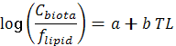 (S3)
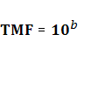 (S4)
where C_{biota} is the concentrations of the OPFRs in organisms, f_{lipid} is the lipid content of biota tissues. Lipid-normalized concentrations were used to reduce variance caused by different lipid contents of the species (Peng et al., 2014).

References
Chemspider, accessed June 2018. http://www.chemspider.com.
Fisk, A.T., Hobson, K.A., Norstrom, R.J., 2001. Influence of chemical and biological factors on trophic transfer of persistent organic pollutants in the northwater polynya marine food web. Environ. Sci. Technol. 35 (4), 732-738.
Hobson, K.A., Welch, H.E., 1992. Determination of trophic relationships within a high arctic marine food web using delta-C-13 and delta-N-15 analysis. Mar. Ecol. Prog. Ser. 84, 9-18.
Hou, R., Liu, C., Gao, X., Xu, Y., Zha, J., Wang, Z., 2017. Accumulation and distribution of organophosphate flame retardants (PFRs) and their di-alkyl phosphates (DAPs) metabolites in different freshwater fish from locations around Beijing, China. Environ. Pollut. 229, 548−556.
Hou, R., Xu, Y., Wang, Z., 2016. Review of OPFRs in animals and humans: absorption, bioaccumulation, metabolism, and internal exposure research. Chemosphere 153, 78-90.
Peng, H., Wan, Y., Zhang K., Sun J. X., Hu J. Y., 2014. Trophic transfer of dechloranes in the marine food web of Liaodong Bay, north China. Environ. Sci. Technol. 48, 5458-5466.
Syracuse Research Corporation. PHYSPROP Database, http://esc.syrres.com/fatepointer/search.asp.
Van der Veen, I., de Boer, J., 2012. Phosphorus flame retardants: Properties, production, environmental occurrence, toxicity and analysis. Chemosphere 88, 1119−1153.

Table S1
Abbreviation, CAS number and physicochemical properties of the target OPFRs.
Name | Abbreviation | CAS number | Solubility  (mg/L at 25 °C)^{b} |  | logK_{ow}ª | logK_{oc}^{b} | Predicted  BCF^{b} | Measured  BAF^{c}
Triethyl phosphate | TEP | 78-40-0 | 1115 |  | 0.80 | 1.68 | 3.2 | -
Tris (2-chloroethyl) phosphate | TCEP | 115-96-8 | 7000 |  | 1.44 | 2.48 | 0.43 | 34.7
Tripropyl phosphate | TPrP | 513-08-6 | 826.6 |  | 1.87 | 2.83 | 63.1 | -
Triisopropyl phosphate | TiPP | 513-02-0 | 501.1 |  | 2.12 | 2.25 | 24.0 | -
Tris (2-chloroisopropyl) phosphate | TCIPP | 13674-84-5 | 51.9 |  | 2.59 | 2.21 | 3.3 | 250
Tris isobutyl phosphate | TIBP | 126-71-6 | 475.6 |  | 3.60 | 3.05 | 19.5 | -
Tris (2-chloro-1-(chloromethyl) ethyl) phosphate | TDCIPP | 13674-87-8 | 7 |  | 3.65 | 2.35 | 21.4 | 27.8
Tris (2-butoxyethyl) phosphate | TBOEP | 78-51-3 | 1100 |  | 3.75 | 4.38 | 25.6 | 38.5
Tri-n-butyl phosphate | TNBP | 126-73-8 | 280 |  | 4.00 | 3.28 | 39.8 | 173
Tris (2,3-dibromopropyl) phosphate | TDBPP | 126-72-7 | 1.0 |  | 4.29 | 3.83 | 1589 | -
Triphenyl phosphate | TPHP | 115-86-6 | 1.9 |  | 4.59 | 3.72 | 113.3 | 1008
Tricresyl phosphate | TMPP | 1330-78-5 | 0.36 |  | 5.11 | 4.35 | 8564 | -
2-Ethylhexyl diphenyl phosphate | EHDPP | 1241-94-7 | 1.9 |  | 5.73 | 4.21 | 855 | 163
Tris (2-ethylhexyl) phosphate | TEHP | 78-42-2 | 0.6 |  | 9.49 | 6.87 | 1 × 10⁶ | 1983
ª values from PHYSPROP Database, Syracuse Research Corporation: http://esc.syrres.com/fatepointer/search.asp.
^{b} complied from Chemspider, 2018; Van der Veen and de Boer, 2012; Hou et al., 2016.
^{c} Hou et al., 2017.

Table S2
MRM parameters for the UPLC-MS/MS analysis of OPFRs and the internal standards. Internal standards were marked as italic. OPFRs were calibrated by the internal standards following them most closely.
Compounds | Monitoring transition | Cone voltage(V) | Collision voltage(eV) | Retention time (min)
TEP | 182.8>98.6 | 20 | 20 | 4.89
TEP-d₁₅ | 197.8>101.6 | 20 | 20 | 4.80
TCEP | 286.9>62.6 | 29 | 29 | 5.67
TCEP-d₁₂ | 299.0>101.5 | 29 | 29 | 5.62
TPrP | 225.0>98.5 | 20 | 17 | 7.93
TiPP | 225.0>98.5 | 20 | 17 | 7.50
TPrP-d₂₁ | 246.0>101.6 | 20 | 17 | 7.81
TCIPP | 327.1>98.5 | 22 | 22 | 7.97
TDCIPP | 431.0>98.5 | 29 | 23 | 9.51
TDBPP | 698.7>98.5 | 31 | 28 | 10.19
TDCIPP-d₁₅ | 446.0>101.8 | 29 | 23 | 9.44
TIBP | 267.1>98.5 | 20 | 20 | 10.44
TBOEP | 399.3>44.7 | 29 | 23 | 11.15
TNBP | 267.1>98.5 | 20 | 20 | 10.63
TIBP-d₂₇ | 294.4>101.6 | 20 | 20 | 10.48
TPHP | 327.1>76.6 | 50 | 38 | 9.63
EHDPP | 363.2>250.9 | 19 | 16 | 12.44
TPHP-d₁₅ | 342.2>81.6 | 50 | 38 | 9.51
TMPP | 369.1>164.9 | 49 | 52 | 11.95
TMPP-d₂₁ | 390.3>173 | 49 | 52 | 11.85
TEHP | 435.4>98.5 | 16 | 16 | 14.77
TEHP-d₅₁ | 486.2>101.7 | 16 | 16 | 14.67

Table S3
Method limits of detection (LODs) and recoveries (average ± standard deviation) of OPFRs in biota samples.
Compound | Biota
Compound | LODs  (ng/g ww) | Recoveries (%) at three spiked concentrations (ng/g ww)
Compound | LODs  (ng/g ww) | Plankton |  |  | Snail |  |  | Whitebait |  |  | Yellow-head catfish
Compound | LODs  (ng/g ww) | 0.5 | 1 | 5 | 0.5 | 1 | 5 | 0.5 | 1 | 5 | 0.5 | 1 | 5
TEP | 0.076 | 60 ± 11 | 64 ± 2 | 74 ± 5 | 60 ± 20 | 77 ± 1 | 87 ± 2 | 62 ± 5 | 78 ± 5 | 103 ± 8 | 72 ± 9 | 83 ± 6 | 78 ± 10
TCEP | 0.14 | 77 ± 7 | 87 ± 5 | 96 ± 11 | 61 ± 9 | 50 ± 4 | 70 ± 6 | 51 ± 2 | 80 ± 5 | 78 ± 16 | 55 ± 6 | 82 ± 2 | 96 ± 5
TPrP | 0.001 | 92 ± 7 | 105 ± 3 | 93 ± 6 | 67 ± 9 | 70 ± 3 | 89 ± 6 | 76 ± 12 | 81 ± 3 | 92 ± 1 | 55 ± 3 | 85 ± 1 | 102 ± 2
TiPP | 0.002 | 84 ± 11 | 103 ± 5 | 95 ± 4 | 55 ± 13 | 79 ± 2 | 85 ± 7 | 80 ± 11 | 83 ± 3 | 97 ± 5 | 71 ± 2 | 87 ± 1 | 98 ± 3
TCIPP | 0.046 | 68 ± 18 | 96 ± 4 | 110 ± 20 | 70 ± 5 | 55 ± 4 | 67 ± 2 | 65 ± 4 | 79 ± 4 | 100 ± 1 | 75 ± 5 | 85 ± 6 | 79 ± 10
TIBP | 0.026 | 80 ± 7 | 93 ± 8 | 101 ± 13 | 67 ± 11 | 58 ± 6 | 70 ± 6 | 59 ± 6 | 80 ± 6 | 90 ± 5 | 58 ± 9 | 80 ± 6 | 105 ± 6
TDCIPP | 0.026 | 96 ± 14 | 110 ± 5 | 120 ± 14 | 50 ± 11 | 53 ± 5 | 78 ± 11 | 65 ± 2 | 87 ± 7 | 102 ± 8 | 65 ± 4 | 77 ± 2 | 99 ± 6
TBOEP | 0.015 | 103 ± 5 | 112 ± 1 | 97 ± 8 | 60 ± 4 | 68 ± 2 | 82 ± 5 | 66 ± 6 | 77 ± 4 | 86 ± 18 | 65 ± 2 | 80 ± 2 | 89 ± 5
TNBP | 0.095 | 88 ± 17 | 112 ± 8 | 94 ± 7 | 58 ± 9 | 67 ± 5 | 91 ± 11 | 68 ± 9 | 83 ± 5 | 107 ± 2 | 72 ± 5 | 80 ± 3 | 93 ± 4
TDBPP | 0.001 | 77 ± 5 | 70 ± 1 | 90 ± 7 | 56 ± 7 | 60 ± 10 | 86 ± 5 | 80 ± 1 | 76 ± 5 | 92 ± 1 | 70 ± 10 | 78 ± 3 | 103 ± 5
TPHP | 0.070 | 85 ± 6 | 104 ± 18 | 91 ± 6 | 47 ± 5 | 48 ± 4 | 66 ± 13 | 55 ± 4 | 60 ± 2 | 74 ± 2 | 48 ± 4 | 70 ± 3 | 95 ± 4
TMPP | 0.003 | 96 ± 9 | 107 ± 1 | 91 ± 3 | 60 ± 14 | 51 ± 4 | 54 ± 3 | 70 ± 9 | 83 ± 3 | 105 ± 3 | 61 ± 1 | 72 ± 4 | 93 ± 3
EHDPP | 0.019 | 60 ± 12 | 82 ± 1 | 77 ± 6 | 46 ± 9 | 48 ± 10 | 60 ± 9 | 59 ± 3 | 66 ± 8 | 101 ± 5 | 58 ± 10 | 71 ± 5 | 95 ± 8
TEHP | 0.011 | 76 ± 17 | 90 ± 18 | 99 ± 1 | 48 ± 19 | 56 ± 17 | 73 ± 2 | 49± 4 | 65 ± 3 | 69 ± 13 | 66 ± 17 | 94 ± 5 | 86 ± 13

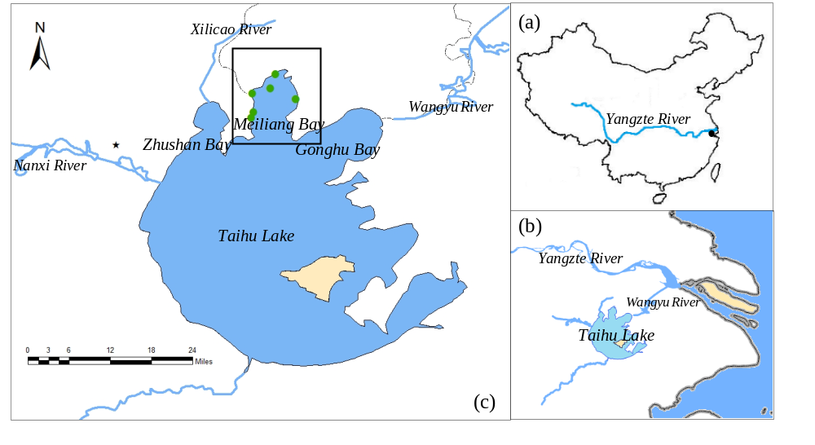
Fig. S1. Location of (a,b) Taihu Lake and (c) biota sampling sites on Taihu Lake. Plankton was collected from six sites on the Meiliang Bay marked by the green dots. Invertebrate and fish samples were collected from the entire Meiliang Bay marked by the black box. The largest OPFRs manufacturer in China, Jiangsu Yoke Technology Co., Ltd., is located ~15 km away from Taihu Lake and was marked by the black star.

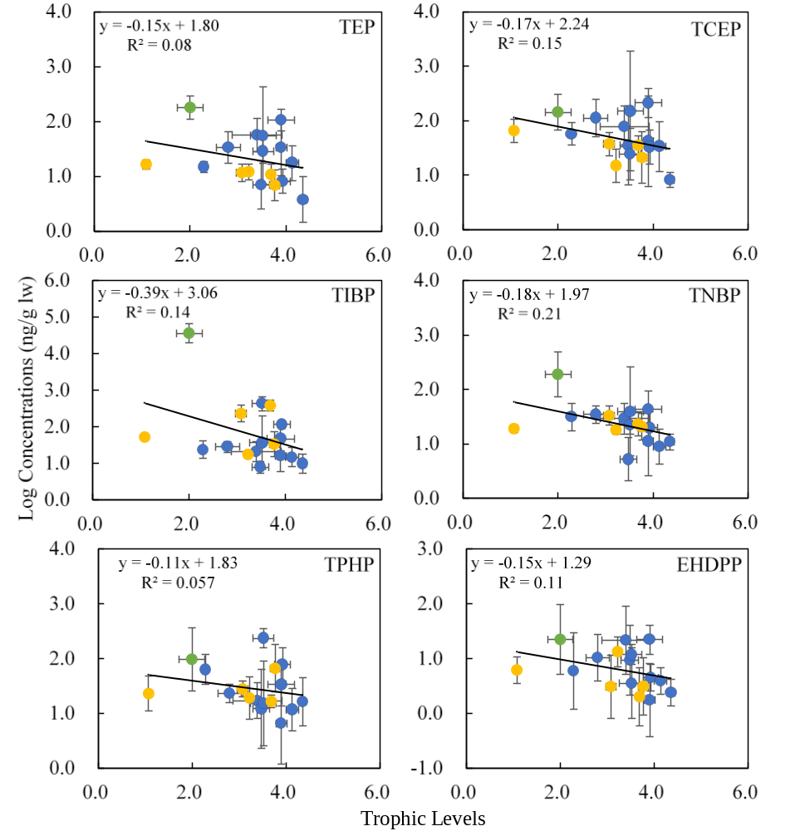
Fig. S2. Relationships between log-transformed concentrations of OPFRs (ng/g lw) and trophic levels of species in the food web which the correlations were not significant. Plankton, invertebrate, and fish species were shown in green, yellow, blue dots, respectively. Error bar indicated ± standard deviation. Regression was based on the geometric mean concentrations of OPFRs in each species.

