Supplementary Data
For
Toxicity of Triphenyltin on the Development of Retinal Axons in Zebrafish at Low Dose

Yue Xiao, Jieqiong Jiang, Wenxin Hu, Yanbin Zhao, and Jianying Hu*
Laboratory for Earth Surface Processes, College of Urban and Environmental Sciences, Peking University, Beijing 100871, China

Pages 10
Text P1-2
Tables 2
Figure 5

This supporting information provides text, figures and tables addressing (1) ddPCR reaction; (2) Primer sequences of genes used in real-time PCR and ddPCR; (3) Information on the MRM transition and analytical parameters in the analysis of RA; (4) Experimental design for the TPT exposure and subsequent malformation study with larvae exposed to TPT; (5) Ocular structural deformations of zebrafish larvae following TPT exposure; (6) Binary images of dynamic pigmentation change of larvae; (7) Typical droplet profile for β-actin, pax6, EphrinB1, EphrinB2, EphB2, EphB3 of zebrafish larval eyes from the control and 15 ng TPT-Cl /g exposure group; (8) Transformation relationship of ROH, RAL and RA.
ddPCR Reaction
For ddPCR reaction, each 20 μL volume reaction mixture consisted 10 μL of QX200 ddPCR EvaGreen supermix (BioRad), 200 nM of primer, and 5μL of cDNA. Droplets were generated using the droplet generator (DG) with 70 μL of droplet generator oil per well in a DG8 cartridge and cartridge holder. About 40 μL of droplets were transferred into each well of a 96-well PCR plate and sealed. The PCR reaction was run on a thermal cycler with: 5 minutes activation at 95°C, 40 cycles for a two-step amplification protocol (30s at 95°C denaturation and 60s at 56°C). The PCR plate was transferred to a QX200 droplet reader (Biorad), and products analyzed with QuantaSoft (Bio-Rad) Analysis software.

Table S1. Primers Used for RT-PCR and ddPCR Analysis.
Target gene | Primer sequence (5' - 3')
Target gene | Forward | Reverse
β-actin | CGAGCTGTCTTCCCATCCA | TCACCAACGTAGCTGTCTTTCTG
RDH1 | GGAGGATACTGCCTGTCCAA | CTCCAGCGTTTCTTCAGGTC
RDH5 | GCTGACAGATGGAGGAGTTGACT | CAGCTCTCATAATGCCAACATTG
RDH8 | CTGGCAAAATAATGCTTGATGAGT | TGATGGTTCGAATGCCTTGTC
Raldh2 | CGACAAGGCTGATGTGGATAAAG | TTCCTCCATACTGAACCCAGAGA
CYP26A1 | AGTGGCCAGCATCAGTGAGAA | GAACGCCCTCATAATGGCCT
pax6 | CGACTCCACGAGACAGAAAATAGTT | TGGACACCTGCAGAATTCTTGAT
EphrinB1 | TGACAGCCATGTGCAGATACG | ACAAACTTGGGATTTTGCGAAT
EphrinB2 | GAAGGTTGGACAAAGTGTTTTGC | TGTCCTTGCCCCCTAAGTCA
EphB2 | CTACTAACCAGGCTGCTCCTTCC | ATTATGCTCGGTCTGGTCCTTCT
EphB3 | GGTGACACATAGACAAAACGCTTCT | TGCTGTCCATAAGAGTCTCCTCAAC

Table S2. Selected Reaction Monitoring (SRM) Conditions of the Target Analytesª
analyte | SRM transition (m/z) | RF Lens (V) | collision energy (eV)
atRA | 299.243 > 119.054^{b}  299.243 > 255.143 | 59 | 23.1  14.5
atRA-d₅ | 304.274 >120.125 ^{b}  304.274 > 194.333 | 62 | 23.4  15.9
ª atRA: all-trans retinoic acid; atRA-d⁵: all-trans retinoic acid-d₅. ^{b} SRM transition used for quantitation.
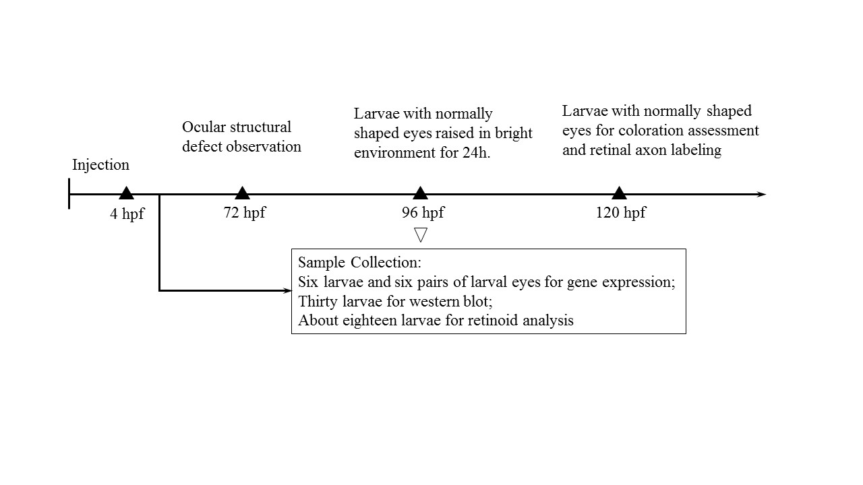
Figure S1 Experimental design for the TPT exposure and subsequent malformation study with larvae exposed to TPT.

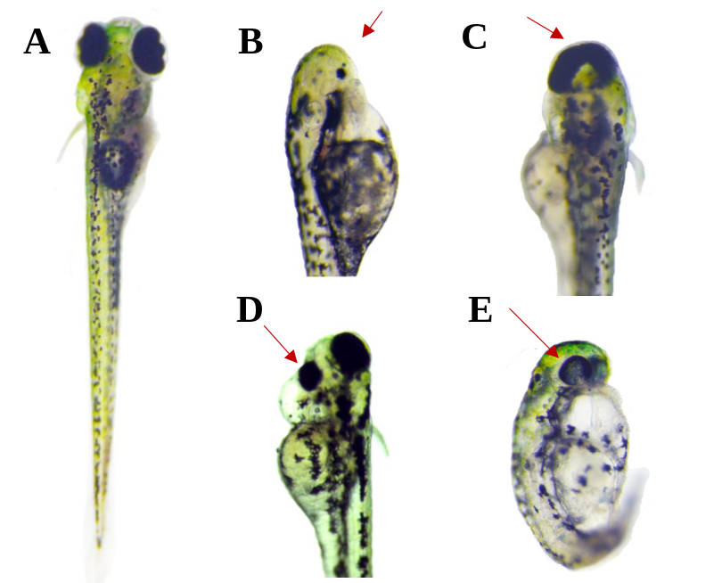
Figure S2. Ocular structural deformations of zebrafish larvae following TPT exposure. (A) Normally shaped eyes; (B) No eye in 0.8 ng/g TPT-Cl exposure group; (C) Single eye in 4.0 ng/g TPT-Cl exposure group; (D) Small eye in 0.8 ng/g TPT-Cl exposure group; (E) Misshapen lens in 100 ng/g TPT-Cl exposure group.
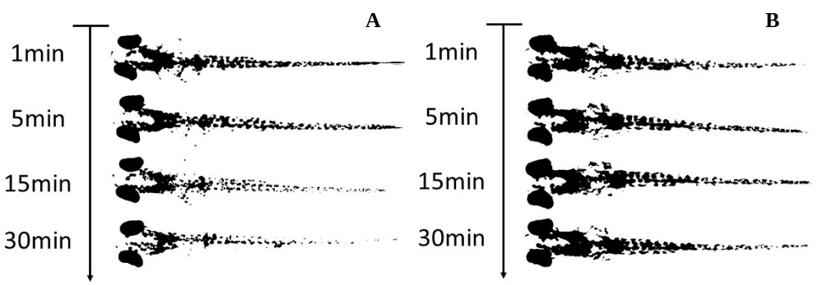
Figure S3. Binary images of dynamic pigmentation change of larvae. All 96 hpf larvae, which are exposed to TPT, were in bright environment for 4 h, and then dark coloration larvae were picked up. The dark coloration larvae together with normal pigmentation larvae were subsequently dark-adapted for 1 h, and then moved to bright environment. (A) Normal pigmentation change of larvae; (B) Larvae failed to change pigmentation in bright environment.
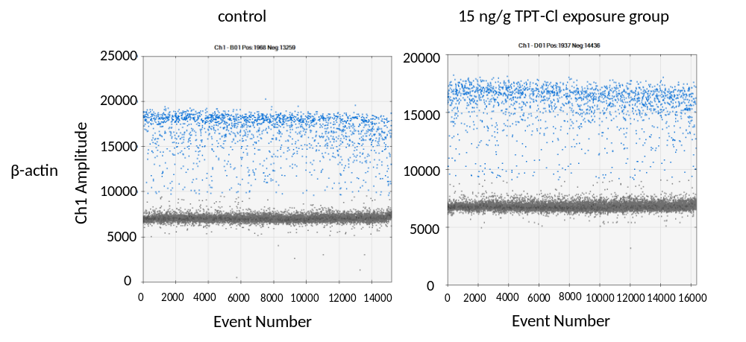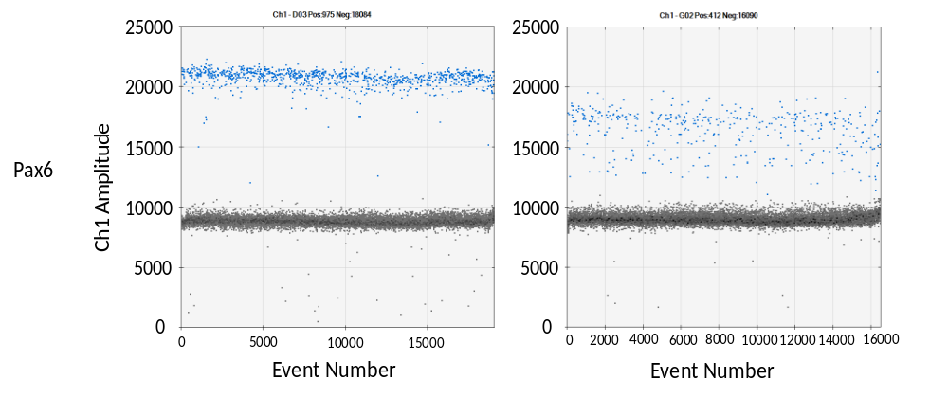
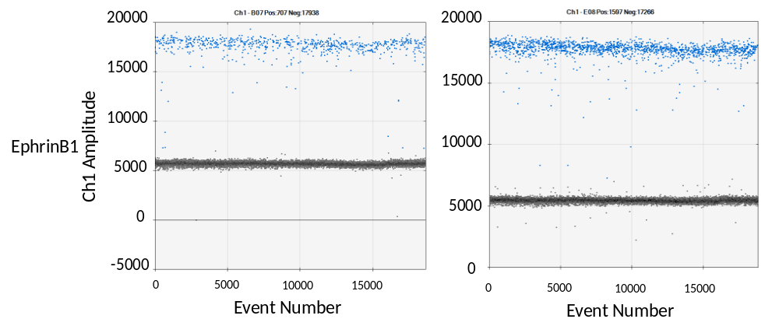
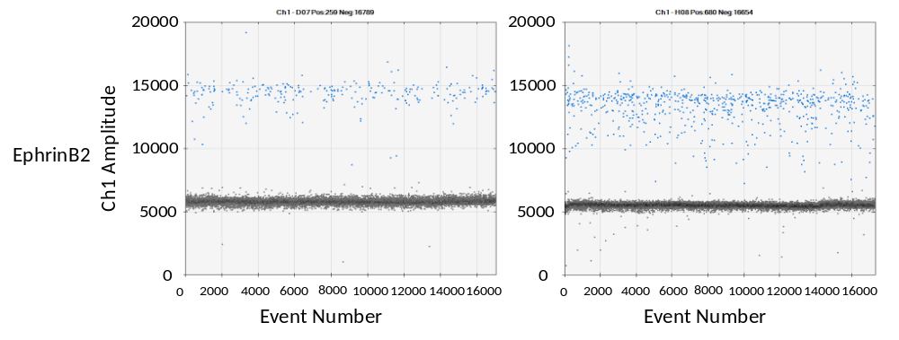
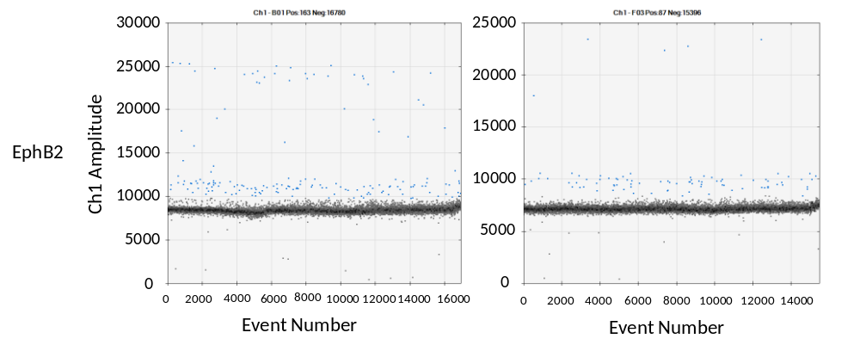
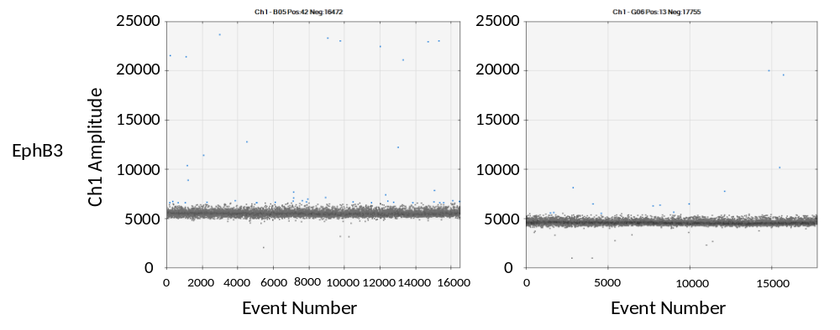
Figure S4 Typical droplet profile forβ-actin, pax6, EphrinB1, EphrinB2, EphB2, EphB3 of zebrafish larval eyes from the control and 15 ng TPT-Cl /g exposure group.

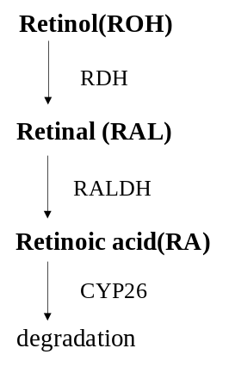
Figure S5 Transformation relationship of ROH, RAL and RA. Retinol (ROH) is first oxidized and converted to retinal (RAL) by retinol dehydrogenases (RDHs). Further oxidation of retinal by retinal dehydrogenases (Raldhs) generates retinoic acid (RA), which acts as a ligand for specific nuclear receptors, such as RAR and RXR, to regulate the transcription of a wide variety of target genes. The excess RAs are degraded by cytochrome P450 enzyme, Cyp26. The enzyme or class of enzymes catalyzing each reaction are abbreviated as follows: RDHs, retinol dehydrogenases; Raldhs, retinal dehydrogenases.
.

